
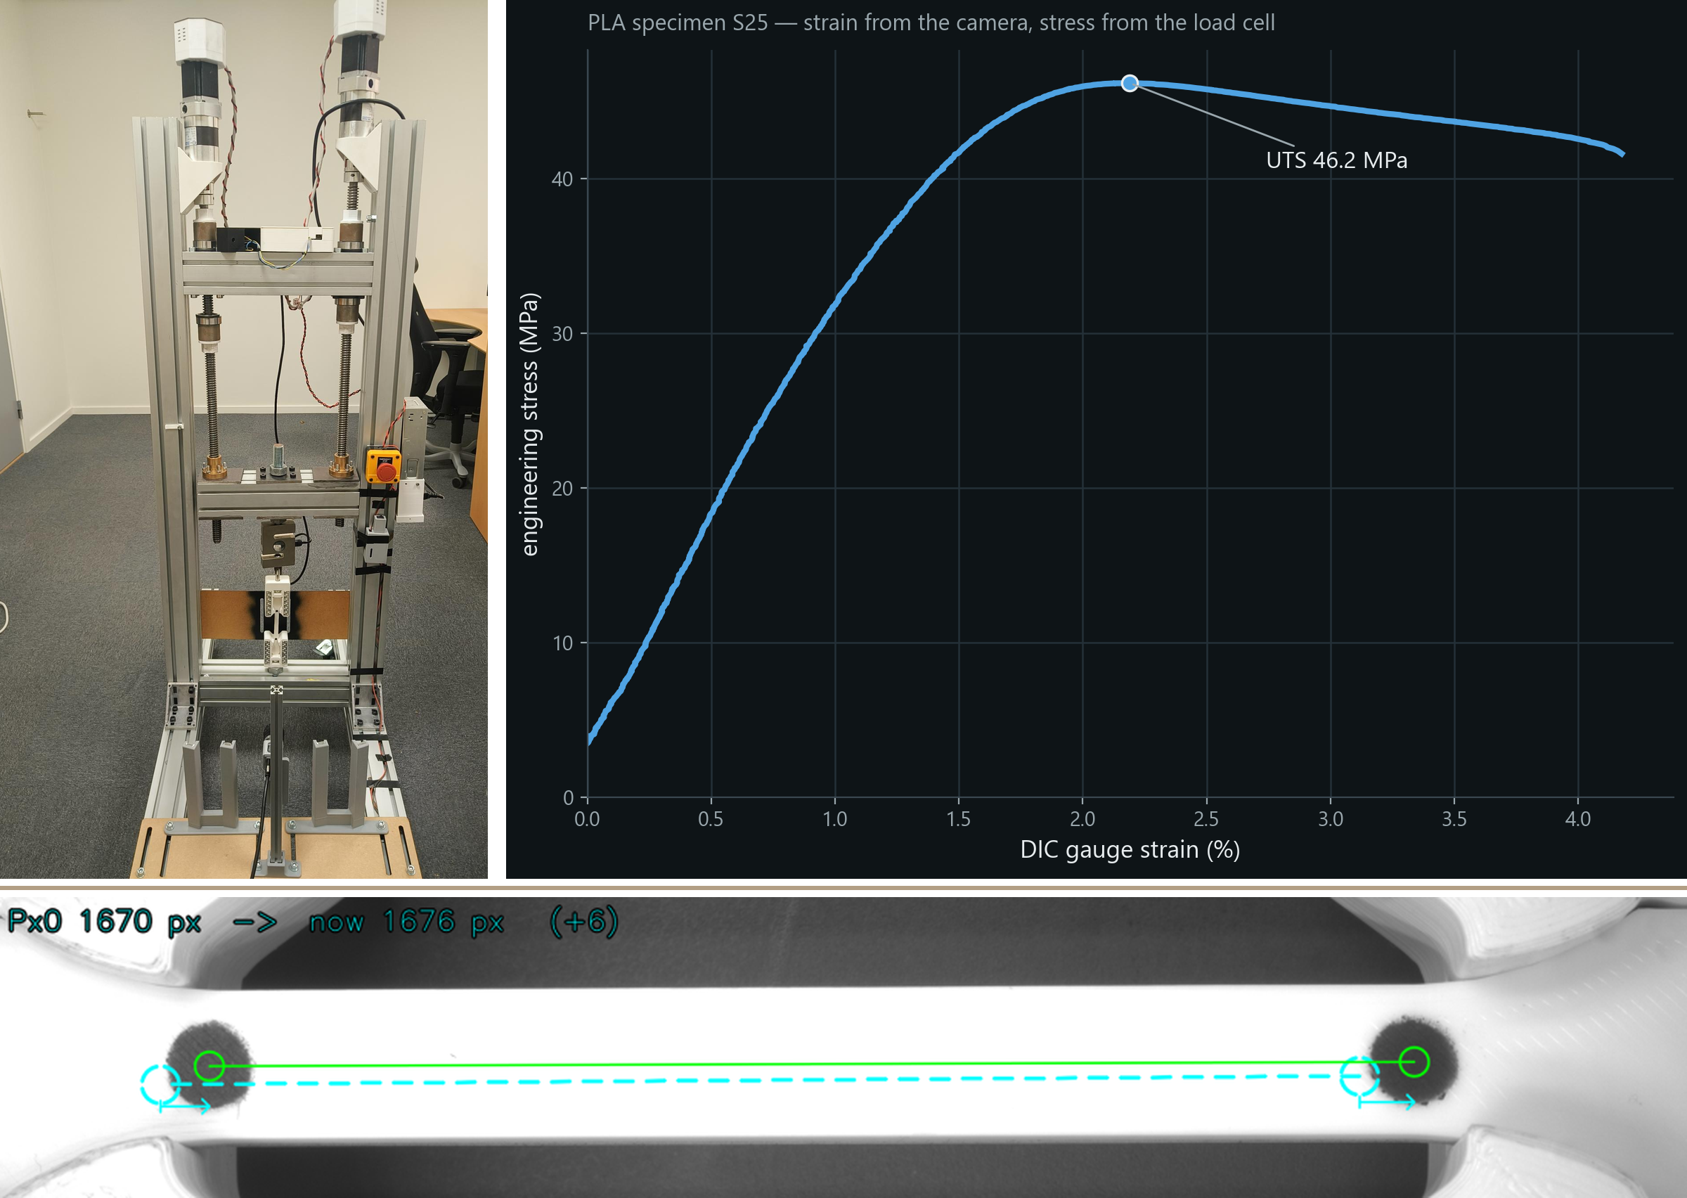
1-D Digital Image Correlation on a Universal Testing Machine for real-time stress-strain measurement
Project report
A contactless strain measurement — built, validated against a certified extensometer, and applied to various printed polymers
ADITHYA SIVAKUMAR
Graduate Research Assistant, School of Engineering, 2026
Department of Product Development, Production and Design
School of Engineering
JÖNKÖPING UNIVERSITY
Jönköping, Sweden 2026
ju.se

Project report — Graduate Research Assistant, School of Engineering, 2026
1-D Digital Image Correlation on a Universal Testing Machine for real-time stress-strain measurement
A contactless strain measurement — built, validated against a certified extensometer, and applied to various printed polymers
Adithya Sivakumar
Supervisors: Johan Jansson · Mirza Cenanovic
Department of Product Development, Production and Design, Jönköping University

Department of Product Development, Production and Design
Jönköping University · School of Engineering
Jönköping, Sweden · September 2026


Abstract
A universal testing machine measures force directly, but it measures strain only through its two points of contact with the specimen: the crosshead counts everything between the grips, dominated by the machine's own compliance and the seating of the specimen rather than by the material. Laboratories fix this with an extensometer that watches the gauge length itself. This project gave a desktop, 4.5 kN universal testing machine that capability with a single industrial camera and its own software: a one-dimensional Digital Image Correlation (DIC) channel that tracks two painted markers and reports strain as the ratio of their separation to its reference value, live, while the pull is running. The purpose is a low-cost, customisable rig that students can use in course laboratories on the materials they print — a certified extensometer cannot be handed to a class, and an in-house channel can be extended, to two-dimensional DIC among other things.
The work covered the whole chain. A camera mount, light enclosure and fixtures were designed and printed; a Python application was written that runs the machine, grabs and analyses frames at ≈20 fps, matches strain to force in time, and draws the stress–strain curve as it forms. Twenty operator-facing automations followed — automatic preload, auto-stop at fracture, stall protection, a guided checklist, six closed-loop test protocols, one-click reporting — and a post-processor that re-measures any recorded video the same way the rig measures live. The evidence trail was kept as a 393-page diary in which every figure is regenerated from the raw runs.
The channel was validated three ways: against itself, through known-displacement and repeatability tests; against the literature, with PLA, PETG and TPU landing inside their published property bands in the predicted order; and against a certified instrument. A Zwick/Roell Z100 with an XT-205 video extensometer agreed with this rig within 1 % on yield strength and fracture strain, and when the laboratory's own footage was re-measured by this project's pipeline the two strain records matched in scale to 0.07 % with a constant offset of −55 µε — seven hundredths of a pixel — over 3 153 frames. The noise floor is tens of microstrain and scales with pixel span exactly as predicted; the remaining ultimate-strength gap to the laboratory (−7.7 %) was traced to pull rate, grip seating and specimen batch, not to the measurement. Secondary studies quantified the effect of filament moisture and the project's carbon footprint (≈3.2 kg CO₂e). The software was written with an AI coding agent in the loop, and that collaboration is reported with measured numbers.
Keywords: Digital Image Correlation · contactless strain measurement · universal testing machine · computer vision · tensile testing · additive manufacturing · PLA · PETG · TPU · verification and validation · measurement uncertainty · closed-loop control · AI-assisted development

Acknowledgments
This project was carried out at the Department of Product Development, Production and Design of Jönköping University's School of Engineering, as a Graduate Research Assistant, between February and September 2026.
I would like to thank my supervisors, Johan Jansson and Mirza Cenanovic, for taking me on board and giving the freedom to build this project, and for providing valuable suggestions that became features, not least the manual marker selection that closed a real gap in the tracker.
I thank Anette Johansson for all the support along the way — and for the invitation to Tallnäs for the department day and the amazing gifts from the department.
I am grateful to everyone at PPD for an amazing time: for the lunch room talks, for the workshop hours, the printer time, the loaned tools and the questions that turned into features and slides. I thank Jacob Steggo, Research Engineer at the Department of Materials and Manufacturing, for helping at the materials-testing laboratory, where two of my specimens were pulled on the Zwick/Roell Z100 with the XT-205 video extensometer and the footage was shared — without that session, the central validation of this report would not exist.
The software in this project was developed with an AI coding agent (Claude Code) in the loop. The division of labour is described in Section 3.10 and measured rather than asserted: every decision, every specimen and every observation on the rig was mine; every number in this report was produced by the rig or recomputed from its raw data by scripts, and the agent never saw the machine. So I have to acknowledge the Claude agent for its efficient work: for turning weeks of plumbing into days.
Finally, to my family and friends: thank you.
Adithya Sivakumar, Jönköping, September 2026

Acronyms
Table 1 lists the acronyms and symbols used throughout this report, in alphabetical order.
Table 1 — Acronyms and symbols used in this report
Acronym | Meaning
AI | Artificial Intelligence
API | Application Programming Interface
ASTM | American Society for Testing and Materials (ASTM International)
AVI | Audio Video Interleave (video container)
CAD | Computer-Aided Design
CO₂e | Carbon dioxide equivalent
CSV | Comma-Separated Values
CV | Coefficient of Variation
DAQ | Data Acquisition
DIC | Digital Image Correlation
DOI | Digital Object Identifier
E | Young's (elastic) modulus
E-stop | Emergency stop
FDM / FFF | Fused Deposition Modelling / Fused Filament Fabrication
FEA | Finite Element Analysis
fps | Frames per second
GUI | Graphical User Interface
HUD | Head-Up Display (the live DIC health panel)
iDICs | International Digital Image Correlation Society
ISO | International Organization for Standardization
JU / JTH | Jönköping University / Jönköping School of Engineering (Tekniska Högskolan)
L, L₀ | Marker separation, and its reference value at the tare
LED | Light-Emitting Diode
MDF | Medium-Density Fibreboard
MFI | Melt Flow Index
MOT | The external materials-testing laboratory used for cross-validation
Mpx | Megapixel
µε | Microstrain (10⁻⁶ strain)
OEM | Original Equipment Manufacturer
PCF | Product Carbon Footprint
PDF | Portable Document Format
PETG | Polyethylene terephthalate glycol
PLA | Polylactic acid
PPD | Product Development, Production and Design (department)
PPD-UTM | This project's universal testing machine, as named in its evidence
Px₀ | Reference marker separation in pixels (the frozen L₀)
px/mm | Pixels per millimetre (optical scale)
RH | Relative Humidity
RMS | Root Mean Square
ROI | Region Of Interest (the sensor window that is read)
RQ | Research Question
SDK | Software Development Kit
SF | Smart Feature (the numbered rig automations, SF1–SF20)
TDS | Technical Data Sheet
TPU | Thermoplastic polyurethane
UI | User Interface
USB | Universal Serial Bus
UTM | Universal Testing Machine
UTS | Ultimate Tensile Strength
V&V | Verification and Validation
XT-205 | The commercial video extensometer used as the reference instrument
εf | Strain at fracture (failure strain)
σy | Yield strength

Contents
Abstract i
Acknowledgments ii
Acronyms iii
Contents v
1 Introduction 1
1.1 Background 1
1.2 Where DIC is used, and where this project sits 2
1.3 Problem statement and objectives 2
1.4 Research questions 3
1.5 Scope and limitations 3
1.6 Method of work and outline of the report 3
2 Theory 5
2.1 The tensile test and its properties 5
2.2 Why the crosshead is not an extensometer 6
2.3 Measuring strain: the extensometer family 7
2.4 Digital Image Correlation and its two-marker form 8
2.4.1 Good practice for DIC, and what it asks of a rig 9
2.4.2 In-house and open-source DIC systems 10
2.5 Image formation, thresholding and the noise floor 10
2.5.1 From light to grey level 10
2.5.2 Thresholding: Otsu and the fixed threshold 11
2.5.3 Marker detection and the centroid 11
2.5.4 The noise floor and how it scales 11
2.5.5 Modulus from a noisy curve 12
2.6 Closed-loop test protocols 13
2.6.1 Staircase (stepped load hold) 13
2.6.2 Cyclic loading 13
2.6.3 Creep 14
2.6.4 Stress relaxation 14
2.6.5 Progressive cyclic 14
2.6.6 Staircase to fracture 14
2.6.7 The loop itself 14
2.7 The materials: PLA, PETG and TPU 15
2.8 Filament moisture and its effect on strength 15
2.9 Product carbon footprint of a development project 16
3 Methodology 17
3.1 The PPD-UTM DIC rig 17
3.1.1 Frame, drive and load cell 17
3.1.2 What it cost 18
3.1.3 Camera, lens and lighting 18
3.2 Designed and manufactured parts 20
3.2.1 The camera mount, and what it has to do 21
3.2.2 The base plate: MDF against sheet metal 22
3.2.3 The damping pad: TPU against neoprene 23
3.2.4 The stand: 20 × 20 against 30 × 30 profile 24
3.2.5 The rail base bracket 24
3.2.6 The carriage, and the rib that stiffens it 24
3.2.7 The camera housing, and how it locks to the carriage 26
3.2.8 Captive-nut holders 29
3.2.9 The light mount and the buck-converter enclosure 29
3.2.10 The specimen marker template 30
3.2.11 Manufacturing and assembly 31
3.3 Specimens and their preparation 33
3.4 Software architecture 34
3.5 The DIC pipeline 36
3.6 Camera configuration 37
3.7 Capture, recording and the post-processor 38
3.8 The twenty smart features 39
3.9 Analysis conventions 42
3.10 AI in the loop: how the software was written 42
3.10.1 The working method 42
3.10.2 What the agent did 43
3.10.3 Measured, not estimated 43
3.10.4 Risks and how they were handled 44
3.11 Validation campaigns 44
3.11.1 V-series: does the channel work? 44
3.11.2 VC-series: repeatability and noise 44
3.11.3 MOT: the external laboratory 44
3.12 The evidence pipeline 46
4 Analysis 47
4.1 The strain channel in operation 47
4.2 Validation against a certified video extensometer 48
4.2.1 Analysis 1 — two rigs, two specimens, one material (Test 2) 48
4.2.2 Analysis 2 — same video, same specimen, two calculation methods 49
4.2.3 Test 1 — the 80 mm gauge, and why Test 2 became necessary 51
4.2.4 How far two specimens can be trusted 52
4.3 Where the remaining differences come from 52
4.3.1 Pull rate 53
4.3.2 Grip seating and machine compliance 53
4.3.3 Specimen and batch 53
4.4 Noise floor and measurement uncertainty 55
4.5 Gauge length: 80 mm against 45 mm 56
4.6 Repeatability and DIC coverage 57
4.7 Otsu against a fixed threshold 58
4.8 Three polymers against their published bands 60
4.8.1 Within-material scatter 62
4.8.2 The infill knockdown and the datasheet 62
4.9 Fracture behaviour 63
4.10 Closed-loop protocols on the rig 64
4.10.1 Staircase 64
4.10.2 Cyclic loading 64
4.10.3 Creep 65
4.10.4 Stress relaxation 65
4.10.5 Progressive cyclic to fracture 66
4.10.6 Staircase to fracture 67
4.10.7 The one that failed, and what it taught 67
4.11 Humidity: the batch effect and the literature 68
4.12 Carbon footprint of the project 69
4.12.1 The counterfactual: what if the code had been typed by hand? 69
4.13 Answers to the research questions 71
5 Conclusion and Future Work 72
5.1 Conclusions 72
5.2 Future work 73
5.2.1 Poisson's ratio and true stress — the nearest step 73
5.2.2 2D-DIC strain field 73
5.2.3 Feeding simulation models 73
5.2.4 Studying fracture behaviour 74
5.2.5 Correlation instead of a binary centroid 74
5.2.6 Better grips 74
5.2.7 The controlled moisture study 74
Bibliography 75
Appendix A Specimen register 79
Appendix B Closed-loop test register 81
Appendix C Smart-feature index 82
Appendix D Data tables 83
D.1 Laboratory comparison 83
D.2 Noise and scaling 83
D.3 Materials 84
Appendix E Python workflow 85
Appendix F Carbon-footprint inventory 87
Appendix G AI collaboration in detail 88

Chapter 1

1 Introduction

1.1 Background
A universal testing machine (UTM) pulls a specimen apart between two grips and records the force it takes. Force is the easy half: a load cell in the load train reads it directly, and a 4.5 kN cell resolves a few newtons without difficulty. Strain is the hard half. The quantity a materials engineer wants is the elongation of the specimen's gauge length divided by that length — but what the machine can measure for free is the travel of its own crosshead, and the crosshead counts everything between the two grips: the elastic stretch of the load train, the bedding-in of the grips, the specimen's shoulders, and only lastly the gauge. On the desktop rig at the centre of this report, only 19–29 % of the early crosshead motion reaches the gauge; the rest is the machine settling. A stress–strain curve drawn from crosshead travel is therefore a curve of the machine, not of the material, and every derived quantity that depends on the slope — the elastic modulus first of all — inherits the error.
Commercial laboratories solve this with an extensometer, an instrument that watches the gauge length itself and ignores the rest of the load train. The classical clip-on extensometer is a spring with knife edges that touch the specimen and a strain gauge glued to the spring; the modern alternative is a video extensometer — a camera that tracks two marks on the specimen and reports their separation. Both are calibrated, certified instruments [1, 2], and both cost more than a desktop rig.
The department's own tensile rig — a compact, twin-ball-screw frame built for teaching and research on 3D-printed specimens — had a load cell and a crosshead and nothing else. It exists for the course laboratories: students print specimens and pull them to study how material, infill and print settings change the properties, and for that they need a machine they can run themselves. The certified extensometers of a commercial materials-testing laboratory cannot be handed to a class; an instrument built in the department can, and it can be customised — a new gauge length, a new material preset, a second camera for two-dimensional DIC — as the coursework and the research need. Its software plotted force against crosshead position and called the result a stress–strain curve. The initial reference for this work was obtained from that machine's own repository [3], which supplied the starting point for the frame, the electronics and the control software; everything this report describes was built on top of it, and the result is a separate repository of its own [4]. This project set out to give that rig a real strain channel with the cheapest possible instrument: one industrial camera and software written for the purpose, using the principle of Digital Image Correlation (DIC) in its simplest, one-dimensional, two-marker form. Figure 1 shows the whole idea on one real frame from the rig: two painted markers on the gauge, the camera tracks their separation, and strain is the change in that separation divided by its starting value.
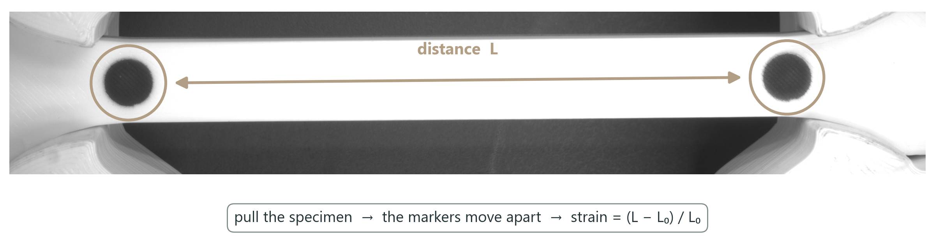
Figure 1 — The principle in one picture: two painted markers on the specimen's gauge, the camera tracks their separation L every frame, and strain is (L − L₀)/L₀ — a ratio of pixel counts, so no calibration enters the strain itself.

1.2 Where DIC is used, and where this project sits
Digital Image Correlation measures how a surface deforms by comparing photographs of it under load [5]. In its full-field form it tracks a random speckle pattern across the whole surface and returns a displacement — and hence strain — map; in its reduced form it tracks a few discrete markers and returns a few numbers. The same trick earns its keep in very different rooms:
- Material testing and characterisation — stress–strain curves, modulus, yield, ultimate strength and failure strain, measured without touching the specimen. This is the arena of the present project.
- Manufacturing quality control — warpage, springback and assembly distortion checked against CAD, contactless and in minutes.
- Aerospace structural monitoring — wing bend and fuselage-skin strain in full-scale tests, thousands of virtual gauges from a pair of cameras.
- Fracture mechanics — strain concentration at a crack tip, crack speed and direction; an item on this project's future-work list.
- Biomechanics and medical devices — tissue, implants and prostheses under load, where a contact instrument is not an option.
- Thermal stress analysis — expansion and warpage under heating, where a glued gauge would not survive.
The two-marker form used here is deliberately the simplest member of that family. It gives up the strain map for a single axial strain, and in return it needs no speckle, no correlation window, no calibration target, and no more than a few hundred lines of tracking code — which is what made it possible to build, validate and apply the whole channel within one project.

1.3 Problem statement and objectives
The problem was not to demonstrate that a camera can see two dots. It was to turn that observation into a measurement an engineer would trust — one whose agreement with a certified instrument is known, whose noise floor is characterised, and whose failure modes are understood — and then to use it. Four objectives followed:
- Build the channel, low-cost and customisable. Mount a camera on the rig, light the specimen, write the software that finds the markers on every frame, and deliver strain live, matched in time to the load cell — with hardware of the order of a thousand euros, and with every part of it the department's own to change.
- Make the rig operable. Automate the steps that make a tensile test repeatable — preload, calibration, tare, stop-at-fracture, reporting — so that the measurement does not depend on the operator's attention.
- Prove it is a measurement. Validate the channel against itself (repeatability, known displacement), against the literature (published property bands), and against a certified video extensometer in a commercial laboratory.
- Apply it. Characterise three printed polymers — PLA, PETG and TPU — and answer the material questions the department actually asks: infill, marker spacing, moisture, fracture character.

1.4 Research questions
The objectives reduce to three questions that the analysis chapter answers explicitly:
- RQ1 — Can a two-marker DIC channel built on a low-cost industrial camera match a certified video extensometer, and to what agreement?
- RQ2 — What sets the channel's noise floor and measurement uncertainty, and can those be predicted rather than merely observed?
- RQ3 — Does the rig reproduce the expected ordering and published property ranges across polymers of very different character?

1.5 Scope and limitations
The channel is one-dimensional: two markers, one axial strain. Full-field strain maps, lateral strain and hence Poisson's ratio are outside the scope, and the report says so where it matters (true stress is estimated analytically, not measured). The rig is a desktop machine with a 4.5 kN load cell and about 30 mm of usable travel; the specimens are 3D-printed mini-dogbones rather than standard-size coupons, so no claim of compliance with ISO 527 or ASTM D638 [6, 7] is made — those standards are used as vocabulary and as the definition of the properties, not as a certificate.
Sample sizes are small: five to nine specimens per PLA condition, three PETG, three TPU, and a single specimen on each side of the laboratory comparison. The comparison itself involved one external laboratory and one instrument. Where a result rests on n = 1 or n = 2 the text says so, and the conclusions are sized accordingly. Numbers that are estimated rather than measured — the solo-effort comparison in the AI section, the AI energy term in the carbon footprint — are labelled as estimates and kept separate from the measurements.

1.6 Method of work and outline of the report
The project ran from February to September 2026 as a weekly cycle of build, test on the rig, analyse, and record. The record is a 393-page progress diary in which every figure is regenerated from the raw test data on each build, so that a plot cannot drift from the numbers behind it; this report is written from that diary and from the code, and its figures are the same regenerated ones. The software was written with an AI coding agent in the loop, a method described and measured in Section 3.10.
Chapter 2 gives the theory: tensile properties, the ways strain is measured, DIC and its two-marker form, image formation and thresholding, noise, the closed-loop protocols the rig runs, the materials, and the carbon-footprint method. Chapter 3 describes what was built and how it was validated — hardware, specimens, software, the DIC pipeline, the camera settings, the automations, the validation campaigns and the evidence pipeline. Chapter 4 presents and discusses the results, ending with explicit answers to RQ1–RQ3. Chapter 5 concludes, lists what is still open, and names the future work. The bibliography and appendices follow.
Chapter 2

2 Theory
This chapter collects the background the rest of the report leans on: what a tensile test measures and why the strain axis is the hard one; how strain is measured in practice; what Digital Image Correlation is and what its two-marker form reduces to; how a camera turns a painted dot into a number, and how that number can be wrong; the closed-loop test protocols the rig runs; the three polymers tested; and the method used to estimate the project's carbon footprint.

2.1 The tensile test and its properties
In a tensile test a specimen of known cross-section A₀ and gauge length L₀ is pulled at a controlled rate until it breaks, while force F and elongation ΔL are recorded. Engineering stress and engineering strain normalise these by the original geometry:
σ = F / A₀ ε = ΔL / L₀ = (L − L₀) / L₀ (2.1)
From the σ–ε curve the standard properties follow [6, 7]. The elastic modulus E is the slope of the initial linear region. The yield strength σy is the stress at which the material departs from that line; for polymers, which yield gradually, this report uses the 0.2 % offset construction — a line of slope E displaced by 0.002 strain, intersected with the curve. The ultimate tensile strength (UTS) is the maximum engineering stress. The strain at fracture εf is the strain at the last frame before the load drops to zero. Toughness is the area under the curve to fracture, in kJ/m³. For the fits in this report the modulus is the slope of the steepest straight run of the rising curve — a window of fixed strain width slid along the curve, the least-squares line with the largest slope among those that are linear — searched the same way for every specimen, so that moduli are comparable across the study (Section 3.9).
Engineering stress divides by the original area, but a stretched specimen thins. True stress accounts for this; under the assumption of constant volume (Poisson's ratio ν = 0.5, exact only for incompressible flow) it is
σ_true = σ (1 + ε) ε_true = ln(1 + ε) (2.2)
Figure 2 draws the two strain definitions side by side, and Figure 3 shows what the correction does to a real PLA curve: the true curve keeps rising past the engineering ultimate strength, because the thinning section is accounted for. The rig measures neither lateral strain nor volume, so true stress in this report is always the analytical estimate of Equation 2.2, shown only where the distinction matters (Section 4.10).
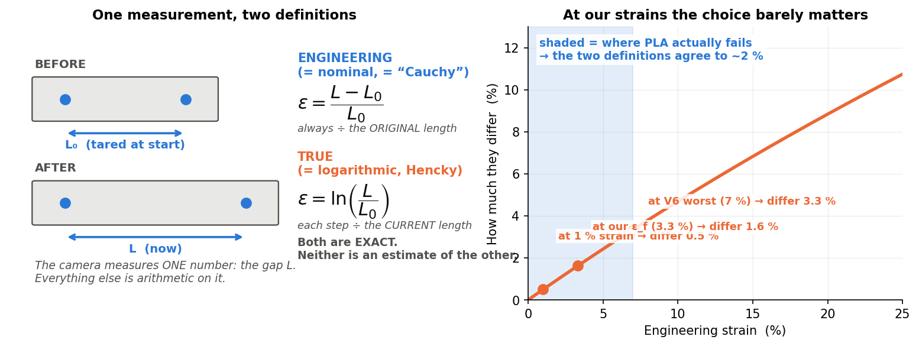
Figure 2 — One measurement, two definitions: engineering strain against the tared reference and true (logarithmic) strain, with the difference between them growing with strain — small for PLA, large for the elastomer.
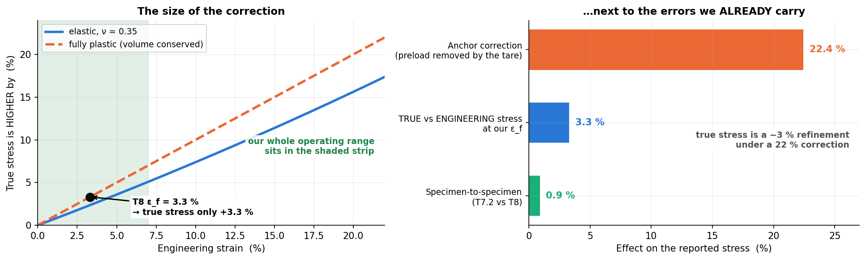
Figure 3 — Engineering and true stress–strain for a printed PLA specimen: the true curve keeps rising past the engineering UTS because the thinning cross-section is accounted for. Analytical estimate (ν = 0.5), not a measurement.

2.2 Why the crosshead is not an extensometer
A universal testing machine records the displacement of its crosshead, which is not the elongation of the gauge. Between the two grips the load path contains the frame, the load cell, the grips themselves, the clamped ends of the specimen, its shoulders, and finally the gauge. Every element has a compliance, and at low load the grips also settle: knurled jaws bite into a polymer specimen, and any slack between the specimen and the grip faces is taken up before the gauge feels the full force. The crosshead therefore reports
ΔL_crosshead = ΔL_gauge + ΔL_shoulders + ΔL_grips + ΔL_machine + ΔL_slack (2.3)
and only the first term is the material. The consequence is a slope error: the crosshead-based strain is larger than the true strain by the ratio of the whole load path's compliance to the gauge's, so the apparent modulus is low by the same factor. The error is not constant — the slack term is largest at the start of the pull and the grip term depends on the clamping force — so it cannot be calibrated out with a single correction. Standards therefore require an extensometer for modulus determination [1, 6].
On the rig studied here, the share of crosshead motion that reaches the gauge was measured directly — with the DIC channel — at 19–29 % during the elastic region (Section 4.3). Put the other way: the crosshead curve of this machine overstates strain, and understates modulus, by a factor of three to five.

2.3 Measuring strain: the extensometer family
Instruments that watch the gauge itself fall into four families.
- Bonded strain gauges — a metal foil glued to the specimen changes resistance as it stretches. Precise (sub-microstrain) but single-use, limited to small strain, and the glue and the gauge stiffen a soft polymer.
- Clip-on (contact) extensometers — a spring frame with knife edges pressed onto the specimen at the gauge marks; a bonded gauge on the spring reads the separation (Figure 4). The laboratory workhorse, ISO 9513 class 0.5 or better, but it touches the specimen, adds mass, can slip at the knife edges, and must be removed before fracture.
- Video extensometers — a camera tracks two marks (or the specimen's edges) and reports their separation. Contactless, survives fracture, and reaches the same class as a clip-on with a calibrated optical scale. The reference instrument of this project, the XT-205 on a Zwick/Roell Z100 [8], is one of these.
- Stereo-camera Digital Image Correlation (2D and 3D DIC) — a speckle pattern on the surface is tracked by correlation over the whole field of view. With one camera normal to a flat specimen this is 2D DIC and returns in-plane displacement and strain maps; with two calibrated cameras looking at the surface from different angles it is 3D (stereo) DIC, which triangulates every point and adds out-of-plane motion and shape, so that curved or bending surfaces are measured correctly [5, 9]. The most information of the four, at the cost of a speckle, a calibration target, two cameras for 3D, and computation.
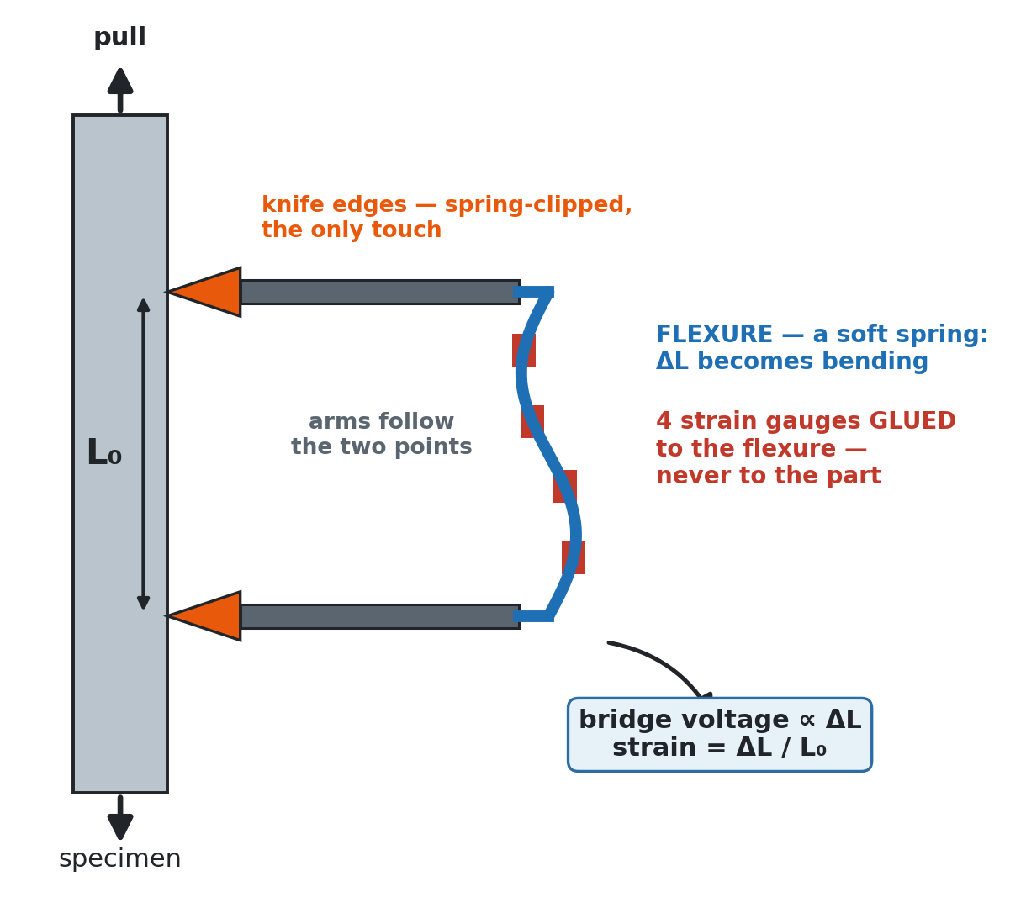
Figure 4 — Schematic of a clip-on extensometer, the instrument DIC replaces: knife edges touch the gauge marks and a strain gauge on the spring reads their separation.
The two-marker DIC channel of this project sits between the third and fourth families. It is a video extensometer in what it returns — one axial strain from two marks — and a DIC instrument in how it is built: the marks are found by image processing on every frame, with no dedicated optics, no calibration target and no vendor software.

2.4 Digital Image Correlation and its two-marker form
Digital Image Correlation [5] measures deformation by locating the same physical points in successive images. In the full-field method a reference image is divided into subsets, each subset is searched for in the deformed image by maximising a correlation coefficient, and the resulting displacement field is differentiated to give strain. Good practice for the method — speckle size, subset size, calibration, uncertainty reporting — is codified by the International DIC Society [10].
The two-marker form discards the field and keeps the principle. Two high-contrast markers are placed on the gauge; each is located on every frame; their separation L in pixels is the measurand. With L₀ the separation frozen at the start of the test (the tare), the axial strain is
ε = (L − L₀) / L₀ = (Px − Px₀) / Px₀ (2.4)
Figure 5 applies Equation 2.4 to two real frames of one pull: the separation frozen on the reference frame, the separation measured on a later frame, and the strain as their ratio. Three properties of the equation do the work of this project:
- Strain is a ratio of pixel counts. The optical scale in px/mm cancels. No calibration target is needed for strain, and a small error in the scale does not propagate into ε — it only affects the conversion of L to millimetres, which the strain never uses.
- The marker centroid is a sub-pixel quantity. A marker covering thousands of pixels has a centroid known to a small fraction of a pixel, because the centroid averages over every pixel of the blob. The channel's resolution is therefore far finer than one pixel over the gauge.
- The reference Px₀ is frozen once and never re-estimated. Everything after the tare is measured against the same number, so the strain record cannot drift through re-referencing; if Px₀ is wrong, every strain is wrong by the same factor, which is a scale error and not noise.
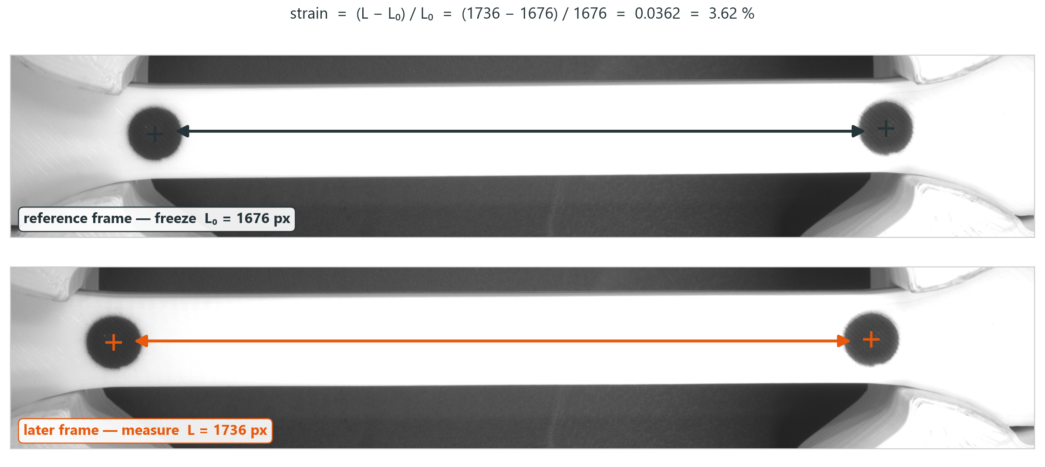
Figure 5 — From pixels to strain on two real frames of specimen S26: the marker separation frozen on the reference frame (L₀) and measured on a later frame (L); the strain is their ratio (Equation 2.4), computed by the script from the frames shown.
The price of the reduction is that only the average strain between the markers is measured. A specimen that necks between the markers reports the average of a localised and an unloaded region; a specimen that necks outside them reports the elastic unloading. Both cases occur in this study and are noted where they affect a number.

2.4.1 Good practice for DIC, and what it asks of a rig
The International DIC Society's good-practices guide (Figure 6) is a 166-page reference rather than a standard, but it is the closest thing the method has to one, and its second edition [10] was read at the start of this project as a specification for the rig rather than as background. Its requirements fall into two groups, and the distinction matters for a two-marker channel.

Figure 6 — The reference this project was built against: the International DIC Society's A Good Practices Guide for Digital Image Correlation, Edition 2, October 2025. Ten sections covering principles, rig setup, the factors that affect a result, calibration, running the test, analysis, and minimum reporting requirements.
The first group is about the rig, and applies to any DIC measurement including this one. The camera should have a global shutter and a monochrome sensor, and every automatic function — exposure, gain, white balance — should be disabled, because an automatic adjustment mid-test changes the grey levels the analysis depends on. The lens should be a fixed focal length with lockable focus and aperture rings, set once and locked. The mount should be rigid and decoupled from the load frame, so that the machine's own motion does not reach the camera. The lighting should be diffuse, symmetric and locked before the test begins. Exposure should be short enough that motion blur stays under half a pixel, and long enough to put the image in the 50–80 % range of the grey scale; the frame rate follows from the test speed by the sampling theorem. Every one of these shaped a decision in Chapter 3, and the mount requirement in particular is why the camera stand stands on its own base plate with a damping pad under it (Section 3.2.1) rather than being bolted to the frame.
The second group is about the pattern and the correlation, and applies to the full-field method rather than to two markers. Table 2 lists those numbers, because they are the specification the future 2D channel of Section 5.2 has to meet, and because they show what the two-marker reduction buys: with discrete markers there is no speckle to size, no subset to choose, no step size and no correlation criterion — the virtual strain gauge is simply the marker separation, and it is set by where the two dots are painted.
Table 2 — The guide's pattern-and-correlation requirements, and how a two-marker channel relates to each. The rows marked not applicable are the ones the reduction removes; they return as requirements the moment the channel becomes full-field.
Parameter | What the guide asks | In the two-marker channel
Speckle feature size | 3–5 px per feature, random, matte, ≈50 % coverage, well bonded | No speckle — two ≈10 000 px sprayed markers instead
Subset size | 31–41 px as a starting point; must contain 3–5 speckles | Not applicable — the marker is segmented, not correlated
Step size | 1/3 to 1/5 of the subset size | Not applicable
Virtual strain gauge | The physical gauge length over which strain is reported | The marker separation itself: 80 mm or 45 mm, chosen when the dots are painted
Aperture | Sets depth of field; set once and lock | f/8 on a lockable-ring lens
Exposure | Motion blur < 0.5 px; aim for 50–80 % grey level | 50 000 µs; at 1–2 mm/min the specimen moves micrometres per frame
Frame rate | From the test speed, by the sampling theorem | ≈20 fps, which oversamples these pull rates by a wide margin
Reporting | Every acquisition and analysis parameter documented | Table 11 and the run's own CSV header, written on every save

The guide also names the path this project took. Its own recommended entry point is a flat tensile specimen, a single camera and a virtual extensometer, moving to full 2D-DIC afterwards — which is exactly the channel built here, and exactly the order of the future work in Section 5.2.

2.4.2 In-house and open-source DIC systems
Building one's own DIC instrument is an established practice, and the open literature documents several systems that a laboratory can reproduce. Blaber, Adair and Antoniou released Ncorr [11], an open-source 2D DIC code in MATLAB with subset-based correlation, and validated it against commercial software on standard image sets; Belloni et al. released py2DIC [12], a Python implementation validated on tensile tests with a consumer camera; Atkinson and Becker showed that a working 2D DIC code fits in 117 lines of MATLAB [13], which makes the method teachable line by line; and Olufsen, Andersen and Fagerholt published µDIC [14], a Python toolkit with a finite-element mesh formulation aimed at research laboratories that want to modify the method rather than buy it. All four are full-field correlation codes: they need a speckle, a calibration and a subset size, and they run offline on recorded images. The channel built here sits below them in the hierarchy — two markers, one strain, no speckle — and above them in one respect: it runs live inside the machine's control loop, with the guards and protocols of Chapter 3 built around it, and it was validated against a certified instrument on the instrument's own footage. The open-source codes are the natural next layer, which is why the 2D-DIC item of Section 5.2 starts from them.

2.5 Image formation, thresholding and the noise floor

2.5.1 From light to grey level
A monochrome industrial camera converts the light falling on each photodiode during the exposure time into a count, scaled by the analogue gain and, optionally, a gamma curve, into an 8-bit grey level. For the marker to be found reliably it must be separated from the background in grey level by a margin much larger than the sensor noise. Two variables set that margin: the exposure time, which trades signal against motion blur and frame rate, and the lighting, which sets the contrast between marker and specimen. Gamma, applied after exposure, redistributes the grey levels — a gamma below one lifts the dark tones and compresses the highlights, which widens the usable margin when the marker is dark on a light specimen.

2.5.2 Thresholding: Otsu and the fixed threshold
The marker is segmented from the frame by thresholding: every pixel above (or below) a grey level T is foreground. Otsu's method [15] chooses T automatically as the level that minimises the within-class variance of the two resulting classes — equivalently, that best separates the two peaks of the grey-level histogram, as Figure 7 illustrates. It needs no parameters and adapts to the lighting, which makes it the right default for an operator who has not tuned anything.
Otsu's method has a known failure mode. It assumes the histogram is bimodal with comparable populations. When one class is tiny — two small markers on a large specimen — the histogram has one dominant peak and Otsu's T slides towards it, so the threshold lands on the wrong side of the valley. The symptom is a marker that grows or shrinks with the lighting, and a centroid that moves with it. The remedy is a fixed threshold chosen once from the histogram valley, with the polarity (marker darker or lighter than the specimen) set explicitly. This project keeps both: Otsu as the default and a fixed threshold as the preset for each material, selected on the evidence of Section 4.7.
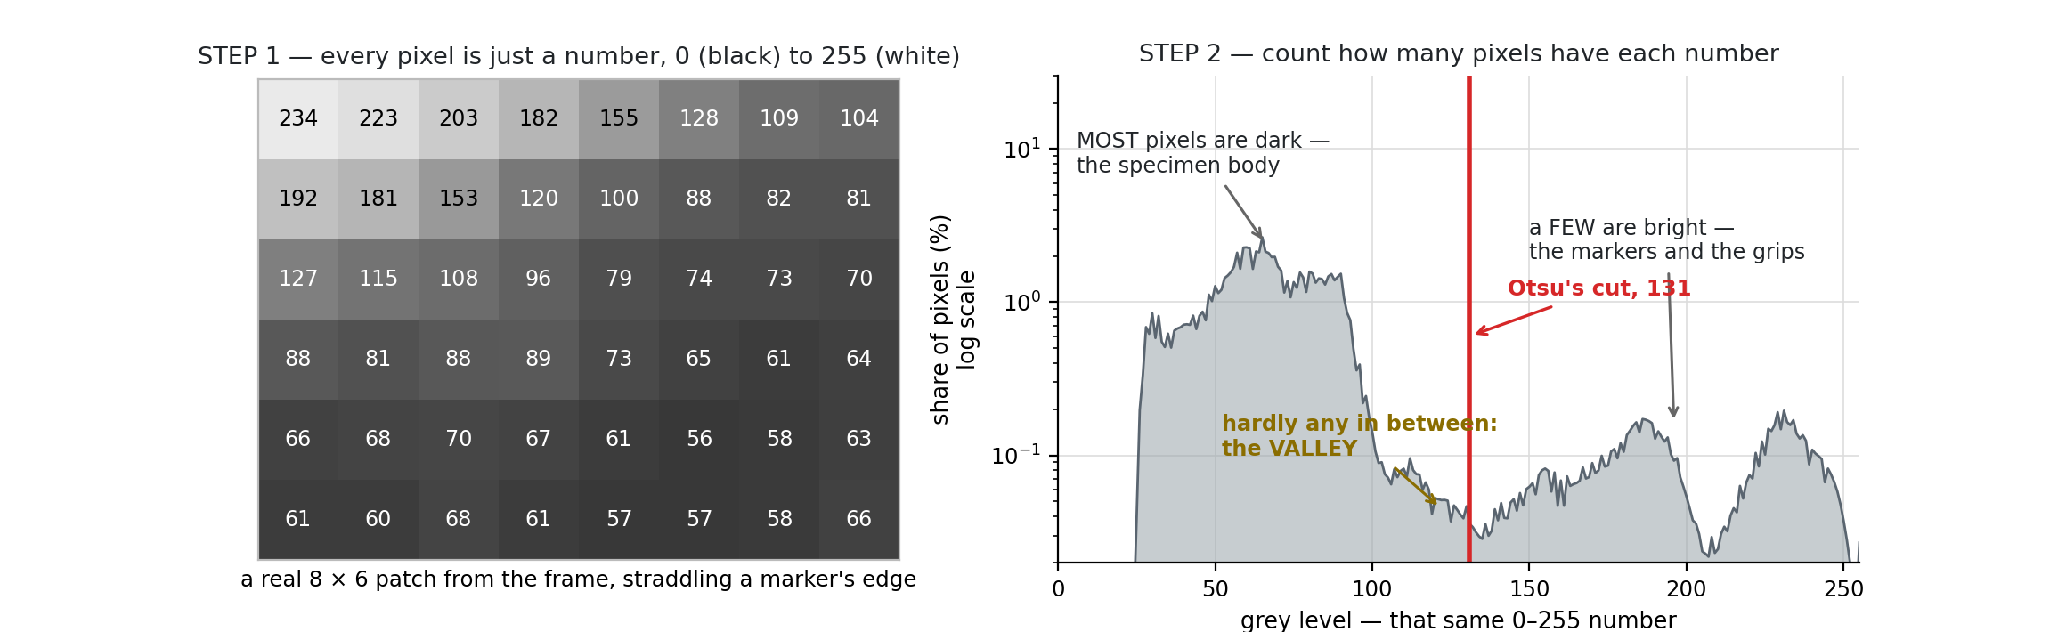
Figure 7 — Otsu's threshold on a bimodal histogram: T is placed where the between-class variance is maximal, which separates the two peaks. The method fails when one class is very small, as it is for two markers on a large specimen.

2.5.3 Marker detection and the centroid
After thresholding, connected components are labelled and filtered by area and circularity, so that a scratch, a shadow edge or the grip does not pass as a marker. The centroid of each surviving blob is its area-weighted mean position, computed from the image moments. For a blob of N pixels whose edge pixels each carry an uncertainty of about half a pixel, the centroid uncertainty scales as 1/√N — for the ≈10 000-pixel markers used here, a few hundredths of a pixel.

2.5.4 The noise floor and how it scales
The strain noise follows from Equation 2.4 by propagation. If each centroid has an uncertainty δ (in pixels) and the two are independent, the separation has an uncertainty √2·δ and the strain
σ_ε = √2 · δ / Px₀ (2.5)
Two consequences are testable and were tested. First, the noise floor in strain is inversely proportional to the reference pixel span: a gauge that spans twice as many pixels has half the strain noise for the same centroid quality. Second, the noise floor does not depend on the strain itself, so it can be measured on an unloaded specimen and used as a specification. Section 4.4 reports the measured floor (tens of microstrain) and the 1/Px₀ scaling, which matched the prediction to two decimals. The other side of the same coin is framing: Figure 8 shows that more pixels per millimetre means less specimen in the frame, so a tighter framing lowers the noise but loses a marker earlier in the pull.
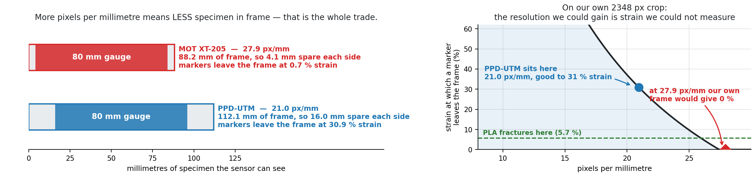
Figure 8 — The optical trade-off: more pixels per millimetre means less specimen in frame. The XT-205 at 27.9 px/mm sees 88 mm and loses a marker at 0.7 % strain on an 80 mm gauge; the PPD-UTM at 21.0 px/mm sees 112 mm and keeps both markers to 31 %.

2.5.5 Modulus from a noisy curve
The modulus is a slope, and a slope from noisy data has its own uncertainty. For a least-squares line through n points spanning a stress range Δσ with strain noise σ_ε, the relative uncertainty of the slope is of order σ_ε·E/(Δσ·√n). With the noise floor of this channel, a 15 MPa fit window and a few hundred frames, the modulus uncertainty from noise alone is well under one per cent — smaller than the specimen-to-specimen scatter. What limits the modulus in practice is not noise but the choice of window: polymers have no sharp linear region, so the slope depends on where it is taken. Figure 9 compares the two candidate rules on one run. This report searches for the steepest straight run and reports its position (Section 3.9); on the same runs, that rule lowers the run-to-run scatter of the modulus from 16 % to 9.6 % for PLA, 13.8 % to 11.3 % for PETG and 5.3 % to 1.2 % for TPU compared with a fixed 0.05–0.40 % strain window, while both rules stay inside the published bands.
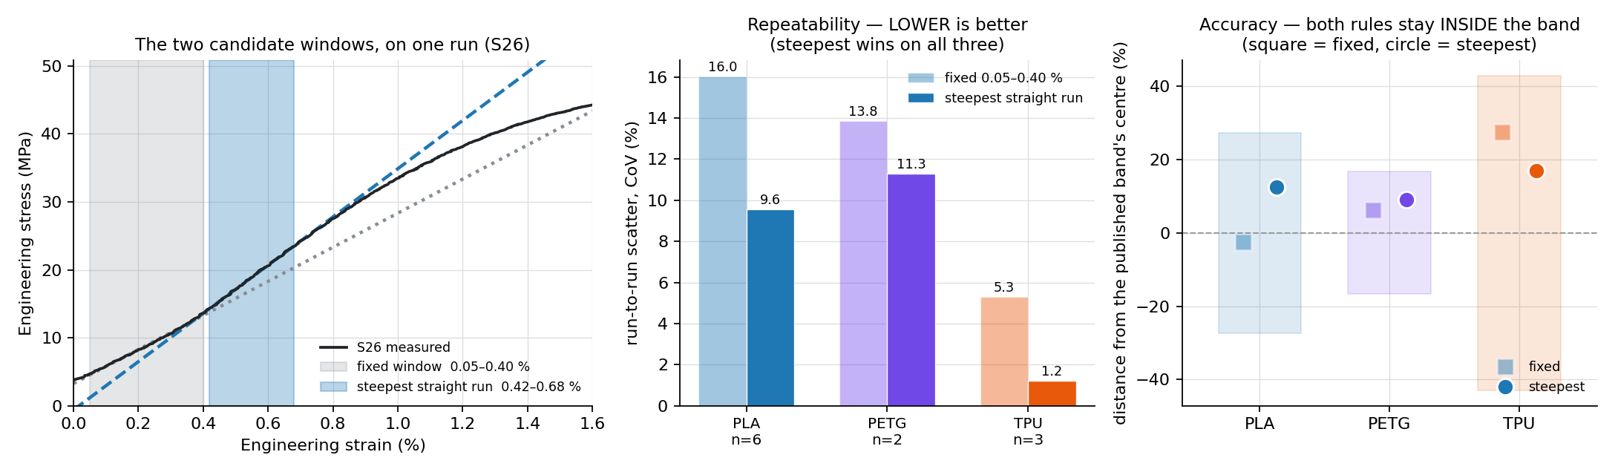
Figure 9 — The two candidate modulus rules on one run (S26): a fixed 0.05–0.40 % strain window against the steepest straight run (0.42–0.68 % here). The steepest run repeats better on all three materials and both rules stay inside the published bands.

2.6 Closed-loop test protocols
A tensile test in displacement control is open-loop with respect to the specimen: the crosshead moves at a set rate regardless of what the force does. Several material questions need the machine to hold or track a force or strain instead, which requires a control loop closed on the measurement. The rig implements six such protocols. Figure 10 sketches the force and strain history of each, idealised from the standards and textbooks that define them [16, 17, 18, 19, 20]; the rig's own measured versions are in Section 4.10.
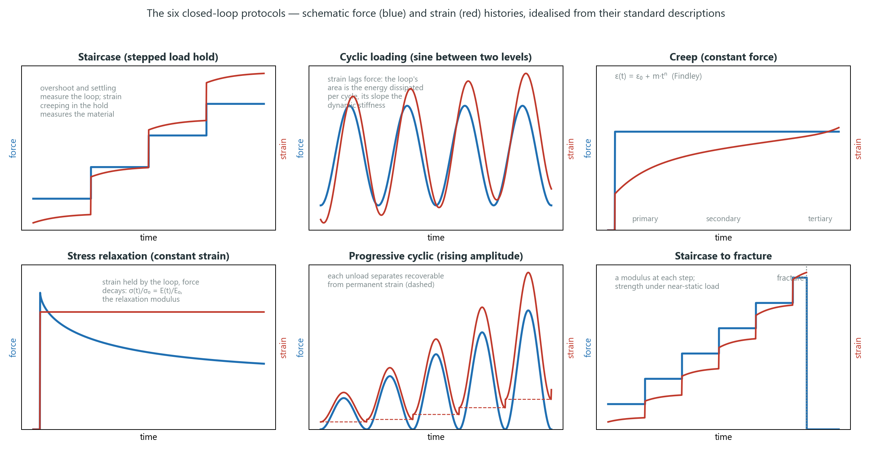
Figure 10 — The six closed-loop protocols as schematic force (blue) and strain (red) histories, idealised from their descriptions in ASTM D2990 and ISO 899-1 (creep, relaxation), ASTM D7791 (cyclic) and the viscoelasticity texts of Findley and of Ward and Sweeney. Not measured data.

2.6.1 Staircase (stepped load hold)
The force is raised in steps and held at each level. Two things are measured at once. The loop's quality is the overshoot on arrival at a step and the time it takes to settle — a proportional controller with too much gain overshoots, one with too little arrives slowly. The material's response is the strain that continues to grow during the hold at constant force, which is short-term creep; on a polymer the creep during a 60 s hold is visible at the microstrain level and grows with the stress level. A staircase is therefore also a quick way to obtain a stiffness at several stress levels from one specimen.

2.6.2 Cyclic loading
The force follows a sine (or triangle) between two levels at a set period. ASTM D7791 [18] defines the uniaxial fatigue test for plastics in exactly this form — sinusoidal by default, at frequencies of a few hertz or lower to avoid self-heating, with the stress kept below the proportional limit. Plotting force against strain over one cycle gives a hysteresis loop: the strain lags the force because the polymer is viscoelastic, the area of the loop is the energy dissipated per cycle, and the slope of the loop is the dynamic stiffness. On a damaged specimen the loop area and the unloading stiffness both fall with cycle count, which is how fatigue damage is tracked. The control metric is the peak-tracking error, the difference between the commanded and the reached peak force.

2.6.3 Creep
A constant force is applied and strain is recorded against time. ASTM D2990 [16] and ISO 899-1 [17] specify the test: a fixed load applied quickly and held, with strain read at logarithmically spaced times over hours to thousands of hours, and the results reported as creep strain, creep modulus (stress divided by the time-dependent strain) and, at higher loads, time to rupture. The classical creep curve has three stages: primary creep, in which the strain rate decreases; secondary creep, in which it is nearly constant; and tertiary creep, in which it accelerates to failure. For polymers below their yield stress the primary stage is described well by the Findley power law [19],
ε(t) = ε₀ + m · tⁿ (2.6)
with ε₀ the instantaneous strain, m a stress-dependent amplitude and n an exponent typically between 0.2 and 0.5; a fit of n is a compact way to say whether a measured curve has the decelerating shape of genuine creep or the linear shape of instrument drift, which is how Section 4.10 uses it.

2.6.4 Stress relaxation
The complement of creep: a constant strain is imposed and the force decays. Relaxation is the direct view of the polymer's viscoelasticity — the ratio σ(t)/ε₀ is the relaxation modulus E(t), which for a linear viscoelastic solid is a sum of exponentials with a spectrum of relaxation times, and for real polymers is usually described by a stretched exponential or a power law [20]. For the DIC rig, relaxation is also the sharpest test of the strain channel's stability, since the strain must be held by the loop using the camera as the sensor: any drift in the strain reading becomes a crosshead motion.

2.6.5 Progressive cyclic
Cycles of increasing amplitude, each returning to a low load. Every unload separates the strain recovered on unloading (elastic plus delayed-elastic) from the strain that remains (plastic), so one specimen yields the onset and growth of permanent strain as a function of peak stress, and the unloading slope of each cycle gives a stiffness at that damage level.

2.6.6 Staircase to fracture
A staircase continued until the specimen breaks. It gives a modulus at each step and a fracture stress reached under near-static loading — a slower path to failure than a constant-rate pull, and therefore a lower apparent strength for a rate-sensitive polymer. Run on a specimen that has already been cycled, it measures residual strength, the quantity used in Section 4.10 to price fatigue damage.

2.6.7 The loop itself
The controller is a proportional controller on the load-cell (or DIC) error with a rate limit, running at the rig's control period. Its performance is governed by the delay in the sensing path — for force, the serial round-trip to the controller; for strain, the camera exposure plus the detection latency — and by the stiffness of the specimen, since a stiff specimen converts a small crosshead step into a large force step. Section 4.10 reports the loop's tuning history from 45 N to about 6 N of overshoot.

2.7 The materials: PLA, PETG and TPU
Three fused-filament polymers were tested, chosen to span the property space: a stiff and brittle one, an intermediate one, and a very soft one. Their published ranges, as collected from datasheets and the literature, are the bands against which the rig's measurements are judged in Section 4.8; Table 3 collects them.
Table 3 — Published property bands for the three printed polymers, as used for the literature comparison in Section 4.8. Bands are for printed specimens where the source gives them, otherwise for the filament datasheet.
Material | E (MPa) | UTS (MPa) | εf (%) | Character | Sources
PLA (polylactic acid) | 2000–3500 | 32–60 | 2–8 | Stiff, brittle; sharp fracture | [21, 22, 23, 24]
PETG (PET-glycol) | 1500–2100 | 30–50 | 5–25 | Ductile; necks and draws | [25, 26, 27]
TPU (thermoplastic polyurethane) | 12–30 | 25–40 | 400–700 | Elastomer; huge strain, low modulus | [28, 29]

Printed parts are anisotropic and porous, so their properties depend on raster orientation, layer height, infill and print temperature as much as on the polymer [23, 24, 30]. Two of those variables were studied here: infill density, where a 50 % gyroid infill leaves a shell carrying most of the load and an interior that mostly adds compliance, so both strength and modulus fall by roughly the ratio of solid cross-section; and moisture, treated in the next section. PLA in particular is sensitive to both. The PLA used throughout was a single brand and spool where the comparison required it [22, 31]. How the rig's own numbers fall against these bands is a result, and is reported in Section 4.8.

2.8 Filament moisture and its effect on strength
PLA is hygroscopic: the filament absorbs water from the air, and the water matters twice. In the printer's hot end, absorbed water flashes to steam, producing bubbles, voids and a rougher extrusion; and during storage and printing the ester bonds of the polymer hydrolyse, lowering the molecular weight. Both mechanisms weaken the printed part, and both are functions of exposure time and relative humidity.
The literature quantifies the effect. Hamid et al. [32] exposed PLA filament to ambient humidity and measured a tensile-strength loss of about 8.5 % after 24 hours and about 11 % after 150 hours, while filament stored under vacuum with desiccant showed no loss. Quader et al. [33] conditioned PLA/PBS filament at controlled relative humidity and found the tensile properties held within 3.7 % of the dry value up to 65 % RH, but that three months at room conditions cost 24–36 % of the strength, accompanied by a 50 % rise in melt-flow index (a proxy for chain scission) and a rise in part porosity from 1.2 % to 3.0 %. Absorption saturates at under 0.7 wt % after a week at 80 % RH — a small mass with a large effect. Manufacturers' guidance is consistent: store dry, and dry the spool before printing if it has been open for more than a day [34].
For this project the practical consequence is that specimens printed from different spools, or from the same spool weeks apart, are not the same material, and that a strength difference of several per cent between two batches is expected rather than surprising. This is the frame for the ultimate-strength gap in the laboratory comparison (Section 4.2), for the batch-to-batch spread in Section 4.8, and for the humidity study of Section 4.11.

2.9 Product carbon footprint of a development project
A product carbon footprint (PCF) is the sum of the greenhouse-gas emissions and removals attributable to a product or activity over a defined boundary, expressed in kilograms of CO₂ equivalent. It is a life-cycle assessment restricted to one impact category, climate change, and it is governed by ISO 14067 [35], which builds on the general LCA standards ISO 14040 and 14044 [36, 37] and is paralleled by the GHG Protocol's Product Standard [38]. The standards prescribe the same sequence of steps.
- Goal and scope. State what is being assessed and why, and define the functional unit — the quantity the result is expressed per (here: one development project, and secondarily one recorded test).
- System boundary. Decide which life-cycle stages and which activities are inside the assessment. A cradle-to-grave study covers raw materials, manufacture, distribution, use and end of life; a partial footprint covers a declared subset, and ISO 14067 requires the exclusions and the cut-off rules to be stated.
- Life-cycle inventory. For every activity inside the boundary, quantify the flows — kilowatt-hours of electricity, kilograms of material, kilometres of transport — from measurement where possible and from documented estimates otherwise, and record the data quality of each.
- Characterisation. Convert each flow to emissions with an emission factor (kg CO₂e per unit of flow), and convert each greenhouse gas to CO₂ equivalent with its 100-year global warming potential from the IPCC [39]. For electricity the factor is the grid mix of the place and time of use; a location-based factor uses the average grid, a market-based one the contracted supply.
- Interpretation and reporting. Sum the contributions, attribute them to activities (contribution analysis), assess uncertainty and sensitivity to the assumptions, and report the result with the boundary, the functional unit and the data sources so that it can be reproduced.
In its simplest form the calculation is
PCF = Σᵢ Aᵢ · EFᵢ (2.7)
with Aᵢ the activity data of item i (for example, hours of use multiplied by power draw, giving kWh) and EFᵢ its emission factor. For an engineering development project the activities are hours of equipment use, and the dominant factor is the electricity mix: the Swedish grid, at about 0.04 kg CO₂e/kWh [40], is among the cleanest in Europe, and the same inventory on the European average would read several times higher.
The boundary drawn here is the development of the rig and its evidence — a partial footprint in the sense of ISO 14067: the desk computer for the hours it was in use on the project, the 3D printer for the specimens and fixtures, the rig itself for the hours it ran, and the AI coding agent's share of data-centre energy. Materials (filament mass, the camera's embodied carbon) and travel are excluded, and the exclusions are stated. The AI term uses a published per-prompt energy figure [41] with a band to reflect its uncertainty; printer and computer power are taken from measured and community-reported figures [42, 43]. Section 4.12 gives the inventory and the result; a car-kilometre equivalent [44] is used only as a scale for the reader.
Chapter 3

3 Methodology
This chapter describes what was built and how it was used: the hardware and the specimens, the software and its DIC pipeline, the camera configuration, the operator automations, the analysis conventions, the working method with an AI coding agent, the validation campaigns, and the evidence pipeline that produced every figure in Chapter 4.

3.1 The PPD-UTM DIC rig

3.1.1 Frame, drive and load cell
The machine is a desktop, vertical tensile frame built in the department from aluminium extrusion; Figure 11 shows it as used for the validation campaigns and Figure 12 its load path. Two ball screws driven by stepper motors move a crosshead between fixed lower grips and the load cell; the motor controller and the load-cell amplifier sit in an electronics box and talk to the computer over one serial link.  The load cell is rated to 4.5 kN, which caps the machine; the usable travel is about 30 mm, which on an 80 mm gauge is a 37.5 % strain backstop. Brackets, load holders and the specimen grips are 3D-printed or machined in the department's workshop. Two emergency stops — a hardware mushroom button that cuts motor power and a software stop in the application — are wired in parallel, and the software adds hard backstops at 4.5 kN and 30 mm (Smart Feature 15).  The rig was built to be used: the department's course laboratories need a tensile machine that students can run themselves on the materials they print, and the certified extensometers of a commercial laboratory cannot be handed to a class. An in-house channel can, and it can be changed — a different gauge, a new material preset, a second camera — without asking a vendor. | 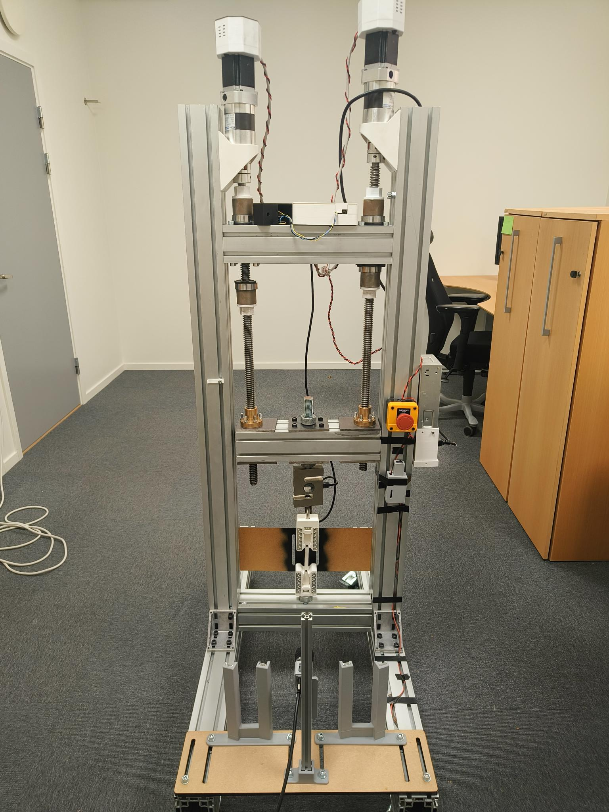  Figure 11 — The PPD-UTM DIC rig as used for the validation campaigns: aluminium frame, twin ball screws, the load cell above the upper grip, the camera on its mount in front of the specimen and the LED-lit enclosure.

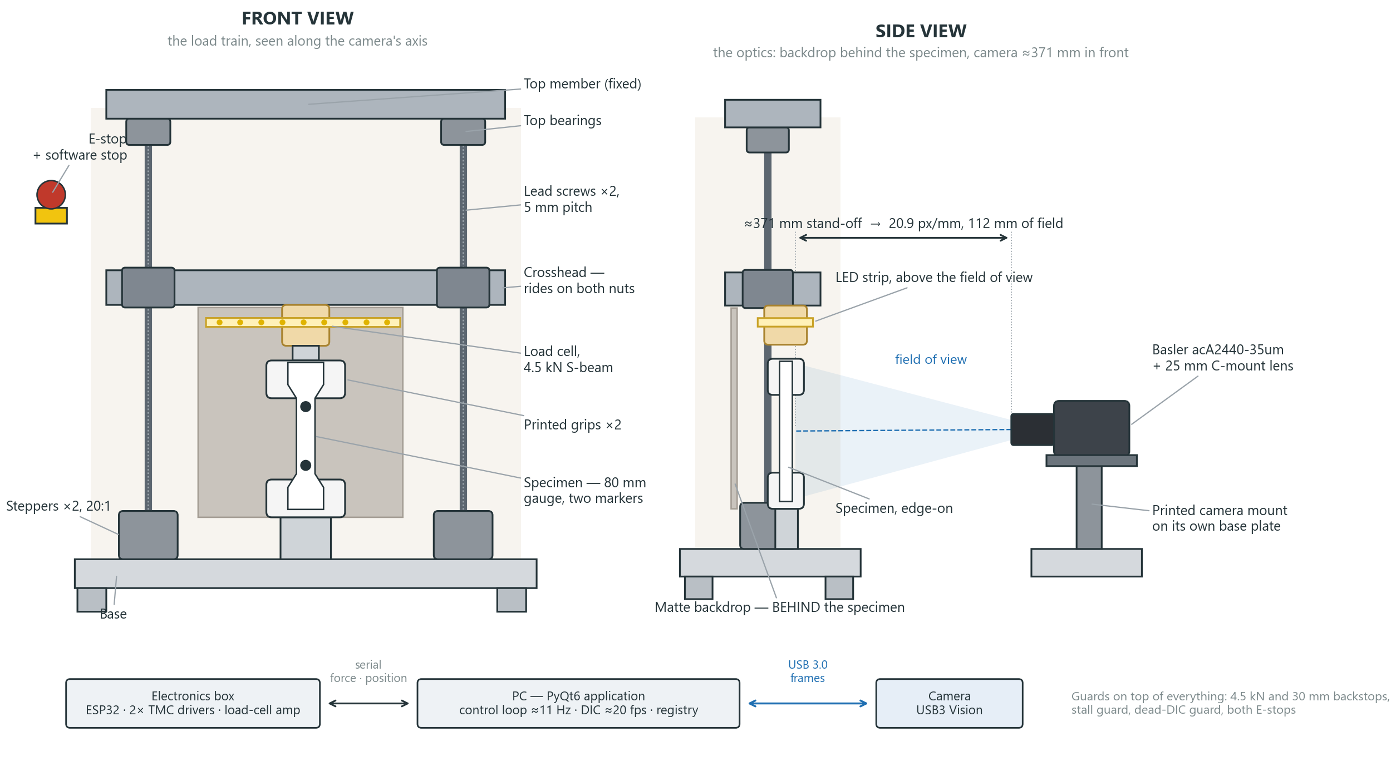
Figure 12 — Schematic of the rig as it stands in September 2026, in two views. Front view: the load path from the lead screws through the crosshead and the load cell to the specimen and the base, with the LED strip, the matte backdrop and the emergency stop. Side view: the optics — the backdrop behind the specimen, the camera on its printed mount ≈371 mm in front of it, and the field of view that stand-off produces. Underneath, the data path: force and position from the electronics box over the serial link, frames from the camera over USB 3.0.

3.1.2 What it cost
The strain channel is cheap by the standards of the instrument it replaces. The camera is a stock industrial USB 3.0 model, the lens a stock 25 mm C-mount, and the lighting, enclosure, mount and grips are an LED strip, a sheet of MDF and printed parts: together of the order of a thousand euros, and the software is the department's own. A commercial video extensometer of the XT-205's class is priced in the tens of thousands of euros, and the universal testing machine it is bolted to in the six figures; those are approximate market figures rather than quotations, but the ratio is two orders of magnitude. The whole rig — frame, motors, load cell, electronics and the channel — cost a few thousand euros in parts. Low cost was an objective in its own right (Section 1.3), because the department needs an instrument it can lend to a class and change at will, and the price of a commercial extensometer rules both out.

3.1.3 Camera, lens and lighting
The strain channel is one Basler ace acA2440-35um industrial camera, whose specifications are collected in Table 4 from the manufacturer's documentation [45, 46]. It is a 2/3-inch Sony IMX264 global-shutter monochrome sensor of 2448 × 2048 pixels with 3.45 µm pixels, read over USB 3.0 at up to 35 frames per second, driven through Basler's pylon SDK [47]. The table gives each specification with the reason it matters for this measurement, because most of them are not free choices: the good-practice guide of Section 2.4.2 asks for a global shutter, a monochrome sensor and every automatic function switched off, and this camera is the cheapest stock model that satisfies all three.
Table 4 — Specifications of the Basler ace acA2440-35um, from the manufacturer's product documentation [46], with what each one buys the strain channel.
Item | Specification | Why it matters for DIC
Model | Basler ace acA2440-35um | —
Sensor | Sony IMX264, progressive-scan CMOS, global shutter | A global shutter exposes every row at the same instant, so a moving marker is not skewed and its centroid is not smeared
Colour | Monochrome | No Bayer filter to interpolate across, so better contrast and signal-to-noise on the grey level the threshold actually uses
Resolution | 2448 × 2048 px (5.0 Mpx) of 2464 × 2056 on the die | Sets the pixels across the gauge, and with them the strain resolution (Equation 2.5)
Pixel size | 3.45 µm × 3.45 µm | With the lens and stand-off, fixes the object size of one pixel — here ≈48 µm
Sensor format | 2/3 inch, 11.1 mm diagonal | Decides which lenses cover the sensor and what field of view a focal length gives
Frame rate | 35 fps at full resolution | Caps how fast a test can be sampled; the region of interest raises it, the exposure lowers it
Exposure and gain | Programmable, all automatic functions disabled | Auto-exposure or auto-gain would change the grey levels mid-test and move the threshold
Pixel bit depth | 10 / 12 bit ADC; Mono8 and Mono12 output | 8 bits are ample once the marker is thresholded; more depth costs bandwidth
Dynamic range | 73.4 dB | Headroom between the dark specimen and the bright marker
Triggering | Hardware and software trigger, free-run | Free-run is used here; a hardware trigger is what a two-camera 2D setup would need
Interface | USB 3.0 (USB3 Vision), 5 Gbit/s, Micro-B with screw locks | Streams full-resolution frames without compression; the screw locks stop a knock unplugging a run
Power | 2.5 W over the USB cable | No separate supply to route past the moving crosshead
Lens mount | C-mount; Azure-2514MML 25 mm f/1.4 fitted | A fixed focal length with lockable focus and aperture rings, as the guide requires
Size and mass | 29.3 × 29 × 30 mm, 80 g | Light enough for a printed carriage to hold without creeping
Software | pylon SDK 25.11 through pypylon | Native control of exposure, gain, gamma, region of interest and the grab strategy

The lens is an Azure-2514MML, a 25 mm f/1.4 fixed-focal-length C-mount lens [48]. Fixed focal length is a guide requirement — a zoom changes the optical scale the moment it is nudged — and this lens has the second property the guide asks for: both rings lock. The front ring sets focus, and the rear ring sets the aperture between f/1.4 and f/16. Wide open at f/1.4 the image is bright but the depth of field is shallow, so a specimen that is not perfectly flat to the sensor goes soft at one end; stopped down to about f/8 the whole gauge is sharp at the cost of light, which the LED strip supplies. Both rings are set once for a given stand-off and then locked, because a change in either invalidates the optical scale and the grey-level margin that the threshold preset was chosen for.
At ≈371 mm from the specimen that lens frames the gauge so that about 20.9 pixels cover one millimetre — one pixel is ≈48 µm in object space; the reference instrument stands closer, at 27.9 px/mm.
The specimen is lit by a strip of white LEDs inside a matte enclosure that blocks room light, so the grey-level histogram of the frame does not change when someone walks past or the sun comes out. This turned out to be the single most important piece of hardware for the threshold's stability (Section 4.7). The camera sits on a printed mount on the frame, normal to the specimen, at a distance set once for the 80 mm gauge and re-set for the 45 mm one; Figure 13 shows the arrangement.
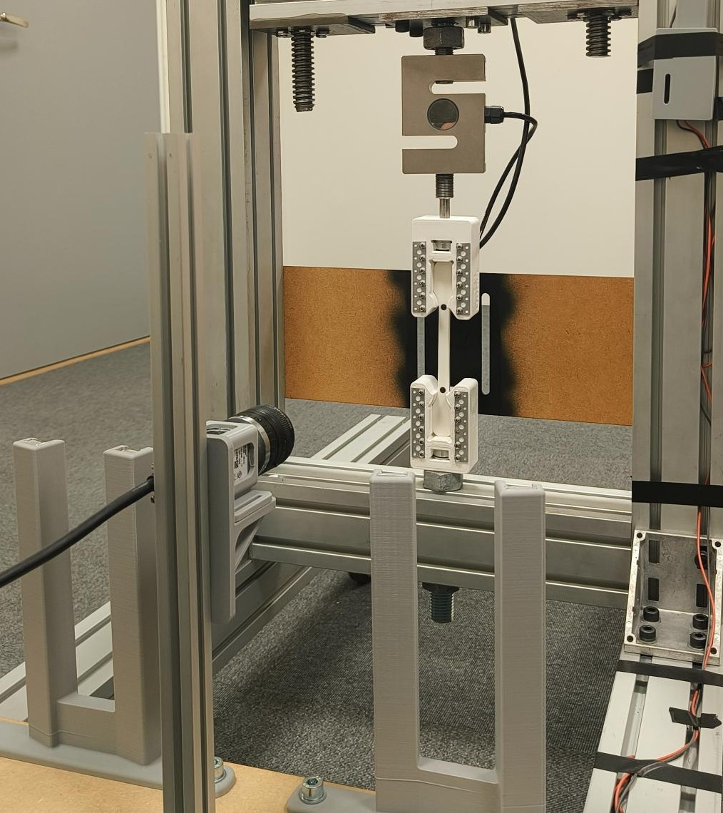
Figure 13 — The camera on its mount inside the enclosure, looking at the gauge with its two painted markers. The LED strip is above the field of view.

3.2 Designed and manufactured parts
The machine already existed as a frame, two motors and a load cell. Everything that turns it into a DIC instrument had to be designed: a stand that holds the camera still and square to the specimen, a base for that stand, a vibration path between the base and a machine that pulls specimens apart, a light and its power supply, and the fixtures that put repeatable markers on a specimen. Those parts were modelled in SolidWorks [49] and made in the department — laser-cut MDF, band-sawn aluminium profile and fused-filament printed PLA and TPU. Table 5 lists them; the subsections that follow take each in turn, with what it does, how it was decided and how it was made.
Table 5 — The parts designed and made for this project. Versions are the CAD revisions kept in the model library.
Part | What it does | Material | Made by | Versions
MDF base plate | Carries the camera stand, locates it to the rig and adds damping mass | MDF, 8 mm | Laser cut | V2–V4
TPU damping pad | Isolates the base plate from the machine's vibration | TPU, 2–3 mm | 3D printed | 1
Rail base bracket | Gusset that clamps the aluminium stand to the base plate | PLA | 3D printed | V1, V2
Aluminium stand | The rigid column the camera rides on | Al T-slot profile | Band saw | 20×20 / 30×30
Camera carriage | Slides on the stand, sets camera height without tools | PLA | 3D printed | V1–V6
Camera housing | Holds the Basler and slides onto the carriage | PLA | 3D printed | V4–V6
Captive-nut holders | Hold M3 and M4 nuts inside the printed joints | PLA | 3D printed | M3, M4
LED light mount | Places the LED above the field of view | PLA | 3D printed | V1–V3
Buck-converter enclosure | Houses the converter powering the LEDs, and its switch | PLA | 3D printed | V1–V4 + lid
Marker template | Locates the two spray dots repeatably on a specimen | PLA | 3D printed | v1–v6
Bottom rail extension | Lengthens the rig's base rail for stability | Al profile | Band saw | 0.4 → 1 m

3.2.1 The camera mount, and what it has to do
The stand carries about 100 g of camera and lens, but its job is not to bear load — it is to hold that camera in the same place, frame after frame, on a machine whose motors and lead screws shake it. Any movement of the camera relative to the specimen is read as strain, so the mount is part of the measurement. Four requirements followed, and the first two come straight from the good-practice guide's rig section (Section 2.4.2): rigid location so the camera does not drift within a pull, and decoupling from the load frame, so the machine's own vibration does not reach the sensor. Two more came from using the thing: adjustment in height without tools, so a new gauge length can be framed in seconds, and a repeatable seat, so remounting does not change the optical scale.
The answer is a chain, drawn in Figure 14: the rig's own base carries a TPU pad, the pad carries the MDF base plate, the plate carries a printed gusset bracket, the bracket clamps the aluminium stand, the stand carries the printed carriage, and the carriage carries the camera housing. Each link was chosen separately, and the two that mattered most — what the base plate is made of, and how the housing locks to the carriage — were decided with a written comparison rather than by preference. Figure 15 is the concept that chain came from. The same exercise made two changes to the machine itself: it gained the camera base plate, and its bottom rail was lengthened from 0.4 m to 1 m, because a stand bolted to a narrow base would have rocked the whole rig rather than steadied the camera.
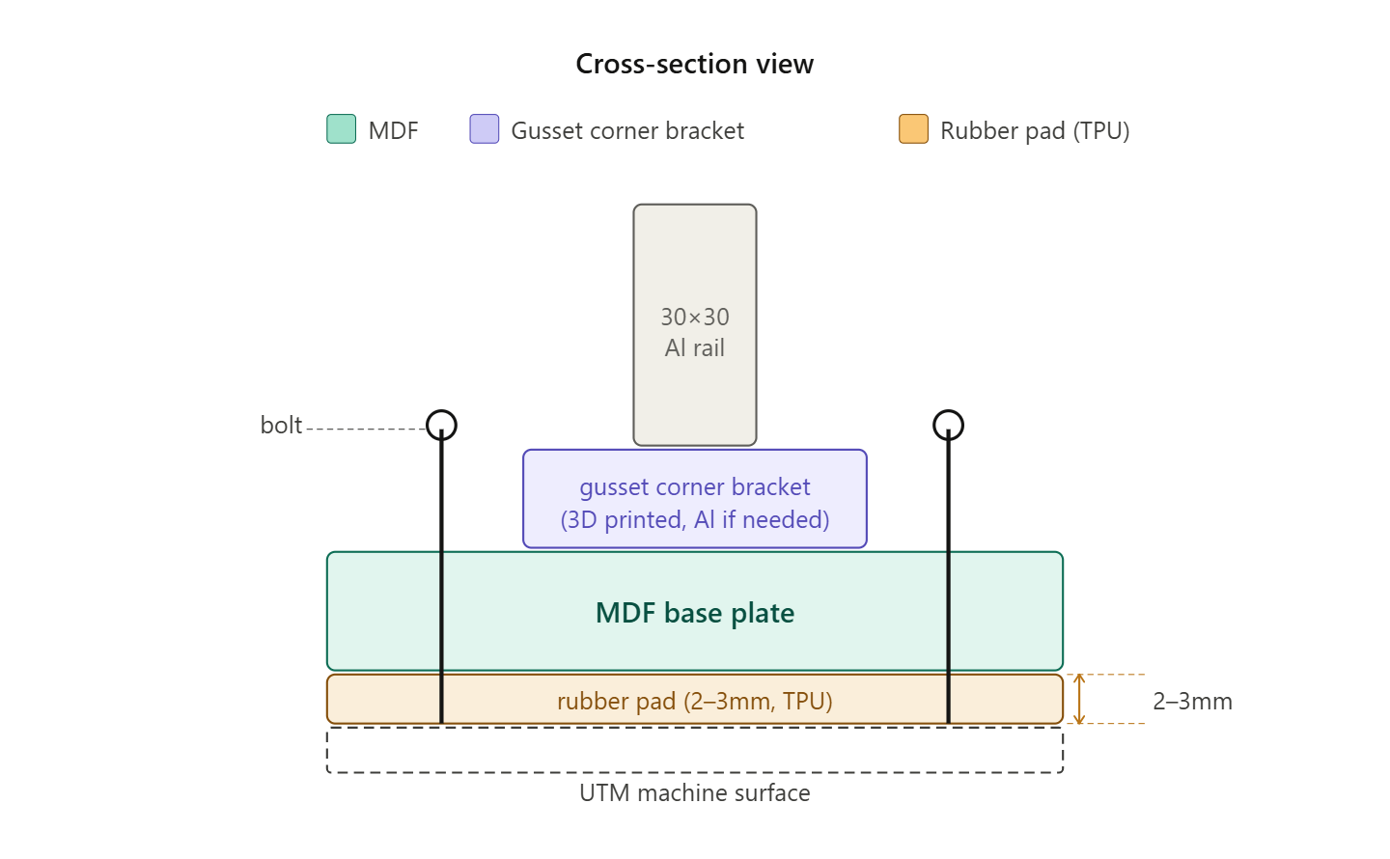
Figure 14 — Cross-section of the mount: the machine's surface, the 2–3 mm TPU pad, the MDF base plate, the printed gusset corner bracket and the aluminium stand, bolted through as one stack.
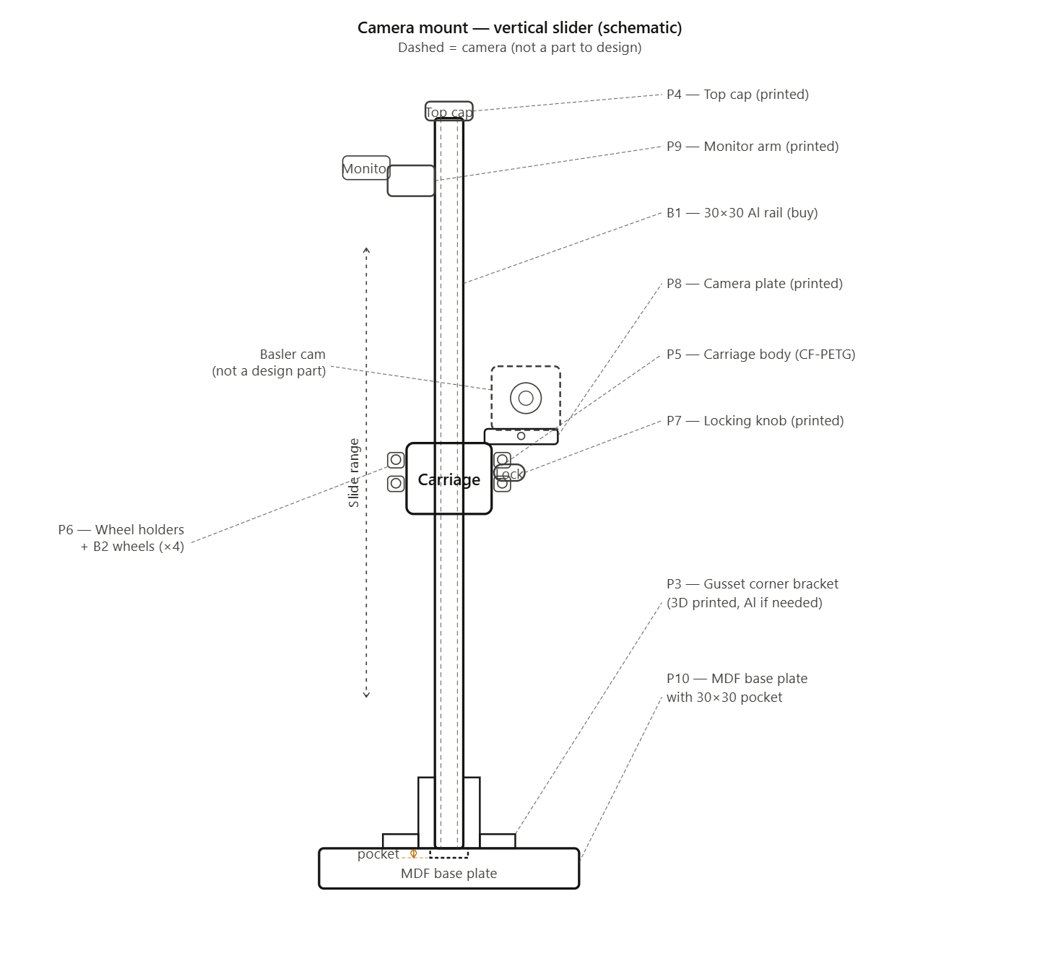
Figure 15 — The camera-stand concept: aluminium profile for rigidity, a printed carriage and brackets, and a base plate with a locating pocket that fixes where the stand sits.

3.2.2 The base plate: MDF against sheet metal
The plate does two jobs at once. It is the structure that locates the stand, and it is the mass that damps it. The two candidates were a sealed MDF board and a thin sheet-metal plate, and they were compared in a Pugh matrix with sheet metal as the datum (Table 6). Four criteria were weighted: vibration isolation highest, because the plate sits on a machine that vibrates; machinability next, because the plate needed slots and a locating pocket cut in the department; moisture and durability, where MDF is the weaker of the two; and weight, where neither has an advantage that matters for a plate that never moves.
Table 6 — Pugh matrix for the base-plate material. Scoring is + better than the datum, S the same, − worse; the weighted score is ±1 × weight. MDF leads at +6, carried by vibration isolation and machinability.
Criterion | Weight | Sheet metal (datum) | MDF
Vibration isolation | 5 | 0 | + (+5)
Machinability | 4 | 0 | + (+4)
Moisture / durability | 3 | 0 | − (−3)
Weight (portability) | 2 | 0 | S (0)
Weighted score | — | 0 (baseline) | +6
+ / S / − | — | 0+ 4S 0− | 2+ 1S 1−

MDF wins by the two criteria the application cares about most, and loses only on moisture, which is answered by sealing the board and by the fact that it lives indoors on a bench. The thickness was then set at 8 mm: an M8 bolt wants about 6 mm of material for full thread engagement, so 8 mm leaves a margin; it is stiff enough to resist flexing under the stand's cantilever load without being overbuilt; and it keeps enough mass to serve the damping criterion that won the matrix in the first place. The plate carries slots rather than holes so the stand can be moved along it, which is how the camera is squared to a new specimen; Figure 16 shows the plate as cut.
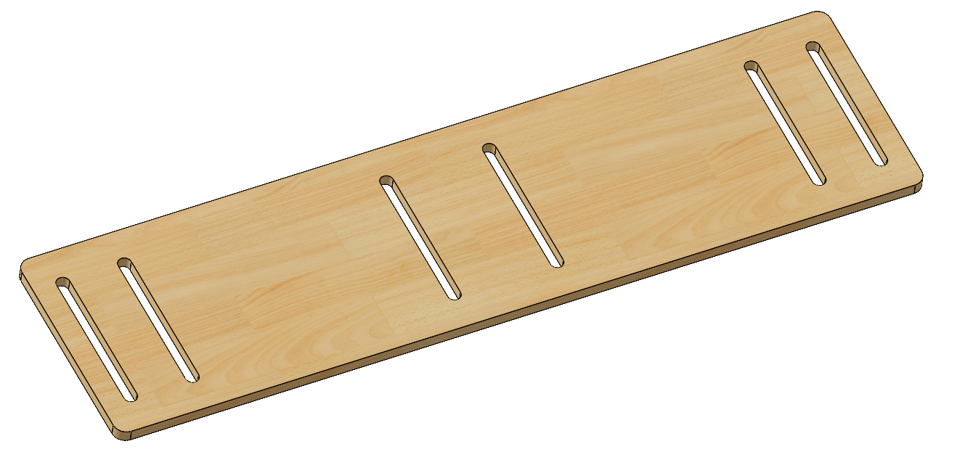
Figure 16 — The base plate as cut: 8 mm MDF with slots for the stand and clearance for the rig's own feet.

3.2.3 The damping pad: TPU against neoprene
Between the MDF plate and the machine sits a 2–3 mm pad. Its job is to break the direct path from the frame into the plate, so that the motors' vibration reaches the camera attenuated rather than through steel and aluminium. The obvious choice is neoprene rubber sheet, and it was compared against two grades of printable TPU (Table 7).
Table 7 — The damping pad: neoprene sheet against two printable TPU grades.
Property | Neoprene / rubber | TPU 95A | TPU 87A
Shore hardness | 40–50A | 95A (too hard) | 87A (closer)
Vibration damping | Excellent | Good | Very good
Compression set | Low | Medium | Medium
Sourcing | Buy as sheet | Print yourself | Print yourself
Custom shape and slots | Cut by hand | Print the exact shape | Print the exact shape
Cost | Low | Filament cost | Filament cost
Consistency | Uniform | Depends on the print | Depends on the print

Neoprene damps better and is more uniform, and on those two rows it wins. It loses on the row that decided it: the pad is not a rectangle. It has to clear the rig's feet and carry the same slots as the plate above it, and a hand-cut sheet gives a different outline every time it is remade, whereas a printed pad comes out of the same CAD file as the plate it sits under. Of the two TPU grades to hand, the softer 87A is the closer match to neoprene's 40–50A and damps better than the 95A, which the comparison marks as too hard to be worth printing. TPU was therefore chosen as printable and sufficiently damping, with the honest caveat in the last row: a printed pad's consistency depends on the print, so a pad that is reprinted should be reprinted with the same settings. The same material is one of the three the rig later characterised (Section 4.8) — the pad's stiffness is a property this machine can now measure for itself.

3.2.4 The stand: 20 × 20 against 30 × 30 profile
Two T-slot aluminium profiles were available in the laboratory, and the comparison is in Table 8. The 30 × 30 was selected: it is the stiffer column for a cantilevered camera, and its 6 mm slot takes M5 hardware rather than the M4 of the 20 × 20. In practice the stand was first built with the 20 × 20 profile, because a dimensionally accurate 30 × 30 model was not available at the time and scaling the 20 × 20 model would have produced parts that did not fit; the printed parts were therefore dimensioned for both, with M5 nuts for the 20 × 20 and M6 for the 30 × 30.
Table 8 — The two T-slot profiles available, as compared before the stand was designed. Profile models from the supplier's library [50].
 | 20 × 20 | 30 × 30
Weight | ≈0.5 kg/m | ≈0.9 kg/m
Rigidity | Moderate | High
Camera weight supported | Up to ≈400 g easily | Up to ≈2 kg easily
Slot width | 5 mm (M4 bolts) | 6 mm (M5 bolts)

3.2.5 The rail base bracket
The bracket is the joint between the aluminium stand and the MDF plate, and it is the one part where a printed component carries a bending moment. It is a gusset corner bracket — a right angle with a diagonal web — printed in PLA and, by design, replaceable with an aluminium one if it ever proved too flexible. Two versions were made (Figure 17): the first used a slot and M5 hardware so the bracket could slide before being locked; the second replaced the slot with a plain M8 hole, because the plate's own slots already provide the adjustment, and tightened the sliding fit to 0.18 mm.
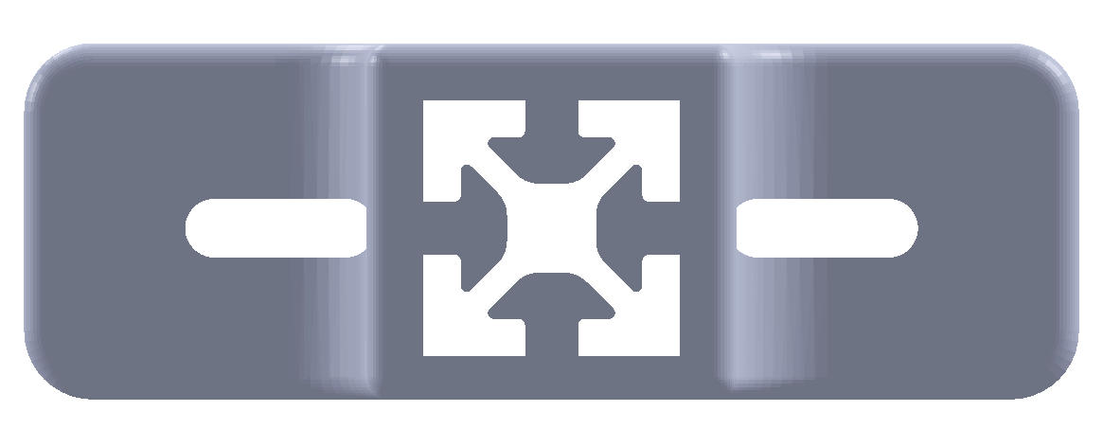  (a) | 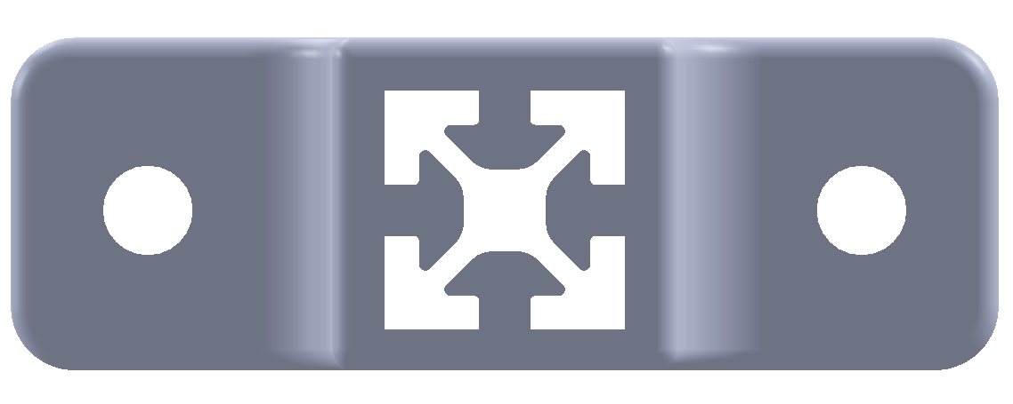  (b)
Figure 17 — The rail base bracket: (a) V1 with a slot for M5 and a looser slider fit, (b) V2 with an M8 hole and a 0.18 mm fit, the version that was printed.

3.2.6 The carriage, and the rib that stiffens it
The carriage is the printed part that rides the stand and carries the housing. Its weak direction is the cantilever: the camera hangs off one side, so the carriage wants to twist. The fix is a rib, and six rib geometries were scored against three weighted criteria — rigidity at 45 %, printability at 30 % and low weight at 25 % — because a rib that cannot be printed without supports, or that doubles the mass hanging off the stand, is not a fix (Figure 18).
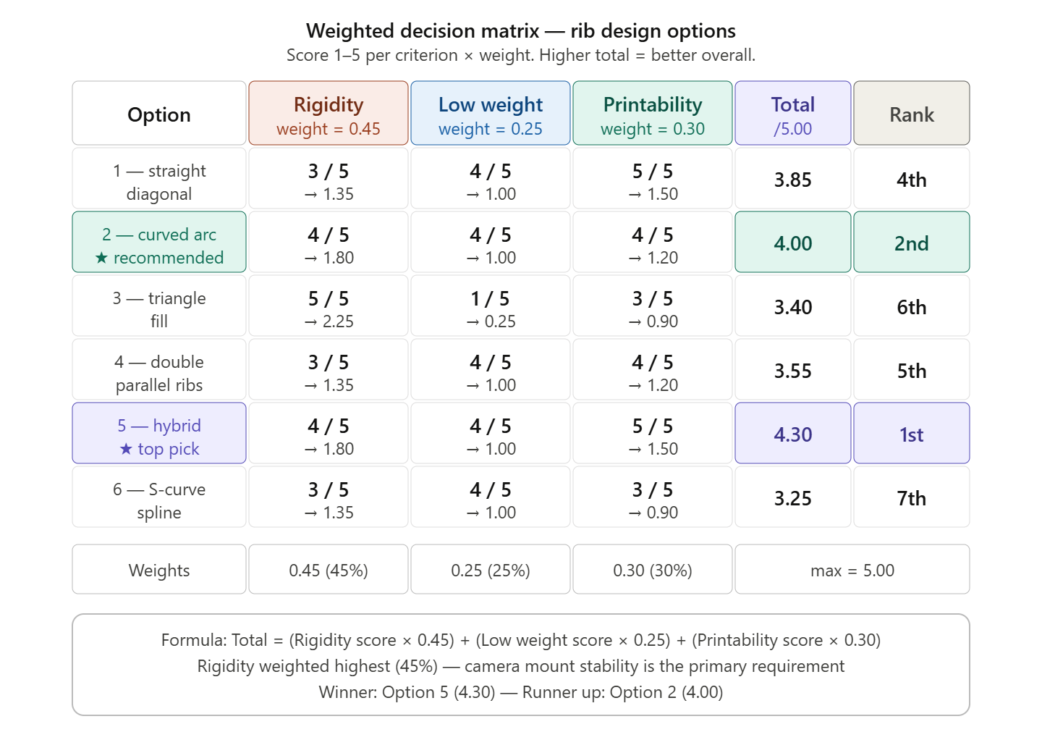
Figure 18 — Weighted decision matrix for the carriage rib. The hybrid rib — a straight diagonal with filleted ends — wins at 4.30 out of 5.00, ahead of the curved arc at 4.00; the triangle fill is the most rigid but the heaviest, and scores 3.40.
The hybrid won for reasons that are all manufacturing reasons. Its rigidity nearly matches the solid triangle fill without the weight penalty; the fillets at both ends remove the crack-starting sharp corners and the overhangs; and a straight diagonal at 45° is self-supporting in PLA, so the part prints with no support material and no scarred surfaces where support would have been removed. That is the recurring theme in these parts: the geometry that prints cleanly usually beats the geometry that is theoretically stiffest. Figure 19 shows the part that resulted, with the winning rib arrowed.
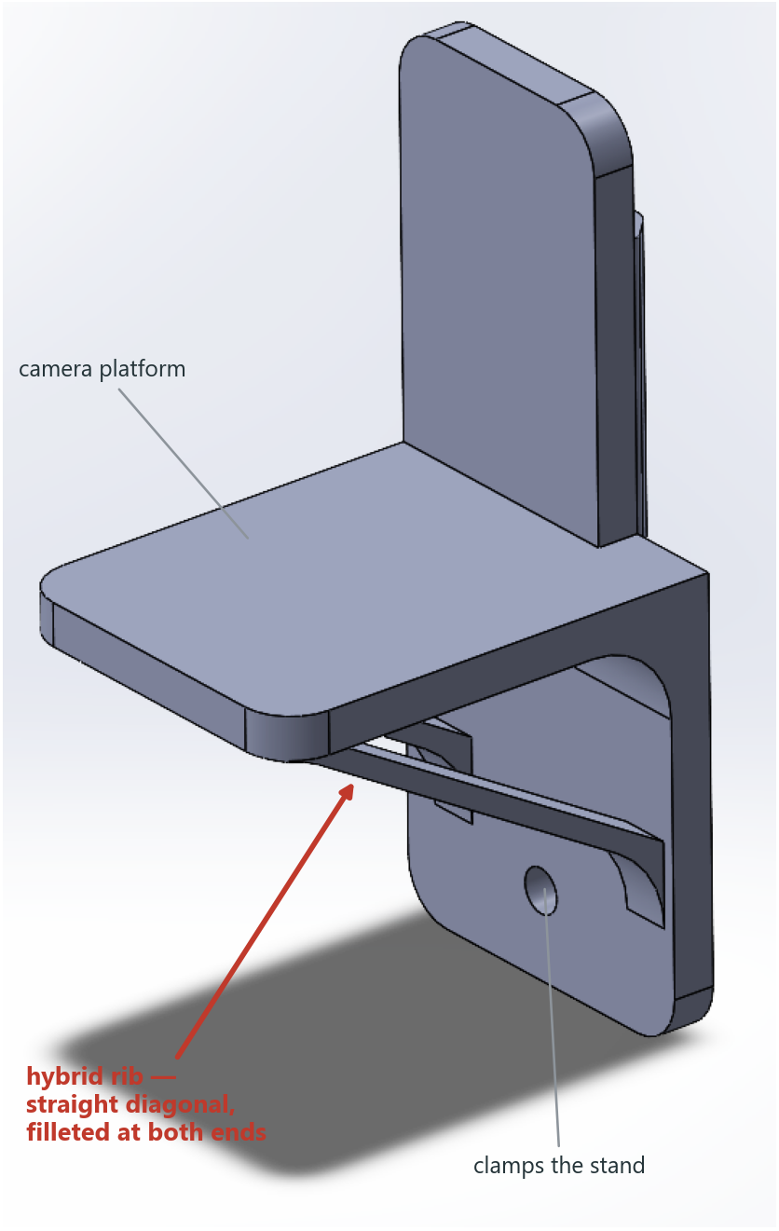
Figure 19 — The camera carriage as designed, with the hybrid rib arrowed: a straight diagonal web, filleted where it meets the platform and the back plate, carrying the cantilever load from the camera platform into the part that clamps the stand.

3.2.7 The camera housing, and how it locks to the carriage
The housing holds the camera body and presents it to the carriage. Four concepts were modelled: V1 a volume template used only to check that the camera fits, V2 a version bolted directly to the rail, V3 a dovetail slider and V4 a mushroom-head slider. Direct bolting was rejected because it makes every height change a tool job; that left the question of which sliding profile to cut into the two parts. Figure 20 is the housing that resulted: a printed shell that captures the camera body and presents a foot underneath it.
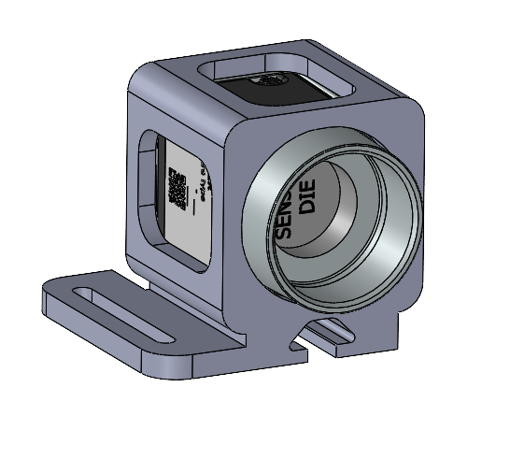
Figure 20 — The camera housing: a printed shell around the camera body, open at the front for the lens and at the top for the mounting thread, with the mushroom-head foot underneath that mates with the carriage.
Six sliding profiles were then drawn as cross-sections and scored on printability (35 %), rigidity (40 %) and ease of assembly (25 %), with each option carrying the printing tolerance it would need (Figure 21). The T-slot mushroom head won at 4.65 out of 5.00. It locks in two directions at once — vertically under the mushroom head, laterally against the channel walls — which is why it scores full marks on rigidity alongside the dovetail, and it slides in from the side and is secured with a single M3 bolt, which is why it beats the dovetail on assembly. The built pair carries 0.22 mm of total clearance: enough to slide by hand, little enough not to rattle.
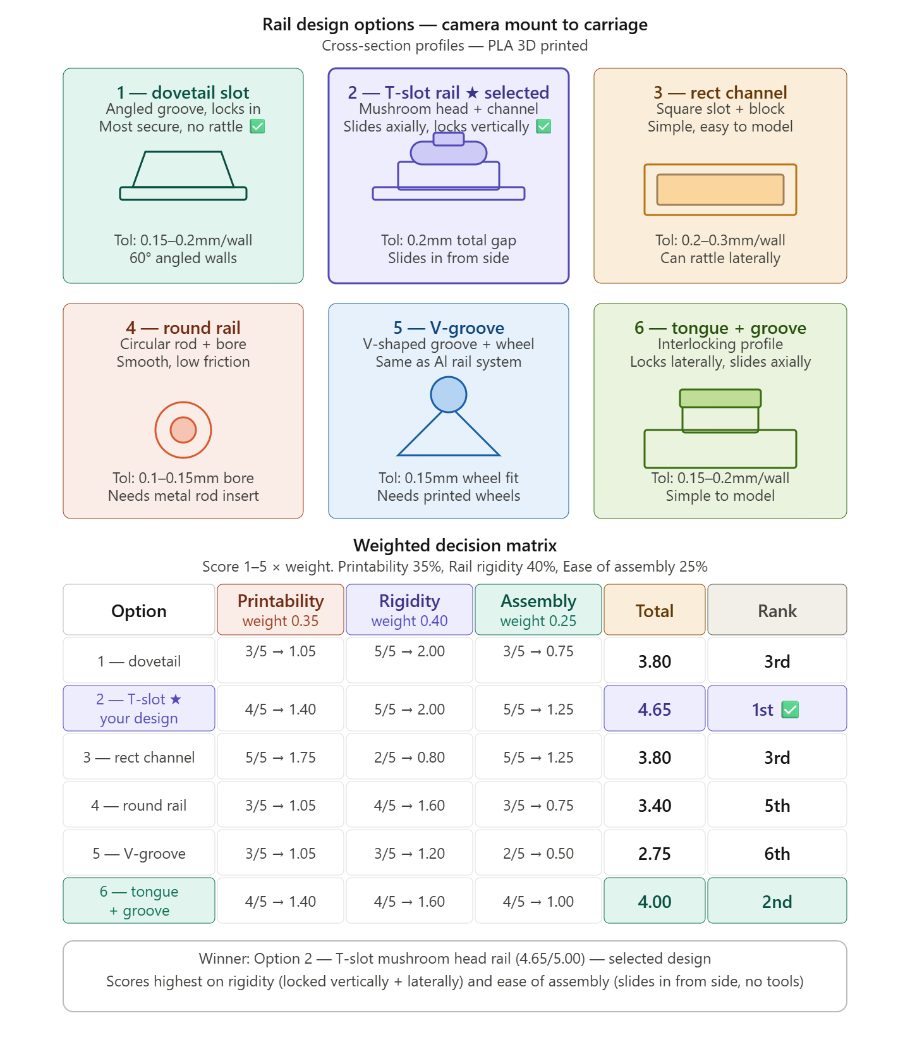
Figure 21 — The six sliding profiles considered for the housing-to-carriage joint, each with its printing tolerance, and the weighted matrix that chose between them. The T-slot mushroom head wins at 4.65 out of 5.00.
Figure 22 shows the joint itself: the mushroom-head rail standing on the carriage platform, and the housing seated on it in the assembly. The camera therefore hangs from a joint with no fastener in its load path — the single bolt only stops the housing sliding back off the way it came.
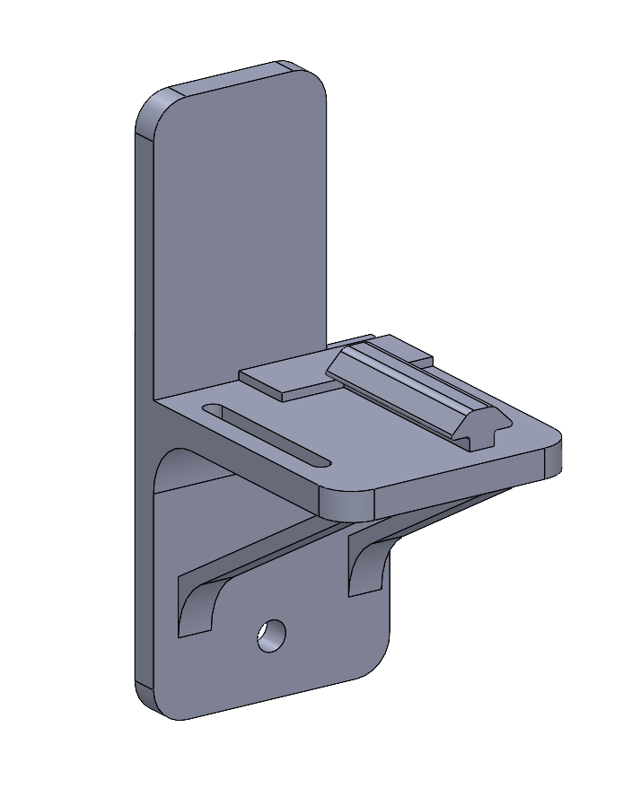  (a) | 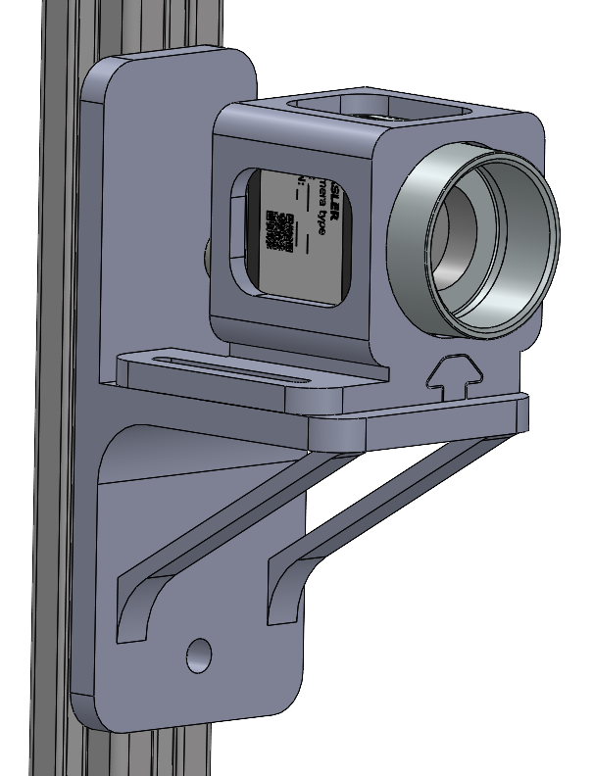  (b)
Figure 22 — The housing-to-carriage joint: (a) the carriage, with the selected T-slot mushroom-head rail standing proud of its platform and the hybrid rib underneath, (b) the housing seated on that rail, the assembly the camera hangs from.

3.2.8 Captive-nut holders
Printed parts cannot hold a thread reliably, so the joints between them use ordinary steel nuts trapped in printed pockets. Holders were drawn for M3 and M4 so the nut is captured before assembly and cannot fall out or spin while a bolt is tightened. It is a small part, but it is the reason the mount can be taken apart and put back together without the fit changing — which matters for a stand whose whole purpose is repeatable placement.

3.2.9 The light mount and the buck-converter enclosure
Section 4.7 shows how much the threshold depends on lighting, so the light needed a mount of its own rather than being propped in place. Three template versions (Figure 23) fixed the LED strip above the field of view, out of the camera's line of sight but lighting the gauge evenly. The converter that powers those LEDs then needed a home: a printed PLA enclosure (Figure 23) with locating pins that align and hold the converter board, a side extrusion that houses the on/off switch, and an open top with side slots for the wiring. Neither part is glamorous, and both remove a source of variation — a light that moves between runs, and a loose board on the bench.
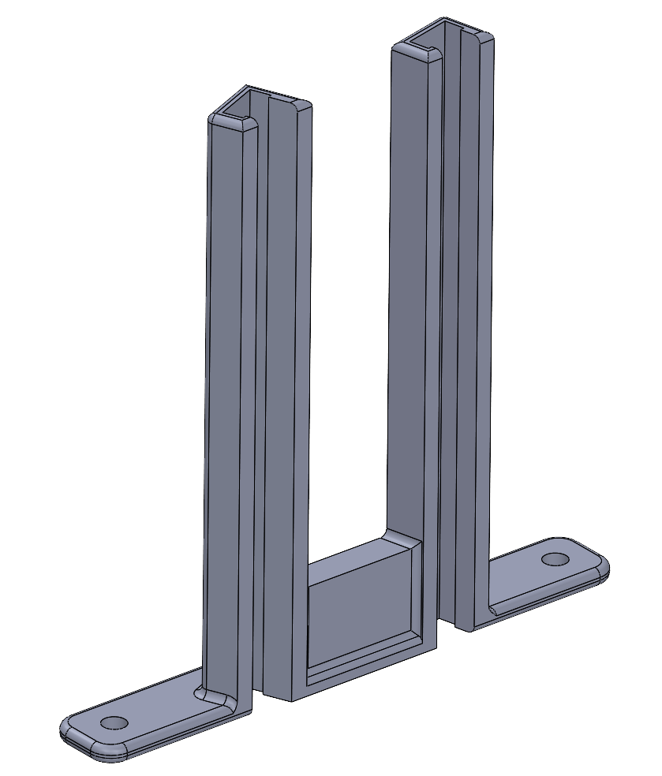  (a) | 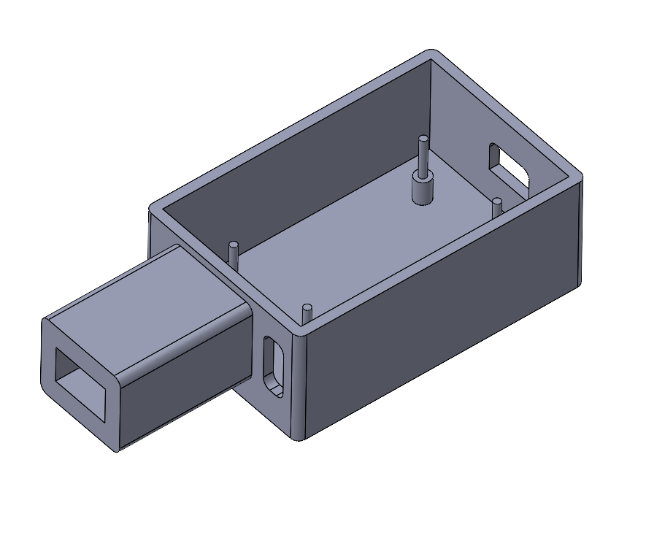  (b)
Figure 23 — (a) The LED light mount: two printed uprights on footed feet that bolt to the base plate and carry the strip above the field of view. (b) The buck-converter enclosure: locating pins for the board, a side pocket for the switch, and an open top for wiring.

3.2.10 The specimen marker template
The two painted dots are the measurement, so where they sit has to be repeatable from specimen to specimen: they define the gauge, and a dot placed 2 mm off shifts the reference span. A printed template solves it — a plate that drops over the specimen with two holes at the gauge ends, through which the paint is applied (Figure 24). Six versions were made, and the interesting part is that the revisions were about fit, not about the hole positions.
- v1 — running fit (clearance). The template rocked on the specimen, so the dots moved with it.
- v3 — sliding fit (clearance). Better, still enough play to blur the edge of the dot where paint crept under the template.
- v4, v5 and v6 — light push fit (transition). The template stays put by itself and the dot edge is clean. v4 is the 80 mm-gauge template; v5 and v6 place the dots for the 45 mm gauge used in the laboratory comparison and for TPU (Section 4.5), with v6 also offered in a 3 mm dot diameter.
- Paint — enamel and spray were both tried through v4. Spray paint through a push-fit template is what the specimens in this report use: white spray on the black specimens and black spray on the white ones, so the markers are the small high-contrast class the detector expects either way (Section 4.7).
A permanent marker also makes a usable dot, and for a single quick pull it is the faster option. The template exists because the dot's shape and size have to be the same from specimen to specimen: the centroid of a hand-drawn blob is as good as its outline, and the area gate in the detector is set for a dot of a known size. Standardising the pattern is what lets one threshold preset and one set of blob gates work across a whole batch without retuning.
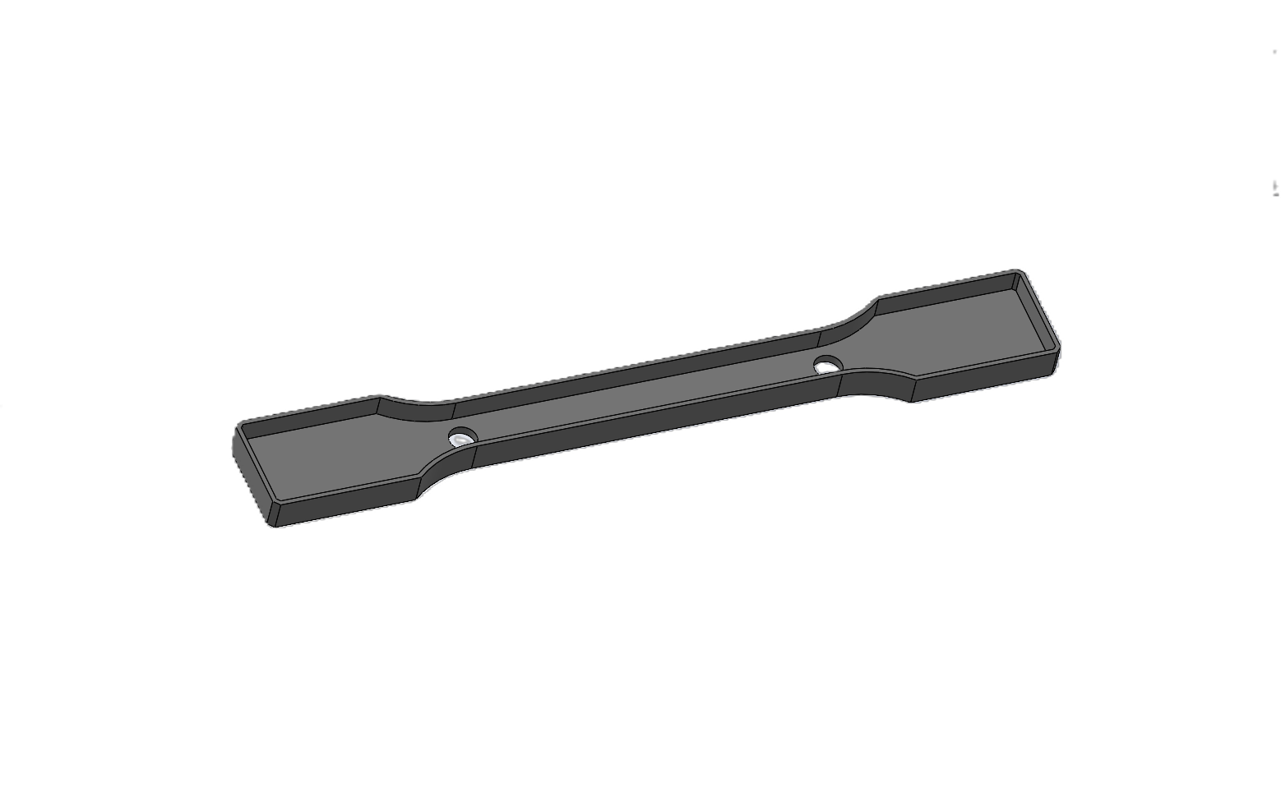  (a) | 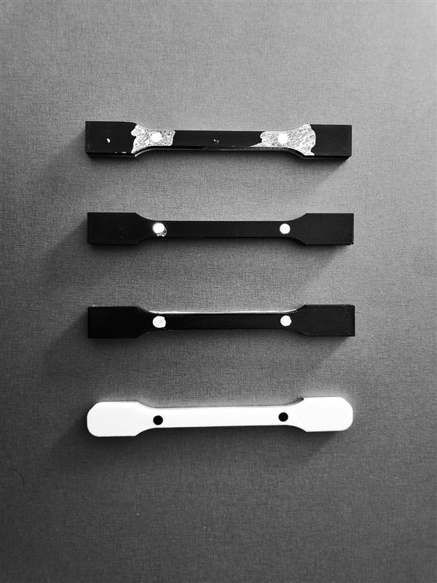  (b)
Figure 24 — (a) The marker template: a printed plate that locates the two dots at the gauge ends. (b) The four combinations tried — template fit from running to light push, and enamel against spray paint — and the dots each produced.

3.2.11 Manufacturing and assembly
Three routes made everything. The MDF base plate was laser cut from a DXF exported straight out of the CAD model, which is what makes the slots and the locating pocket accurate enough to seat the stand without shimming. The aluminium profiles — the stand and the rig's lengthened bottom rail — were cut on the workshop's automatic band saw. Everything else was 3D printed: the carriage, the housing, the brackets, the nut holders, the light mount, the enclosure and the templates in PLA, and the damping pad in TPU. The whole set of printed parts is a few days of printer time and a few euros of filament, which is the point of Section 3.1.2: the mount is cheap because it is printed, and it is adjustable because it was designed to be. Figure 25 shows the printed parts doing their job on the machine.
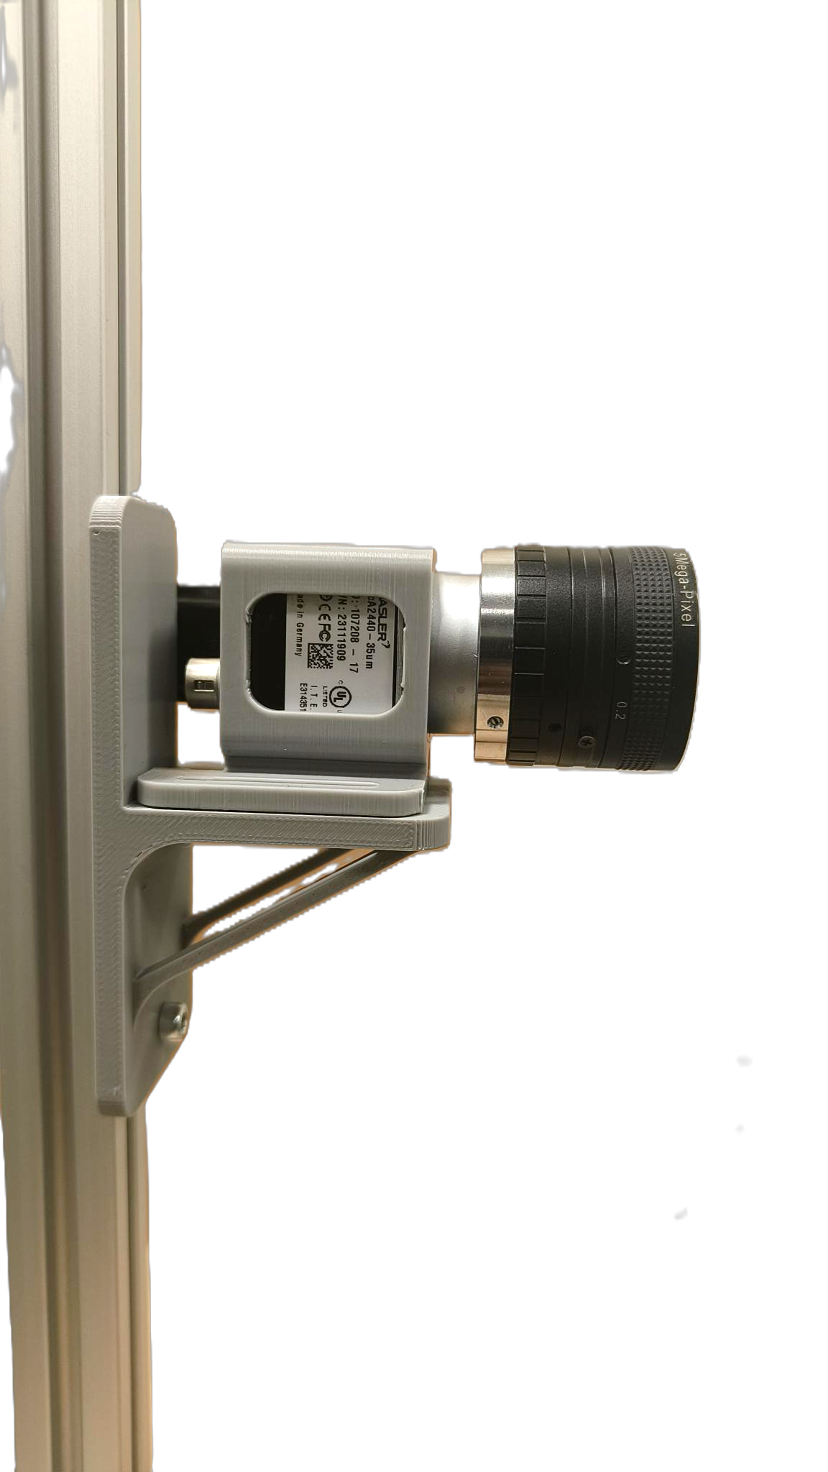
Figure 25 — The printed camera carriage and housing assembled together on the rig: the carriage bolted to the aluminium stand, the housing seated on its rail, and the camera and lens carried by the housing.
Figure 26 closes the loop: the assembly as modelled, and the same assembly on the machine. The stand bolts to the base plate through the gusset, the plate sits on the TPU pad under the rig's own frame, and the camera looks across at the specimen from the height its carriage was slid to.
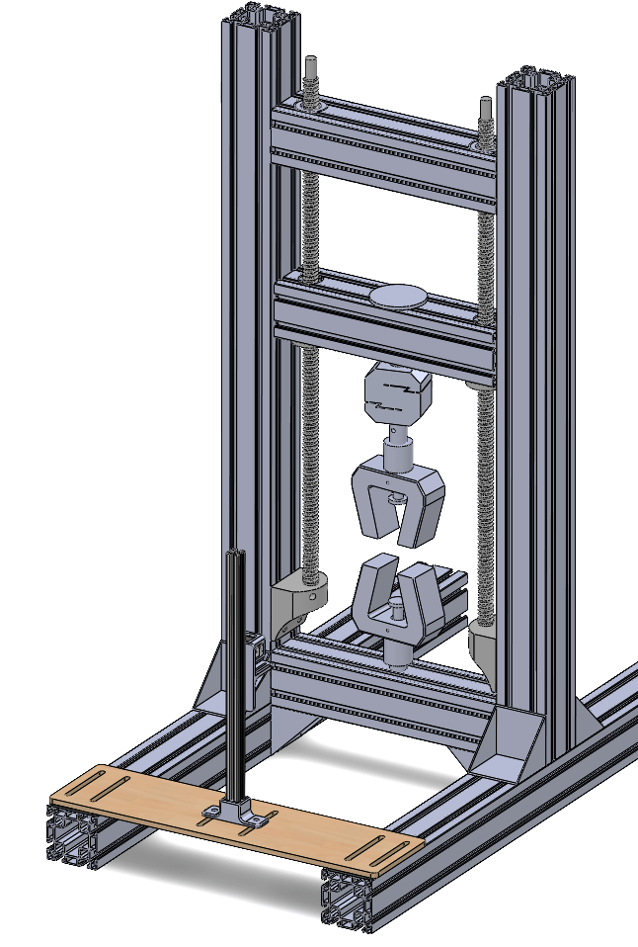  (a) | 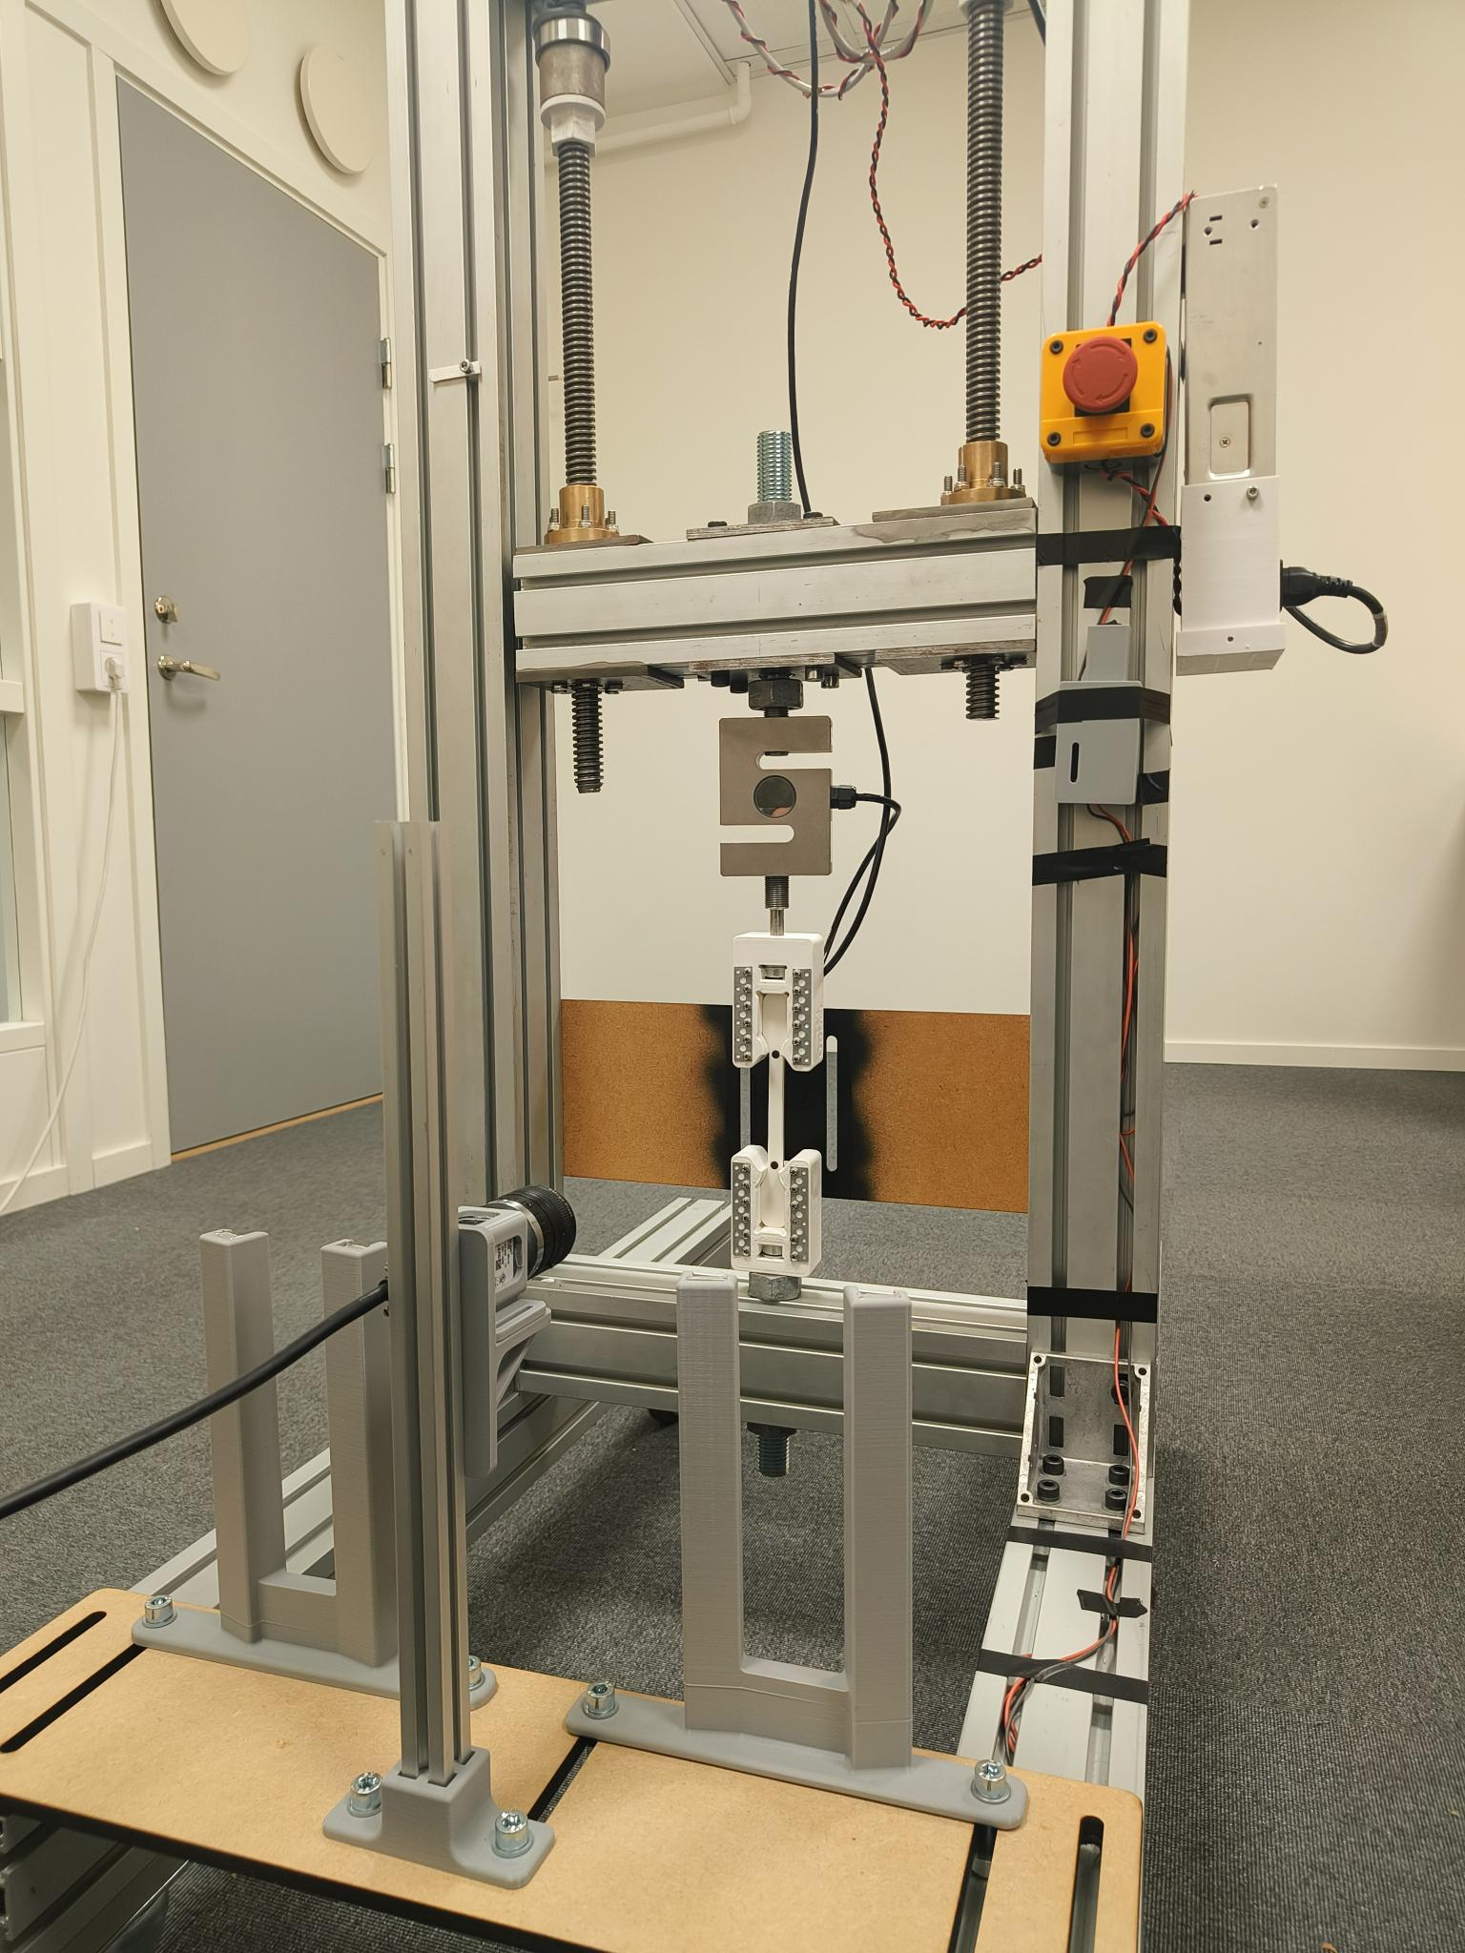  (b)
Figure 26 — The camera mount (a) in CAD and (b) built and bolted to the rig, with the printed light-mount uprights standing on the same base plate and the camera looking across at a specimen in the grips.

3.3 Specimens and their preparation
All specimens were fused-filament mini-dogbones printed on a Prusa MK4S [43] sliced in PrusaSlicer [51] from CAD models drawn in SolidWorks [49]; Table 9 lists the print specification and Figure 27 shows the specimen as sliced. The standard geometry has an 80 mm gauge and an 80 mm² cross-section; a shorter 45 mm-gauge variant was made for the laboratory comparison and for TPU, whose strain would otherwise run a marker out of the frame. Cross-section and gauge are entered per specimen in the application and stored in the run's CSV header and in the registry, so stress and strain are always computed from the specimen's own numbers.
Table 9 — Specimen print specification.
Item | Setting
Printer | Original Prusa MK4S, 0.4 mm nozzle
Slicer and profile | PrusaSlicer, 0.20 mm STRUCTURAL
Materials | PLA (white and black), PETG, TPU — generic profiles
Infill | 100 % (solid, rectilinear fill pattern as suggested by Prusa for solid infill) or 50 % gyroid
Supports / brim | supports everywhere, no brim
Specimen geometry | Mini-dogbone, 80 mm gauge (standard) or 45 mm gauge; 80 mm² section
Filament per specimen | 23.4 g, 7.85 m (100 % PLA)
Print time per specimen | 48 min (normal mode)
Markers | Two spray-paint dots through a stencil at the gauge ends, ≈10 000 px each
Marker polarity | Black on white PLA; white on black PLA and on PETG

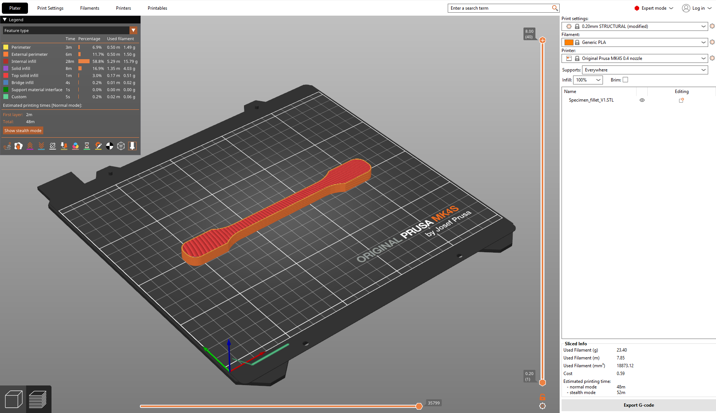
Figure 27 — The specimen in PrusaSlicer: 0.20 mm STRUCTURAL profile, 100 % infill, MK4S with a 0.4 mm nozzle — 23.4 g of filament and 48 minutes per specimen.
Two print settings were varied on purpose: infill (100 % solid, or 50 % gyroid) and, for PLA, the spool and its age, which is the moisture variable of Sections 2.8 and 4.11. For the 100 % specimens the rectilinear fill pattern was used, as Prusa suggests for solid infill; it lays every layer's lines parallel and alternates the direction between layers, which is the pattern behind the raster-orientation effect discussed in Section 2.7. Specimen masses were recorded with a laboratory balance as a check on infill and porosity.
The DIC markers are two dots of spray paint through a stencil, placed at the ends of the gauge. On white PLA they are black; on black PLA and on PETG they are white. Marker size is a compromise: a large dot has a better centroid (Section 2.5) but must stay inside the gauge and inside the frame at the end of the pull. The dots used here cover about 10 000 pixels each and pass the detector's area gate of 2 000–200 000 pixels with a wide margin.

3.4 Software architecture
The application is a single Python program built on PyQt6 [52], OpenCV [53], NumPy [54] and Matplotlib [55], twenty modules and 19 147 lines in total (Table 10). The main window owns the test state machine — idle, preload, running, fracture, release — and everything the operator sees. Two worker threads feed it: a serial thread that polls the controller for force and position, and a camera thread that grabs frames and runs the DIC pipeline. Both post their results to the GUI thread through Qt signals, and the main window stamps each with the same monotonic clock, which is how a strain sample is matched to a force sample. Figure 28 shows which modules a live test pulls in.
Table 10 — The application's modules, with line counts from an abstract-syntax-tree scan of the source on 6 September 2026.
Module | Lines | Role
main.py | 8 101 | Application window, test state machine, all controls and plots
utm_postdlg.py | 3 046 | DIC post-processing dialog (SF18): measures any recorded video
utm_postproc.py | 1 740 | Video reading, frame probing, offline pixel-to-strain engine
camera_manager.py | 992 | Basler pylon grab thread, ROI/exposure/gamma, frame sinks
widgets.py | 667 | Custom Qt widgets: camera view, HUD, gauges
control_policies.py | 620 | Closed-loop controllers for the six advanced modes (SF9)
utm_capture.py | 565 | Video and still recording (SF17)
utm_analysis.py | 501 | Modulus, yield, UTS, fracture and toughness from a run
serial_manager.py | 380 | Serial link to the motor controller and load cell
utm_capdlg.py | 321 | Capture settings dialog
theme.py | 300 | Application theme and colours
utm_recipes.py | 286 | Settings recipes and material presets (SF3)
utm_wizard.py | 273 | Guided wizard (SF13)
utm_report.py | 251 | One-click report generation (SF4)
utm_camdlg.py | 228 | Camera setup dialog
utm_registry.py | 221 | Test registry (SF14)
utm_dic.py | 191 | Marker detection and the pixel-to-strain rule
utm_autocal.py | 189 | DIC auto-calibration sweep (SF12)
utm_blobpick.py | 144 | Manual blob picker (SF20)
utm_noisedlg.py | 131 | Noise-capture dialog (SF19)

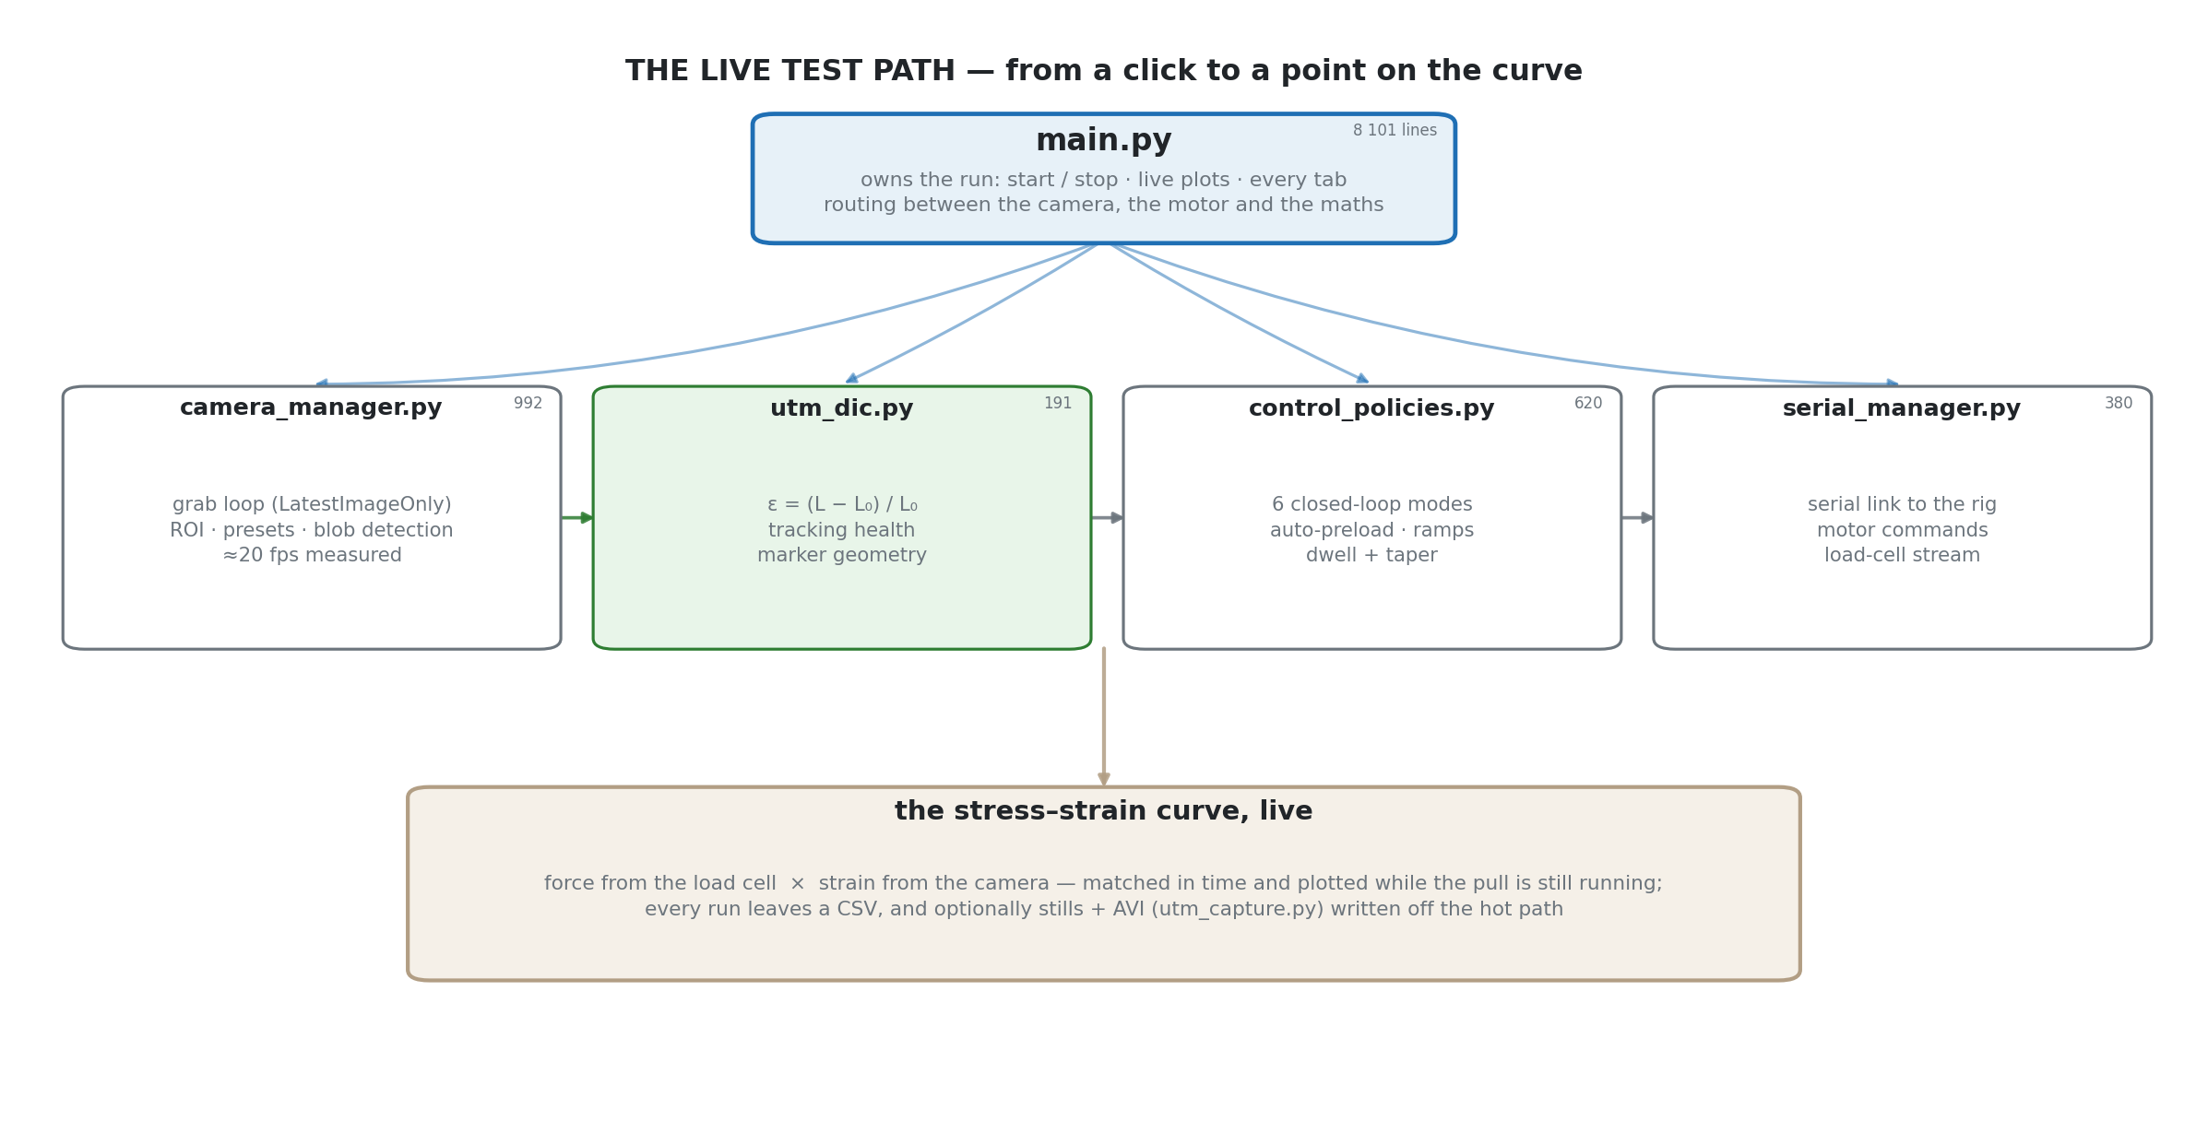
Figure 28 — The live-test import graph: which modules the main window pulls in for a running test, from the serial and camera threads through detection to the plots.
Three design rules run through the code. The pixel-to-strain rule lives in one place (the DIC module) and is imported by the live path, the post-processor and the tests, so the rig and the offline re-measurement cannot disagree by construction. Every automation is a guard or a policy, not a special case in the main loop: the stall guard, the dead-DIC guard, the auto-stop and the six closed-loop modes are separate objects that the state machine consults. Every run leaves a complete record: a CSV with a header of the whole setup, the captured video and stills, a registry row, and optionally a report — linked by name so that nothing can be orphaned.

3.5 The DIC pipeline
Each frame passes through six stages in the camera thread; the region it works on is the gauge strip of Figure 29.
- Wait — the grab call blocks until the camera delivers a frame. The grab strategy is latest image only: if the pipeline falls behind, frames are dropped rather than queued, so the strain the operator sees is never stale.
- Rotate — the sensor is mounted so that the specimen's axis runs along the sensor's long side; the frame is rotated for display only.
- Sink — the frame is handed to the recorder (video and stills, Smart Feature 17) when recording is on. Measured cost ≈47 µs per frame.
- Detect — threshold (Otsu or fixed, with polarity), connected components, area and circularity gates, then the two best candidates by the pair rule (similar area, aligned along the axis). Measured cost ≈1.4 ms per frame on the 2348 × 419 region.
- Strain — the centroid separation Px is divided by the frozen Px₀ (Equation 2.4); a separation guard and a speed guard reject a physically impossible jump.
- Emit — strain, marker count, jitter and the overlay geometry are posted to the GUI, which draws the HUD (Smart Feature 1) and the live Px₀ overlay (Smart Feature 16).
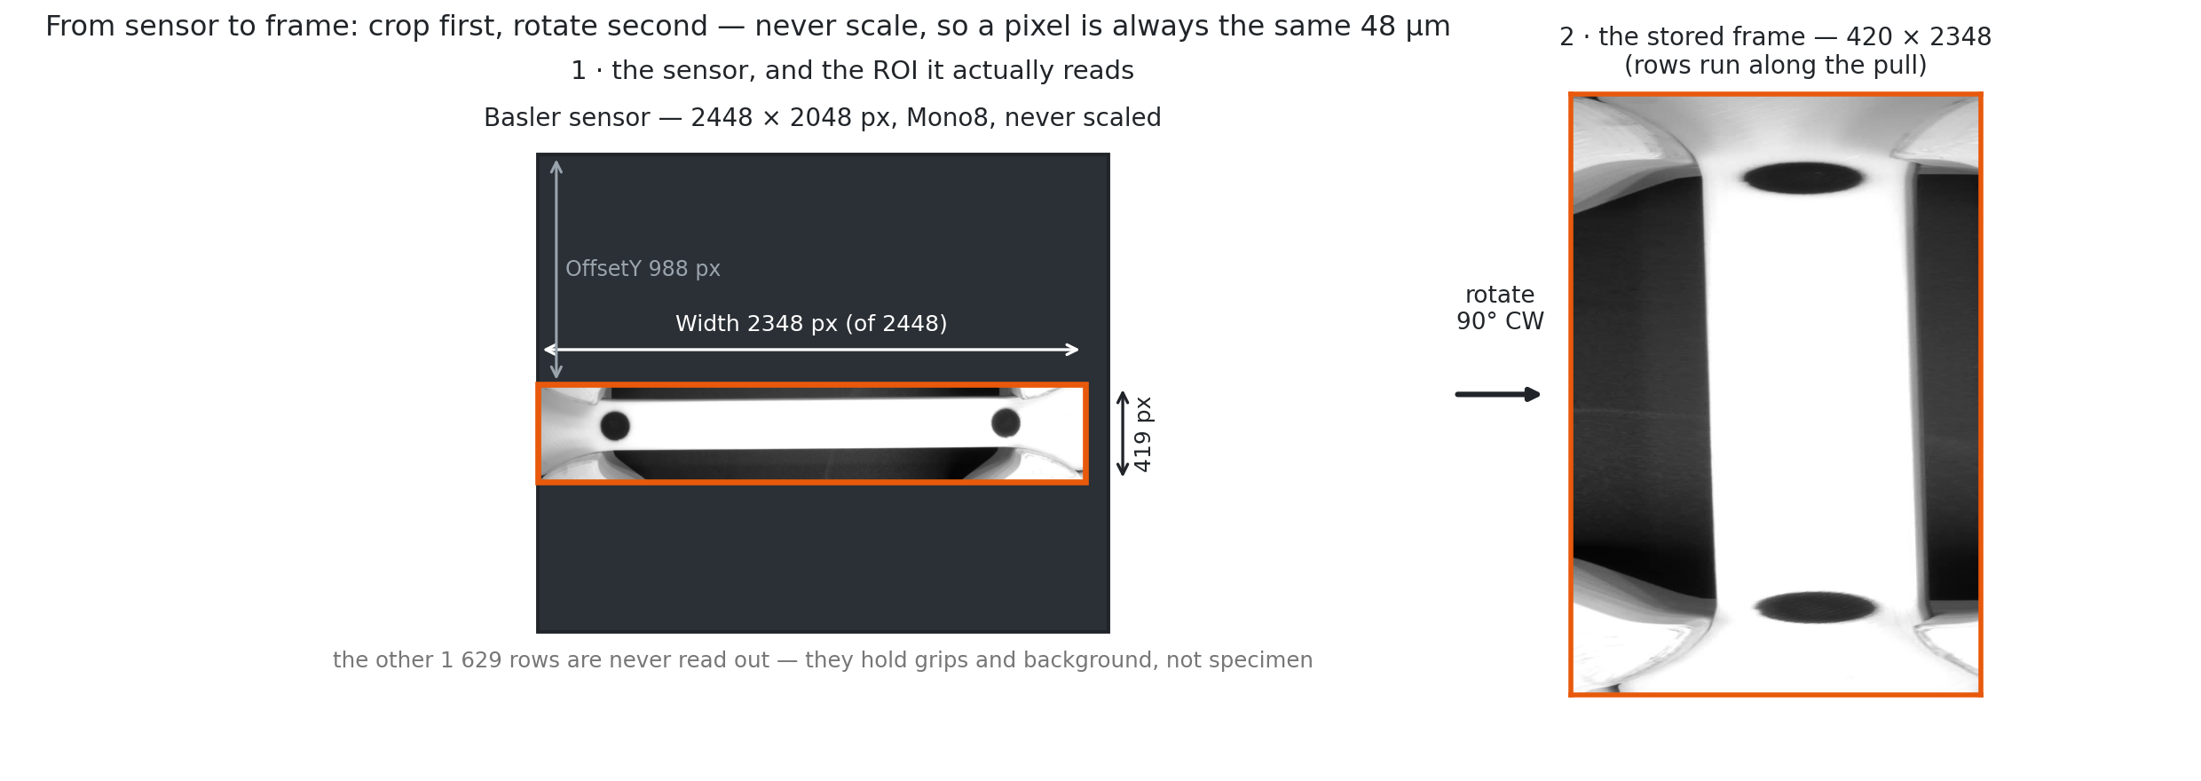
Figure 29 — The region of interest on the sensor: the 2348 × 419 px gauge strip is read from the 2448 × 2048 frame, so each frame the pipeline handles is about a fifth of the full sensor.
Two thresholds are kept as material presets (Smart Feature 3): White uses a fixed threshold of 150 with inverted polarity (dark markers on a light specimen), and Black uses a fixed threshold of 149 (light markers on a dark specimen). Otsu remains available as the default for an untuned setup, with the caveat of Section 2.5 that Section 4.7 quantifies. Figure 30 shows the application at the moment the reference is frozen.
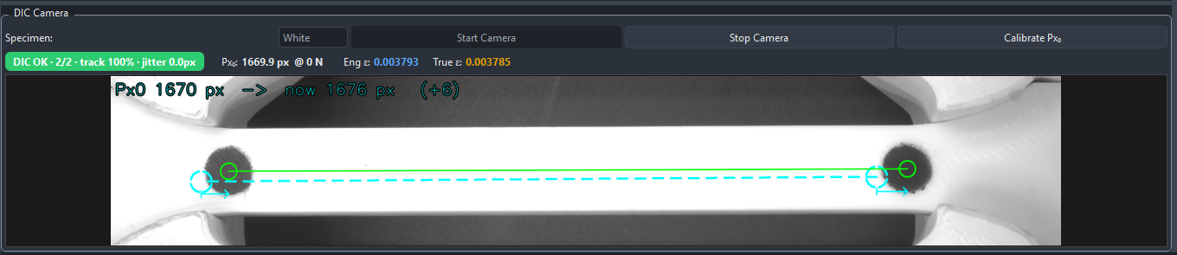
Figure 30 — The application during Calibrate Px₀: both markers detected (2/2), the frozen reference pair and the live pair drawn on the feed, and the strain readout at zero.

3.6 Camera configuration
The camera's settings are the result of the exposure, region and frame-rate trade-off of Section 2.5, and each was measured rather than assumed; Table 11 lists them.
Table 11 — Camera and detection settings used for every run in Chapter 4.
Setting | Value | Why
Pixel format | Mono8 | Grey level only; 8 bits are ample for a thresholded marker
Region of interest | 2348 × 419 px at (0, 988) | The gauge strip only — ≈20 % of the 5.0 Mpx sensor, so frames are ≈5× lighter
Exposure | 50 000 µs | Enough light for a wide grey-level margin under the LED strip
Gamma | 0.5 | Lifts the dark tones so the dark marker separates cleanly
Frame-rate limit | 35 fps | The camera's ceiling at full resolution
Delivered rate | 19.9 fps | 1 / 50 ms exposure — the exposure, not the sensor, sets the rate
Grab strategy | Latest image only | Never a stale frame; drops rather than queues
Blob gates | area 2 000–200 000 px, circularity ≥ 0.5 | Rejects scratches, edges and grips; passes the ≈10 000 px markers
Optical scale | ≈20.9 px/mm (≈48 µm/px) | Set by lens and distance for the 80 mm gauge

Why 19.9 frames per second and not 35: the exposure is 50 ms, and a global-shutter camera cannot deliver frames faster than it exposes them (Figure 31). A shorter exposure would raise the rate but narrow the grey-level margin unless the light were raised with it; for a pull at 1–2 mm/min the specimen moves a few micrometres per frame, so 20 frames per second oversamples the strain by a wide margin and the exposure was kept. The optical scale is not a setting but a distance: Figure 32 shows how px/mm and field of view follow from where the camera stands, and Figure 33 what the region's width buys in strain before a marker leaves the frame.
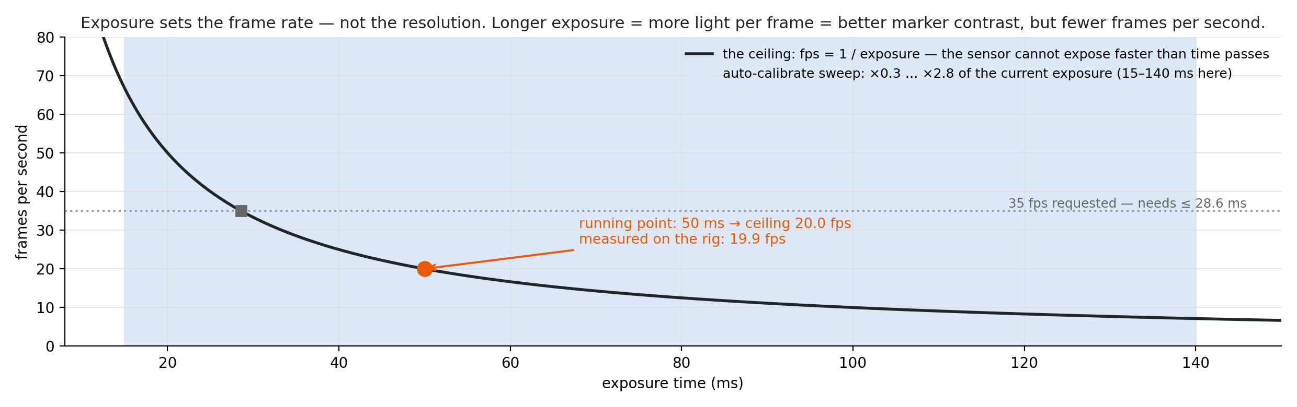
Figure 31 — Delivered frame rate against exposure time with the 50 000 µs setting marked: beyond the sensor's own read-out time the exposure, not the sensor, sets the rate.
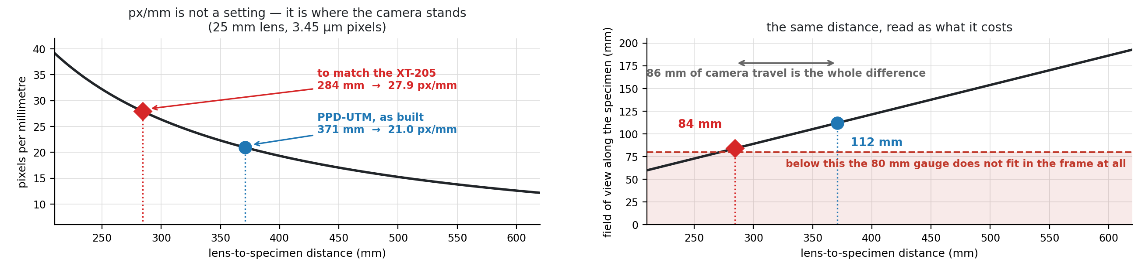
Figure 32 — Pixels per millimetre is where the camera stands: with a 25 mm lens and 3.45 µm pixels, 371 mm gives the rig's 21.0 px/mm and 112 mm of field; matching the XT-205's 27.9 px/mm would need 284 mm and leave 84 mm of field for an 80 mm gauge.
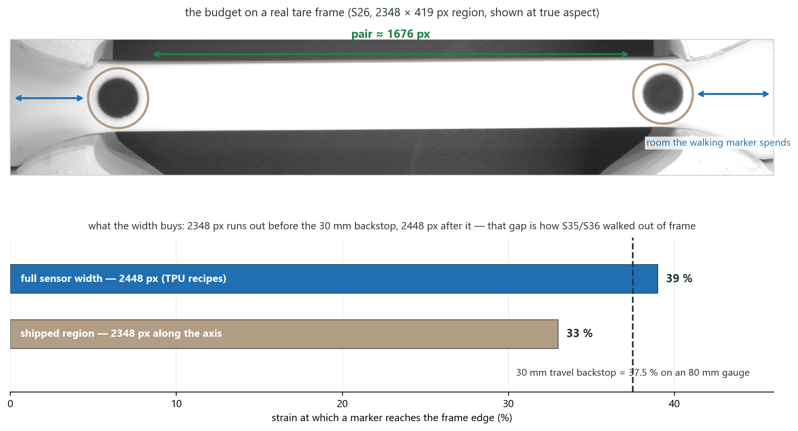
Figure 33 — What the region's width buys, on a real S26 tare frame at true aspect: the marker pair spans ≈1 676 px and the walking marker has the room to its right. With the 2348 px strip a marker reaches the frame edge at 33 % strain, with the full 2448 px at 39 %, against the 37.5 % travel backstop on an 80 mm gauge. That gap is how the TPU specimens S35 and S36 walked out of frame, and why S37 was pulled on the 45 mm gauge.

3.7 Capture, recording and the post-processor
Every run can be recorded (Smart Feature 17) as PNG stills at a chosen interval and as three AVI views written together: the raw frame, a contrast-boosted view for the human eye, and an adaptive-speckle view that shows the threshold's decision. Codecs and still formats were chosen by measurement — the cost of each sink in the camera thread (Figure 34) and the file size per minute — so that recording cannot slow detection.
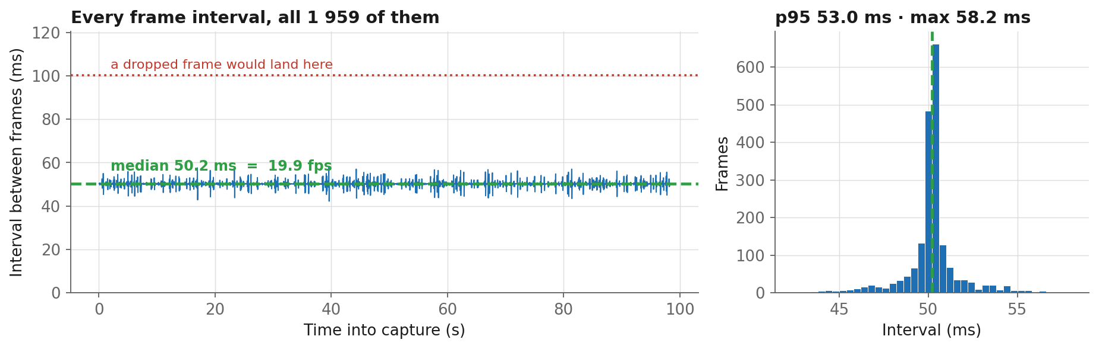
Figure 34 — Measured per-frame cost of each capture sink in the camera thread: recording adds tens of microseconds and never touches the detection budget.
The DIC post-processor (Smart Feature 18, Figure 35) is a dialog that opens any recorded video — the rig's own, or another machine's — and measures it with the same detection code and the same pixel-to-strain rule as the live path. The operator picks the tare frame, the threshold and polarity, and the gauge; the tool returns the strain record, a health trace and a stress–strain curve if a force CSV is supplied. Three guards were added after running an external laboratory's footage through it: a frame-count check against the container's metadata, a tare-frame sanity check, and a marker-count trace so that lost frames are visible rather than interpolated. The post-processor is the tool behind the same-footage comparison of Section 4.2.
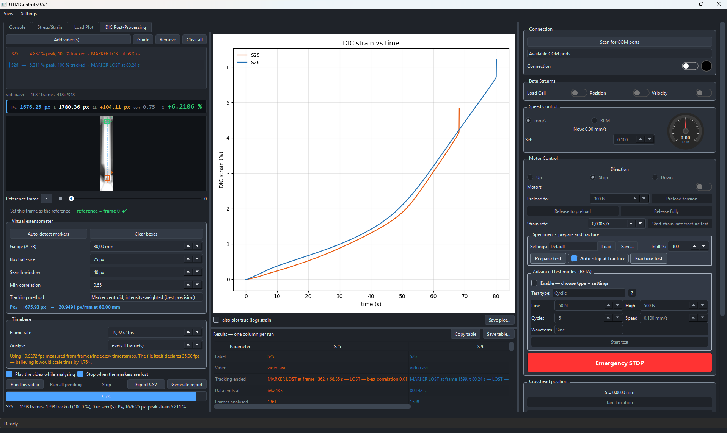
Figure 35 — The DIC post-processing dialog: the video, the detection overlay, the tare frame and threshold controls, and the resulting strain trace.

3.8 The twenty smart features
Twenty operator-facing automations were built over the project; Table 12 lists them. The rule for admitting one to the list was that the person running a test can invoke it, or that it acts on the machine during a run; developer tooling — the simulation harness the controllers were tuned on before hardware, the test suite — is methodology, not a feature. Eighteen have been validated on the rig; two are built and verified offline on recorded frames and await a rig session.
Table 12 — The smart features SF1–SF20 as of 6 September 2026.
SF | Feature | What it does for the operator | Status
1 | DIC health HUD | Live 2/2 marker count, tracking %, jitter on the camera feed | rig-validated
2 | Prepare specimen | One click tares position, force and DIC (Px₀) together | rig-validated
3 | Settings recipes | Save and reload a whole setup — camera, thresholds, test | rig-validated
4 | Generate report | One-click PDF and PNGs of the run with the key numbers | rig-validated
5 | Auto-stop at fracture | Halts the crosshead on load collapse | rig-validated
6 | Strain-rate test | Constant gauge dε/dt using the DIC channel as the sensor | rig-validated
7 | Stall guard | Halts a frozen motor under load before the driver overheats | rig-validated
8 | Release load | Controlled return through zero to −preload after a test | rig-validated
9 | Advanced test modes | Six closed-loop protocols: cyclic, staircase, relaxation, creep, staircase→fracture, progressive cyclic→fracture | rig-validated
10 | Auto-preload | Speed schedule 0.2→0.1→0.02 mm/s, stops at 1.03× target | rig-validated
11 | Auto-metadata link | Every save links CSV, capture and registry row | rig-validated
12 | DIC auto-calibration | Exposure/threshold sweep with a live parameter readout | rig-validated
13 | Guided wizard | Nine-step checklist from power-on to saved run | rig-validated
14 | Test registry | Every run indexed with E, σy, UTS, εf, toughness and force anchor | rig-validated
15 | Dead-DIC guard + backstops | Freeze at 0.2 s of frozen strain, halt at 1.0 s; 4.5 kN / 30 mm caps | rig-validated
16 | Live Px₀ overlay | Frozen reference pair and live pair drawn on the feed | rig-validated
17 | Video + image capture | PNG stills plus three AVI views recorded with the run | rig-validated
18 | DIC post-processing | Measures strain from any recorded video with the rig's own rule | rig-validated
19 | Noise capture | Records the instrument at rest; separates drift from residual sd | built, offline-verified
20 | Manual blob selection | Operator picks the two markers on a frozen frame; gates off | built, offline-verified

Three of them carry most of the operator's day. Prepare specimen (SF2) collapses three tares — position, force and Px₀ — and a marker check into one button, which removed the most common source of a wasted specimen: a run started with a stale reference. Auto-stop at fracture (SF5) halts the crosshead on load collapse, so the grips are never driven into each other and the fracture frame is the last frame with load. The guided wizard (SF13) walks a new user from power-on to a saved run in nine steps and refuses to advance past a step whose check fails; Figure 36 shows it beside the auto-calibration dialog (SF12), which sweeps exposure and threshold and scores each candidate on marker count and centroid stability.
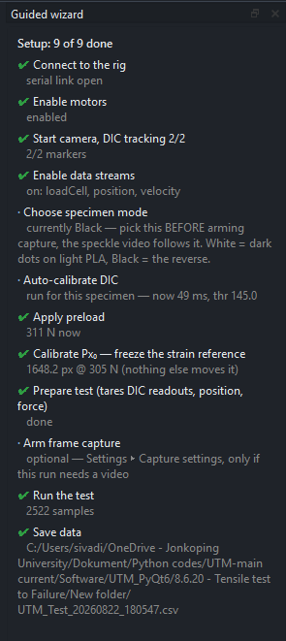  (a) | 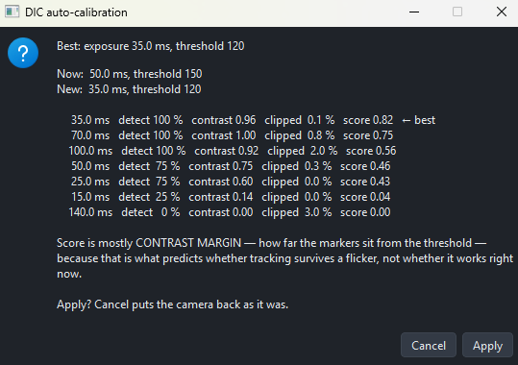  (b)
Figure 36 — (a) The guided wizard (SF13): nine steps from power-on to a saved run, each with a check that must pass before the next is enabled. (b) DIC auto-calibration (SF12): the exposure and threshold sweep, scored on marker count and centroid stability, with the winning setting applied.
The six closed-loop modes (SF9) are the largest single feature. Each is a policy object with a target profile, a controller and its own limits; the state machine runs the policy at the control period and the policy commands a crosshead speed. Figure 37 shows the six as the rig actually ran them; Section 4.10 reports the loop's behaviour in detail.
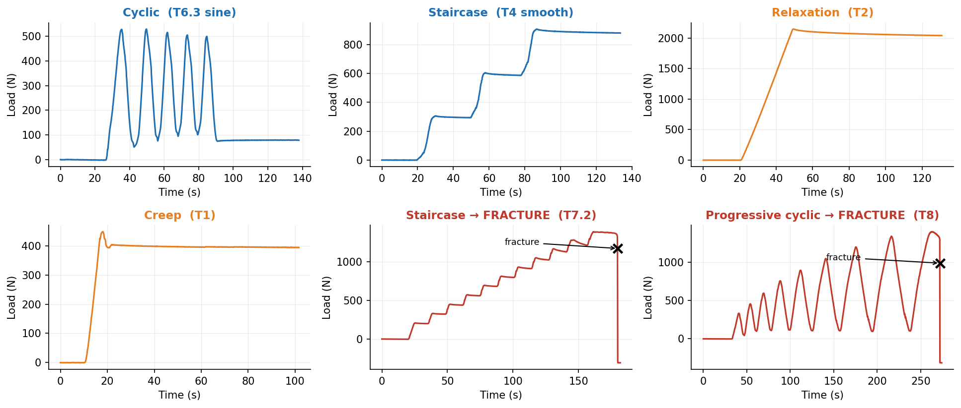
Figure 37 — The six closed-loop protocols as measured on the rig: force (or strain) against time for staircase, cyclic, relaxation, creep, staircase-to-fracture and progressive cyclic.

3.9 Analysis conventions
Every number in Chapter 4 comes from the same analysis module, applied to the run's CSV, with these conventions.
- Force anchor. The force at the end of preload is recorded as the anchor; stress is computed from the tared load unless stated. The anchor is stored with the run so that the choice is auditable.
- Modulus. The steepest straight run: a window of fixed strain width is slid along the rising curve and the least-squares line with the largest slope among the linear candidates is taken. Chosen over a fixed 0.05–0.40 % window because it repeats better (PLA 9.6 % against 16.0 % run-to-run scatter) while staying inside the published bands. The window's position and residual are stored with the result.
- Yield. The 0.2 % offset intersection with the fitted modulus line.
- UTS. The maximum engineering stress.
- Fracture strain. The DIC strain on the last frame before the load-collapse detector fires; where the markers were lost before fracture the value is flagged.
- Toughness. Trapezoidal area under the σ–ε curve to fracture.
- Noise floor. Standard deviation of the DIC strain over a window with the crosshead stopped; a short window (10–40 s) gives ≈12 µε, a 900 s window ≈26 µε, and the report says which is used. Windows are kept equal when specimens are compared, because the RMS moves with the window length.
The test registry (SF14) holds one row per run with these values, the specimen's geometry, material and infill, and the file links; Appendix A reproduces it.

3.10 AI in the loop: how the software was written

3.10.1 The working method
The application, its tests and the evidence scripts were written in Visual Studio Code [56], with an AI coding agent — Claude Code [57] — in the loop in the editor's own terminal, in a division of labour that was kept the same for the whole project. The engineer owned the machine and the questions: what to test, what a result meant, what the next feature was, whether a number was plausible. The agent owned the typing: implementing a feature against a spec written in the conversation, writing the tests for it, refactoring, generating the plots and slides from the data, and reviewing its own and the engineer's code. The agent never ran the rig, never saw the machine, and never produced a measurement; every number in this report was produced by the rig or recomputed from its raw CSVs by a script that is itself in the repository.
The loop for one feature ran as follows. The engineer described the feature and its acceptance test in plain language — usually with a rig observation that motivated it. The agent proposed an implementation, wrote it and its unit tests, and ran the tests. The engineer ran the feature on the rig, reported what happened, and the cycle repeated until the rig behaviour matched the intent. Every commit records the agent as co-author, so the share is measurable rather than remembered.

3.10.2 What the agent did
- Features. All twenty smart features were implemented this way, from the one-line stall guard to the six closed-loop policies and the 3 000-line post-processing dialog.
- Tests. A suite of 98 unit and offline tests, including detection tests on real recorded frames — the manual-blob feature, for instance, is proven on frames from specimen S13 where the circularity gate is deliberately set to kill automatic detection.
- Analysis and evidence. The 95 scripts (≈30 000 lines) that compute every figure in this report from the raw runs, and the two deck builders that assemble the progress diary and the final presentation from those figures.
- Review. Reading the code for a bug the rig had exposed — the infill label that reverted after a restart, the frame-count lie in a video container, the dangling hyperlink that broke a slide deck — and proposing the fix.
- Writing. Drafting documentation, the roadmap and this report from the diary, with the engineer editing for correctness and voice.

3.10.3 Measured, not estimated
Table 13 gives the collaboration in numbers.
Table 13 — The AI collaboration in numbers. The first six rows are measured; the solo estimate and the ratio are estimates and are labelled as such.
Quantity | Value | Source
Prompts to the agent | 853 | Conversation logs, 28 May – 6 September 2026 (101 days)
Commits in the period | 337 (370 in the repository) | git log
Commits co-authored by the agent | 94 % | git log trailers
Development lines (app + tests + scripts) | 26 468 | AST scan
Unit and offline tests | 98 | test runner
Engineer hours with the agent | ≈195 h | Session logs
Estimated solo-development hours | ≈1 300 h | Estimate: lines and features at a conventional rate
Ratio | ≈7× | Estimate, see text

The solo estimate is the weakest number in the table and is presented as such: it assumes a conventional rate of tested lines per engineer-day for a GUI application with hardware in the loop, and it does not credit the engineer with the speed-up they would have gained by writing the code themselves and knowing it better. A factor of seven is the right order of magnitude; a factor of three would still have made the project possible in the time. What is not an estimate is the shape of the work: with the typing delegated, the engineer's hours went to the rig, the specimens and the questions — 39 recorded tests, three materials, one laboratory comparison — rather than to Qt boilerplate.
Where the commits went is also measurable: the main window took 90, the camera manager 24, the post-processor 21, the analysis module 14, the tests 8, and the documentation and evidence scripts 53. The detection module itself — the pixel-to-strain rule — took three commits in the whole project, which is the point: the measurement is small and stable, and the effort went into making it usable and proving it.

3.10.4 Risks and how they were handled
An agent that writes plausible code is a risk to a measurement project in one specific way: it can produce a number that looks right. Three rules contained that. First, no number is typed: every figure and every table in the diary is generated from the raw CSV by a script, and the script is committed. Second, the rig is the oracle: a feature is done when it behaves on the machine, not when its tests pass. Third, the agent's own reports are cross-checked — video metadata that claimed one frame count was verified by decoding the file; a carbon-footprint total was recomputed by hand; a literature page range was checked against the running heads of the paper. Each of these caught an error.

3.11 Validation campaigns
The channel was validated in three campaigns of increasing independence.

3.11.1 V-series: does the channel work?
The early V-series pulls (specimens S2–S11, June 2026) established that the markers could be tracked from tare to fracture, that the strain record was continuous, and that the stress–strain curve had the right shape. They also produced the first published-band comparison for PLA and the first infill-knockdown measurement, and they exposed the failure modes — lost markers, a threshold that wandered with the light, a stall under load — that became Smart Features 1, 5, 7 and 12.

3.11.2 VC-series: repeatability and noise
The VC-series (S12–S28, August 2026) ran the same PLA under controlled conditions, in pairs and triplets, to measure specimen-to-specimen scatter, the noise floor and its 1/Px₀ scaling, the black-versus-white marker question, the 50 % versus 100 % infill knockdown, and the DIC coverage of a run. This series is the source of most of Sections 4.4 to 4.9.

3.11.3 MOT: the external laboratory
Two specimens from the rig's own print batch, XT205-S1 and XT205-S2, were pulled in an external materials-testing laboratory on a Zwick/Roell Z100 universal testing machine [8] equipped with an XT-205 video extensometer (Figure 38) — a camera that tracks two painted marks, the same principle as the rig's DIC in certified form. There were two sessions: Test 1 with the rig's standard 80 mm gauge, and Test 2 with a 45 mm gauge at 2 mm/min and a 300 N preload, after Test 1 showed that an 80 mm marker pair leaves the XT-205's field of view within the first per cent of strain (Section 4.2.3). The laboratory provided its stress–strain data and, for Test 2, the extensometer's own video.
Two analyses were defined on that material and are used by name throughout Chapter 4:
- Analysis 1 — instrument against instrument. The XT-205's certified strain readout on the laboratory's specimen against the rig's DIC on a matched specimen from the same batch; E, σy, UTS and εf each computed twice, independently, on the two machines. It compares two rigs, two specimens and one material, so specimen scatter and pull conditions are inside the difference.
- Analysis 2 — the rig's calculation on the laboratory's footage. The session's raw XT-205 video re-measured frame by frame by the rig's post-processor (SF18) with the rig's own pixel-to-strain rule, and compared with the XT-205's own strain record on the same frames. Specimen, machine and pull drop out; only the two strain calculations remain. Figure 39 shows the two records aligned at the tare frame.
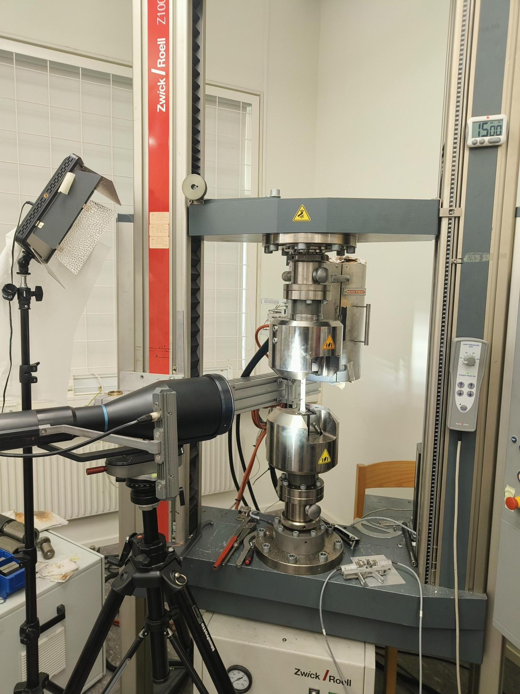  (a) | 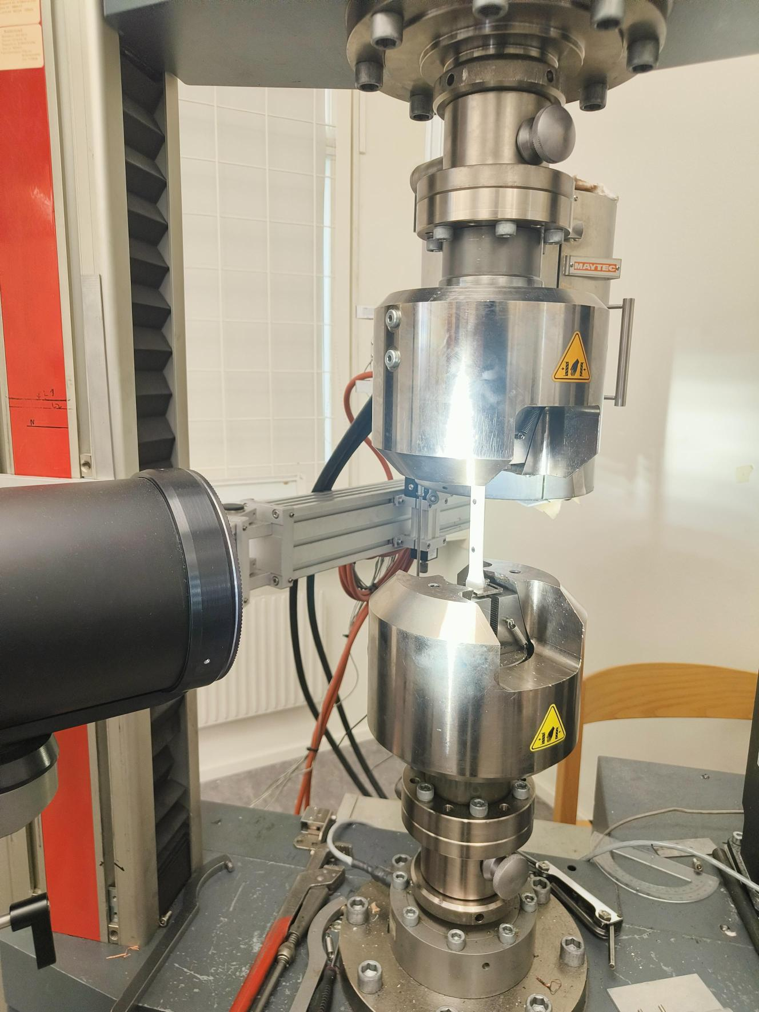  (b)
Figure 38 — The external laboratory's Zwick/Roell Z100 with the XT-205 video extensometer: (a) the machine and the extensometer camera; (b) the specimen in the grips with its two markers — the footage the post-processor later re-measured.
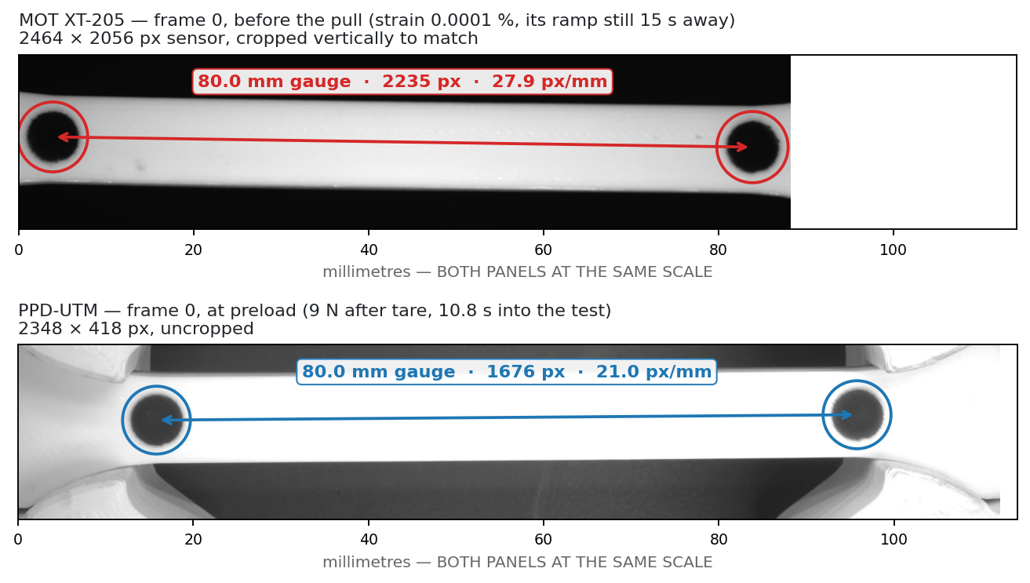
Figure 39 — The same-footage comparison: the XT-205's own strain record against the post-processor's measurement of the XT-205's video, with the tare frame aligned.

3.12 The evidence pipeline
The project's record is a 393-page weekly progress diary, built by a script from the figures, and a 24-page final presentation. The figures are produced by 38 analysis scripts that read the raw run CSVs and videos and write PNGs; 28 slide-block scripts place them (Figure 40). No figure is edited by hand and no number is transcribed: when a run is re-analysed, the figure and its slide change with it. A drift gate compares each rebuilt deck with a stored baseline so that an unintended change to a slide is caught before it is presented. This report's figures are the same files.
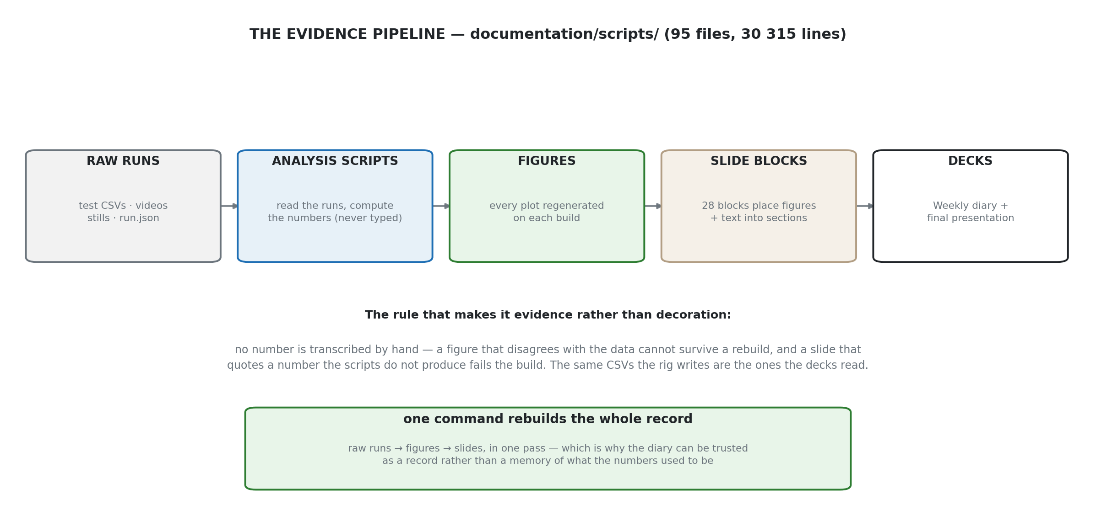
Figure 40 — The evidence pipeline's import graph: analysis scripts read the raw runs, figure scripts write PNGs, slide-block scripts place them, and the deck builders assemble the diary and the final presentation.
Chapter 4

4 Analysis
This chapter presents the results in the order of the validation logic: first the channel against a certified instrument, then the sources of the remaining differences, then the channel's noise, its predictability and the effect of gauge length, then what the channel measured about the materials, the closed-loop protocols, moisture and the project's carbon footprint. It ends with the answers to the three research questions.

4.1 The strain channel in operation
Figure 41 shows what the operator sees during a pull: the stress–strain curve forming in real time with strain from the camera and stress from the load cell. Figure 42 shows the quantity underneath it — the two marker blobs on the region of interest, the pixel grid of one marker's edge, and the pixel-to-strain rule applied to the centroids. Every run in this chapter was recorded this way, at ≈20 frames per second, and the strain record is the camera's, not the crosshead's.
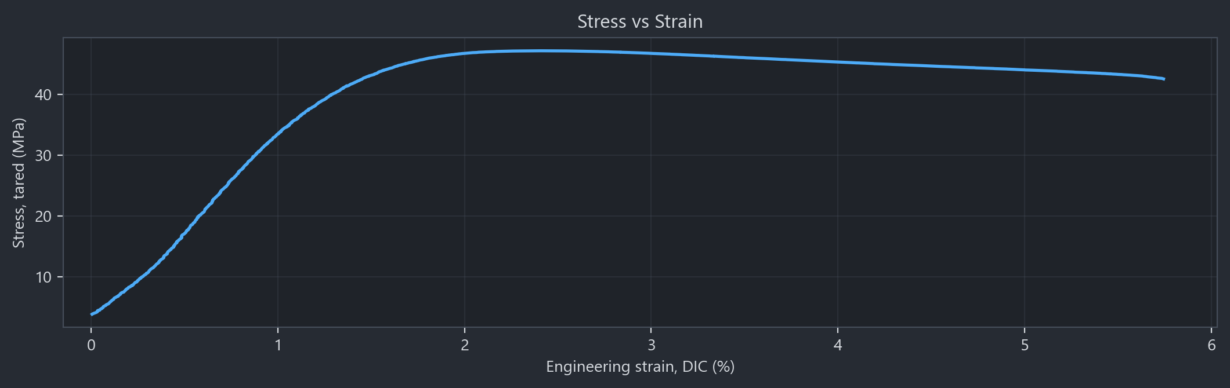
Figure 41 — The stress–strain curve as the application draws it during a PLA pull: strain from the camera, stress from the load cell, updated every frame.
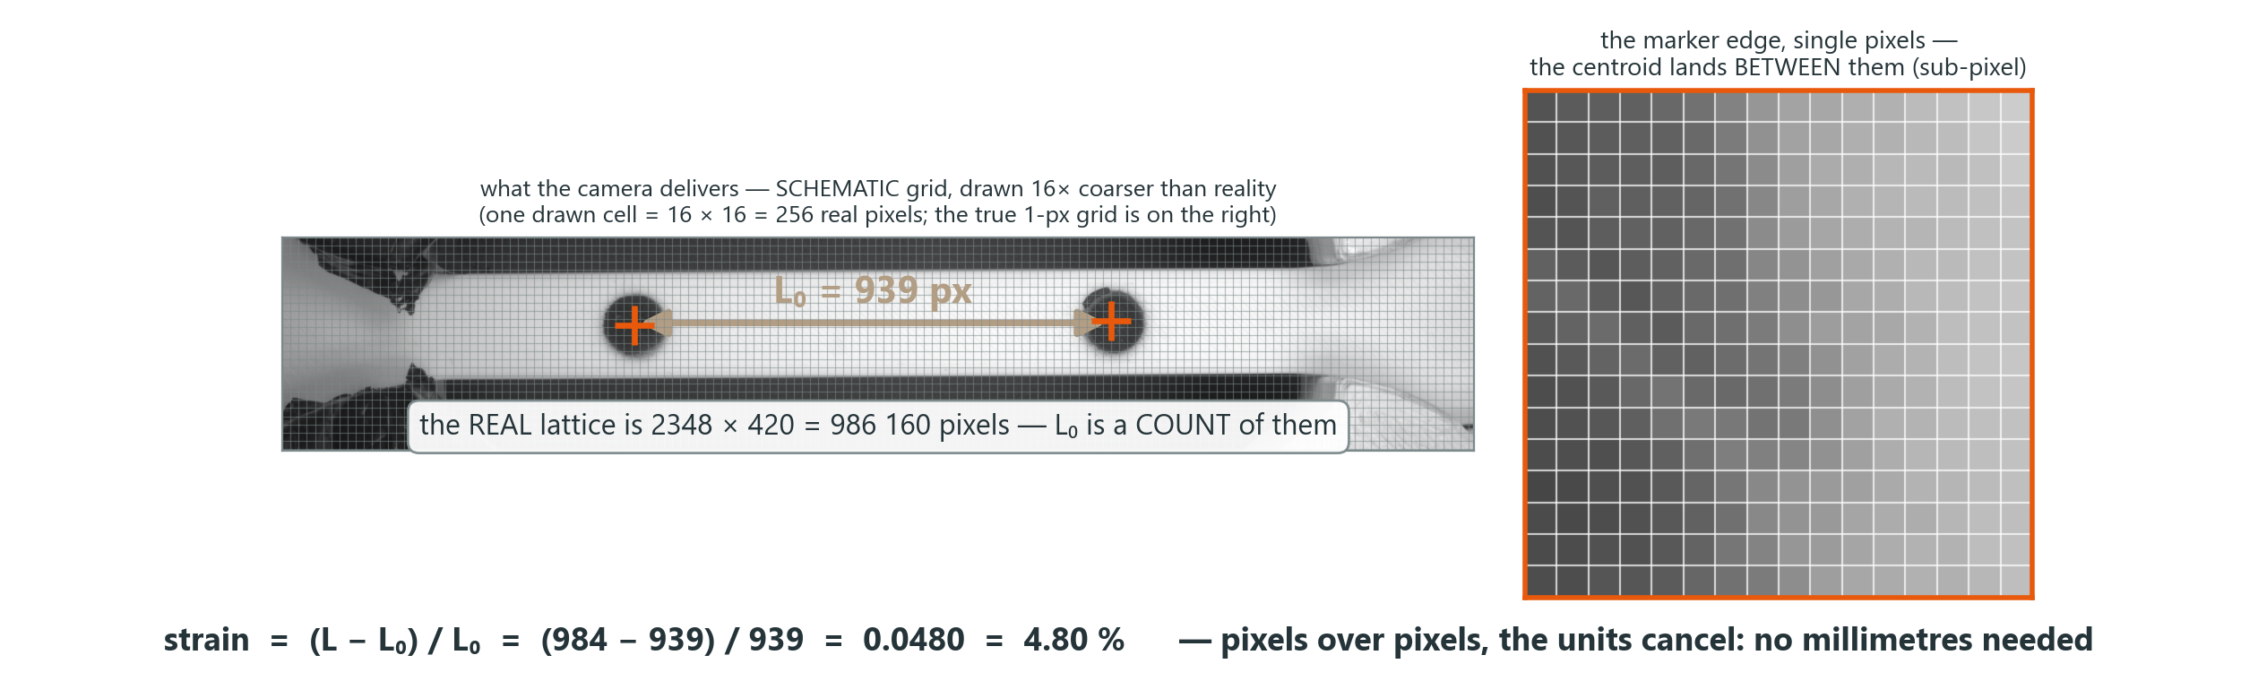
Figure 42 — The measurand at pixel level: the two marker blobs on the region of interest, the pixel grid of one marker's edge, and the pixel-to-strain rule applied to their centroids.

4.2 Validation against a certified video extensometer
The laboratory comparison was run as the two analyses defined in Section 3.11.3. Analysis 1 is instrument against instrument: the XT-205's certified strain on the laboratory's specimen against the rig's DIC on a matched specimen, with E, σy, UTS and εf each computed twice and independently. Analysis 2 is method against method on the same footage: the laboratory's own XT-205 video re-measured frame by frame by the rig's post-processor, so that the specimen, the machine and the pull drop out and only the two strain calculations remain. Analysis 1 says how close two machines land; Analysis 2 says whether the rig's software is a measurement.

4.2.1 Analysis 1 — two rigs, two specimens, one material (Test 2)
The decisive Analysis 1 comparison is the second laboratory session, with the 45 mm gauge. Specimen S34 was pulled on the PPD-UTM DIC rig and a specimen from the same batch (XT205-S2) on the Zwick/Roell Z100 with the XT-205 extensometer, at 2 mm/min with a 300 N preload. Table 14 compares the four headline properties and Figure 43 overlays the two curves on the same preload-frozen zero; Figure 44 adds the second 45 mm specimen S33.
Table 14 — Analysis 1, Test 2 (45 mm gauge): the rig against the laboratory on specimens from the same batch. Differences are laboratory relative to rig.
Property | PPD-UTM DIC (S34) | XT-205 (S2) | Difference
Ultimate tensile strength | 48.34 MPa | 44.62 MPa | −7.7 %
Yield strength (0.2 % offset) | 39.23 MPa | 39.61 MPa | +1.0 %
Elastic modulus | 3.45 GPa | 3.23 GPa | −6.4 %
Strain at fracture | 5.25 % | 5.21 % | −0.8 %

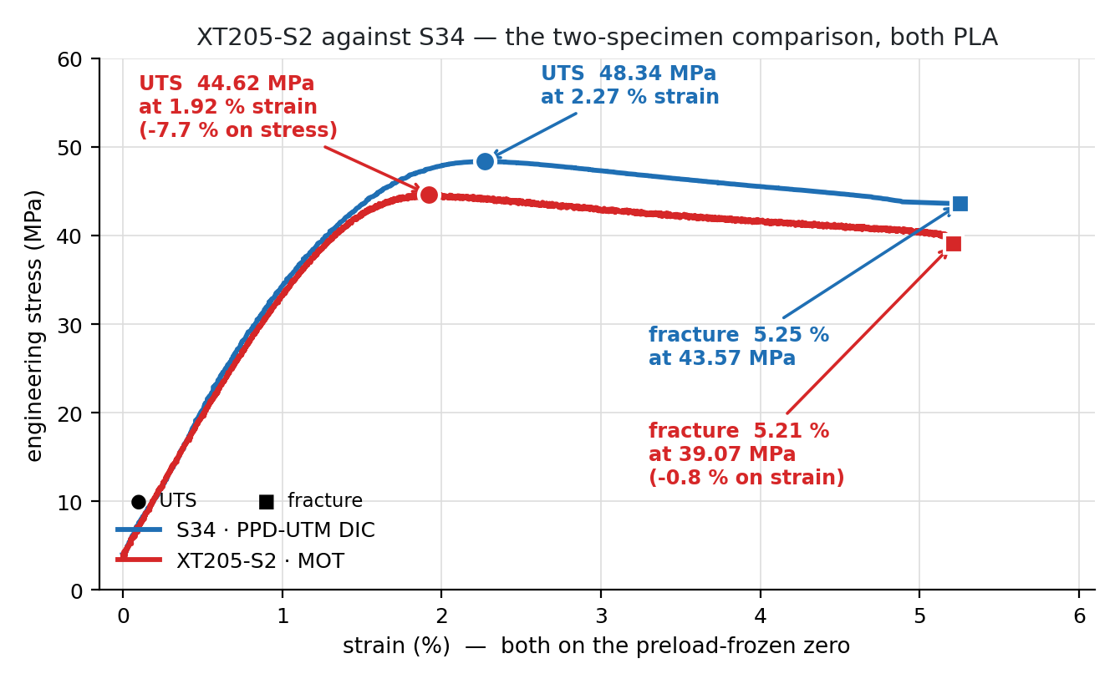
Figure 43 — Analysis 1: XT205-S2 on the laboratory machine against S34 on the rig, both PLA from the same batch, both on the preload-frozen zero. UTS 44.62 against 48.34 MPa (−7.7 %), fracture at 5.21 against 5.25 % strain (−0.8 %).
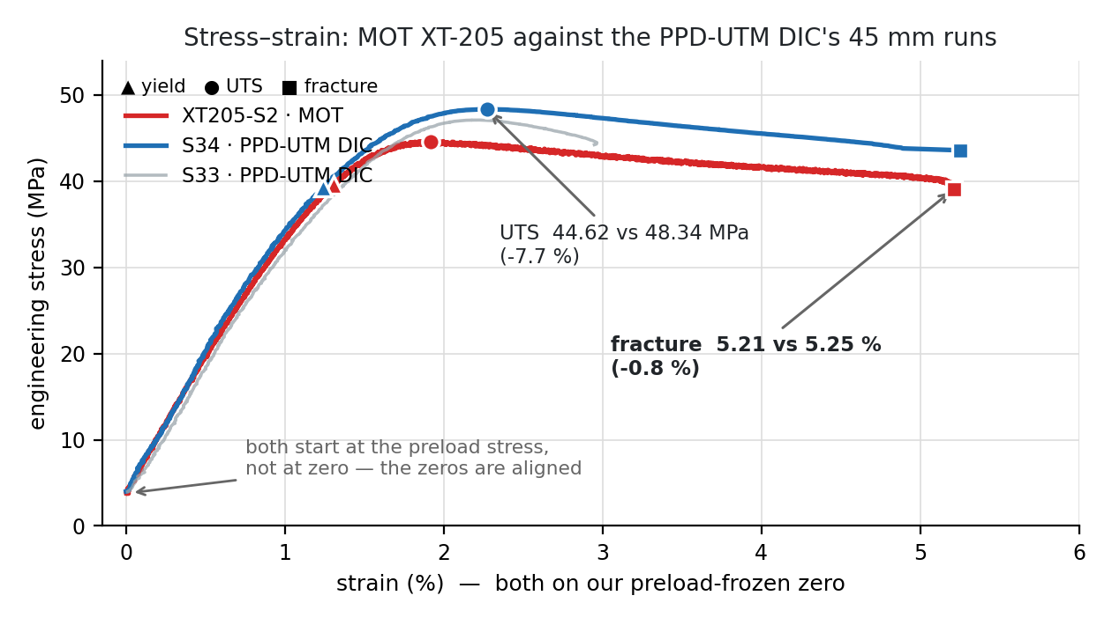
Figure 44 — Analysis 1 with both 45 mm rig specimens: S33 and S34 (DIC strain) and the laboratory's S2 (XT-205 strain) overlaid. Yield and fracture strain coincide; the UTS and the elastic slope differ by a few per cent.
Yield strength and fracture strain — the two properties that depend on the strain channel most directly — agree within one per cent, and the whole curve shape matches. The modulus and the UTS differ by six to eight per cent, and Section 4.3 takes those apart: they carry a pull-speed difference and ordinary specimen scatter. But Analysis 1 is still two machines on two specimens, so specimen scatter is inside the difference; Analysis 2 removes it.

4.2.2 Analysis 2 — same video, same specimen, two calculation methods
The laboratory provided the XT-205's video of its pull. The rig's post-processor measured that video — 3 153 frames from tare to fracture — with its own detection and its own pixel-to-strain rule, and the result was compared frame by frame with the XT-205's own strain record. Table 15 summarises the agreement; Figure 45 shows the whole pull with the per-frame difference beneath it, Figure 46 plots the two strains against each other for every frame, and Figure 47 shows the two records against time.
Table 15 — Analysis 2: the rig's algorithm on the XT-205's own frames against the XT-205's record.
Quantity | Value
Frames compared | 3 153
Fracture strain, XT-205 / post-processor | 5.21 % / 5.22 % (+0.08 %)
Scale factor (post-processor vs XT-205) | 0.99928
Coefficient of determination R² | 0.9999964
Constant offset | −55 µε = 0.069 px on a 1 255 px reference
Elastic slope, post-processor / XT-205 | 3.21–3.24 GPa / 3.23 GPa

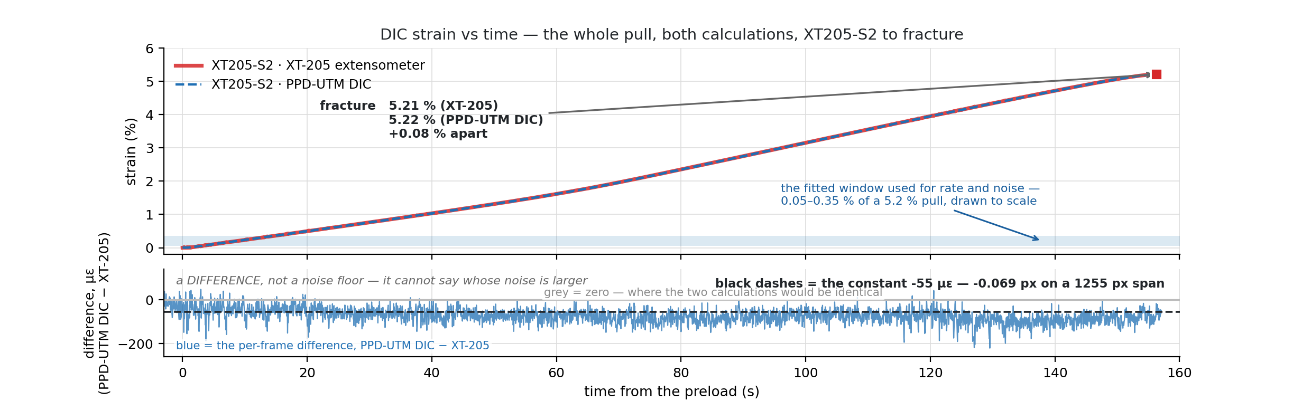
Figure 45 — Analysis 2, the whole pull: DIC strain against time from the XT-205 (red) and from the post-processor on the same frames (blue, dashed) to fracture at 5.21 and 5.22 %; below, the per-frame difference around its constant −55 µε (−0.069 px on a 1 255 px span). The shaded band is the window used for rate and noise.
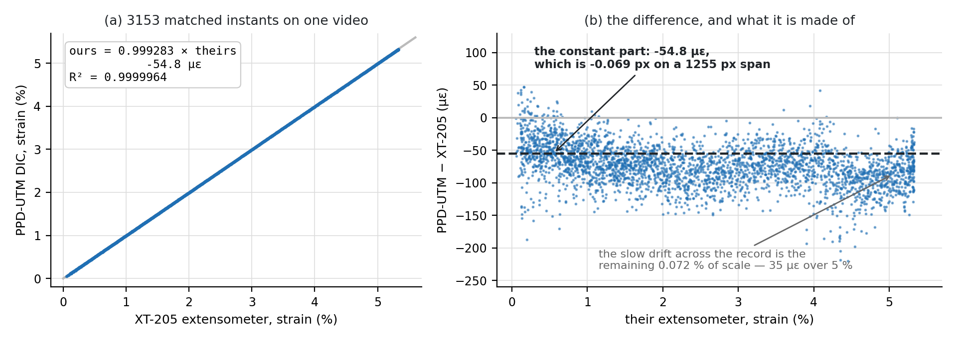
Figure 46 — Analysis 2: post-processor strain against XT-205 strain for every one of the 3 153 frames: a line of slope 0.99928 with R² = 0.9999964 and an offset of −55 µε.
The two calculations agree in scale to 0.07 % and in fracture strain to 0.08 %. The residual is a constant offset of −55 µε, which on a 1 255-pixel reference span is 0.069 of a pixel — the difference between two sub-pixel centroid conventions on the tare frame, not a measurement disagreement, and it vanishes from every slope. When the modulus is fitted to the post-processed strain it lands at 3.21 GPa with the fixed window and 3.24 GPa with the steepest run, against the laboratory machine's 3.23: the slope agrees, not only the endpoints. This is the central result of the project: given the same frames, the rig's software measures what a certified extensometer measures.
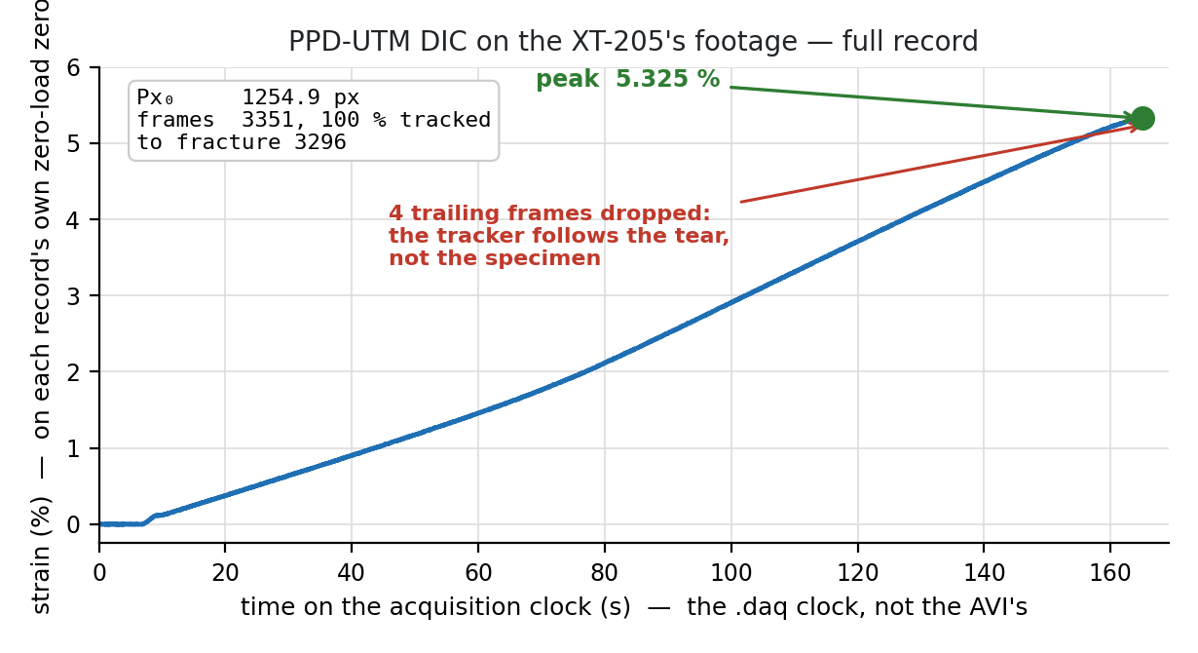
Figure 47 — Analysis 2: strain against time for the laboratory's pull, measured by the post-processor from the XT-205 video; the XT-205's own record lies on top of it to the width of the line.

4.2.3 Test 1 — the 80 mm gauge, and why Test 2 became necessary
The first laboratory session used the rig's standard 80 mm gauge, and it produced only a partial record. The XT-205 stands closer to the specimen than the rig's camera — 27.9 px/mm against 20.9 — and sees a field of 88 mm. With the markers 80 mm apart, a marker reaches the edge of the XT-205's field after only about 0.7 % strain (Figure 8), so the extensometer's strain record stops in the first seconds of the pull, before yield. Test 1 therefore yielded a noise and rate comparison over the elastic region rather than a full curve, and the second session was run with the 45 mm gauge, which keeps both markers in the XT-205's field to fracture. That is also why the rig's 45 mm specimens S33 and S34 exist, and why Section 4.5 checks that the shorter gauge does not change the properties.
What Test 1 did measure is valuable in its own right: the noise floors and the strain rates of the two channels over the same elastic window, given in Table 16 and Figure 48.
Table 16 — Test 1 (80 mm gauge, elastic window only): noise and rate of the two strain channels.
Quantity | PPD-UTM DIC | XT-205
Strain noise, RMS (two runs) | 23.5 / 23.6 µε | 44.9 µε
Median absolute residual | 12 µε | 13 / 17 µε
95th-percentile residual | 116 µε | 45 µε
Strain rate during the pull | 7.42 × 10⁻⁴ /s | 2.67 / 4.06 × 10⁻⁴ /s
Rig runs agreeing with each other | 0.4 % | —

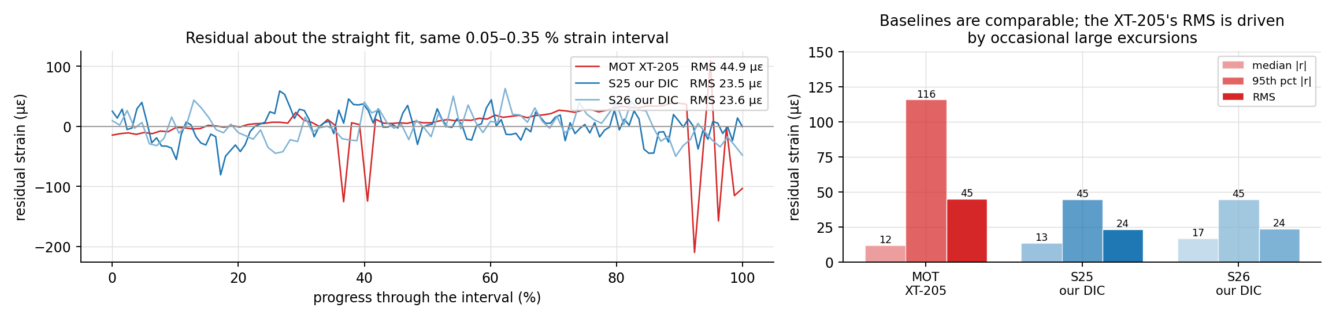
Figure 48 — Test 1 noise comparison: the rig's DIC residuals (RMS 23.5 µε) against the XT-205's (44.9 µε). The rig is quieter at the centre and has a longer tail.
The rig's channel is quieter than the laboratory's in RMS and in the median, and noisier in the tail: its 95th-percentile residual is twice the XT-205's. The tail is the occasional frame where the threshold catches an edge pixel; it is the reason the fixed threshold replaced Otsu (Section 4.7). The rate row is the explanation for the UTS gap, treated next.

4.2.4 How far two specimens can be trusted
The whole external validation rests on one laboratory session and n = 2 specimens pulled against the XT-205. That is too small a sample to trust the agreement to the precision the percentages suggest. With two specimens there is no distribution to speak of: a single unlucky print, a single grip that seated differently, or one specimen drawn from the tail of the batch would move the −7.7 % UTS difference or the −6.4 % modulus difference by more than the effects Section 4.3 attributes them to, and nothing in the data would separate the two explanations. Two specimens can show that a difference is small; they cannot establish how small, and they cannot bound how often it is small.
Two things keep the conclusion standing in spite of that. Analysis 2 does not depend on the sample size at all — it is the same video of the same pull measured two ways, so specimen scatter is removed by construction, and the scale factor of 0.99928 with R² = 0.9999964 is a statement about the two calculation methods rather than about two specimens. And the rig-side repeatability is separately characterised over many more runs (Section 4.6). What is missing is the third leg: repetition of the two-machine comparison itself.
More validation at the laboratory is therefore needed, and it is the first thing this work asks of whoever continues it. A defensible campaign would take five to ten specimens from the same print batch through the XT-205 and the rig under one agreed pull rate and gauge length, so that the difference in each property could be reported as a mean with a confidence interval instead of a single number, and so that the rate and seating effects of Section 4.3 could be estimated from the data rather than argued from two curves. Repeating it on a second material would show whether the agreement is a property of the channel or of PLA. Until that exists, the honest reading of Section 4.2 is that the strain channel agreed with a certified instrument on the specimens tested, not that its agreement is established to a stated tolerance.

4.3 Where the remaining differences come from
The two properties that disagreed by more than a per cent in Table 14 — UTS at −7.7 % and modulus at −6.4 % — were each traced to causes that are not the strain measurement.

4.3.1 Pull rate
The rig pulled at 2.21 times the laboratory's strain rate (7.42 against 2.67–4.06 × 10⁻⁴ /s in Test 1; Figure 49). The speed the operator enters is the crosshead's, in mm/s — 0.1 mm/s on the rig against 2 mm/min in the laboratory — and it is open-loop with respect to the specimen: nothing tracks whether the gauge is stretching at that rate. Polymers are strain-rate sensitive: a faster pull gives a higher apparent strength and a slightly higher modulus, because the chains have less time to relax. The rate effect moves the slope more than the UTS, and on its own predicts under 1 % of the stress gap; the open item on the roadmap — one pull at the laboratory's 2 mm/min — is the direct test.
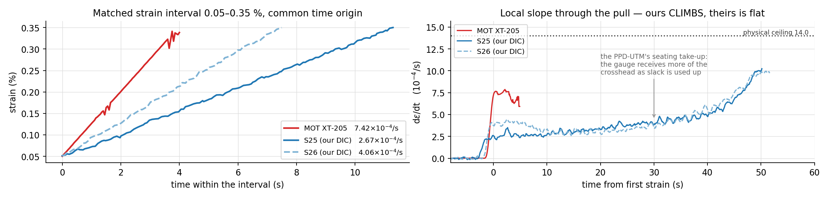
Figure 49 — Strain rate against time for Test 1: the rig's crosshead schedule gives 2.21× the laboratory's rate at the gauge.

4.3.2 Grip seating and machine compliance
The DIC channel makes it possible to measure how much of the crosshead's motion reaches the gauge: on the rig, 19–29 % during the elastic region (Figure 50), the rest being the printed grips seating and the load train stretching. About half of the early crosshead travel, under 1 % strain, is eaten by slack in the grips before the gauge feels anything, and the four rig runs cluster at 21 % of travel reaching the gauge — a joint that either seats or does not. This has no effect on a DIC-measured modulus — that is the point of the channel — but it bends the toe of the curve, delays the moment at which the specimen is fully loaded, and the laboratory's grips seat differently from the rig's printed ones.
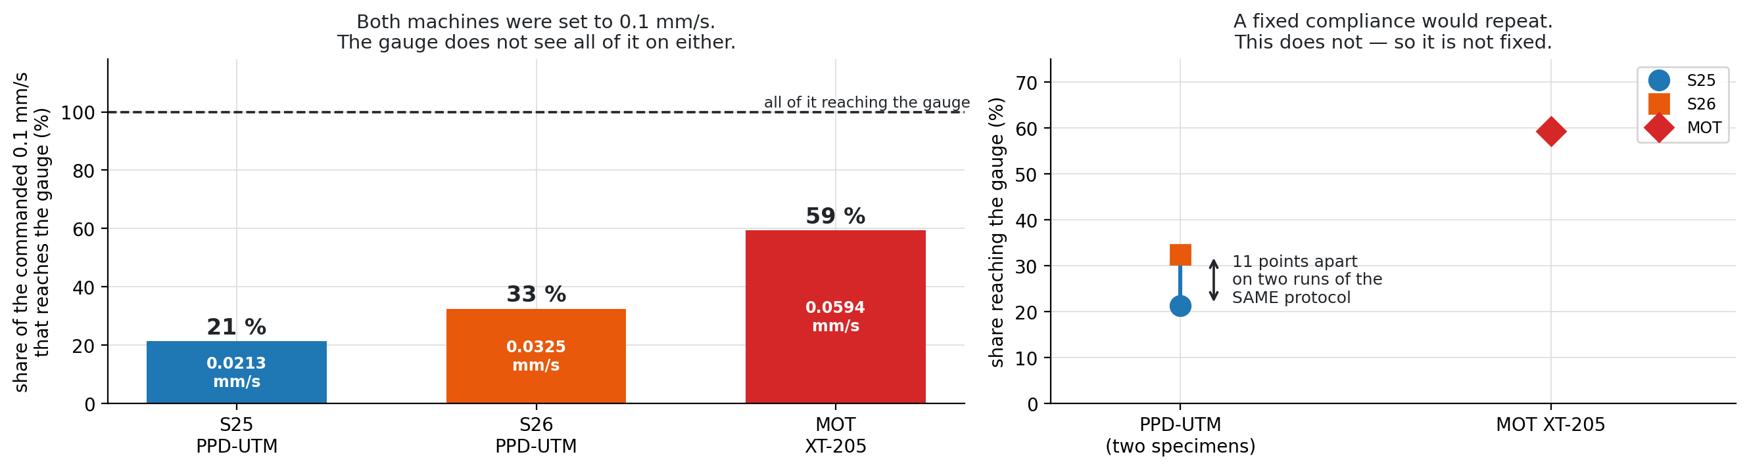
Figure 50 — Share of crosshead motion that reaches the gauge, measured by DIC: 19–29 % in the elastic region. A crosshead-based strain would be too large by a factor of three to five.

4.3.3 Specimen and batch
The two specimens of Analysis 1 were printed from the same spool but were different objects, printed at different times. How much that alone is worth can be read from the rig's own PLA record, where the same material was pulled as a pilot and then as a batch printed eight days later, and again two months later. Table 17 gives the individual specimens and Table 18 the offsets.
Table 17 — The 100 % PLA specimens from one spool: the pilot, the batch printed eight days later, and the August series. Modulus values follow the analysis convention of Section 3.9.
Specimen | Printed / pulled | UTS (MPa) | E (GPa) | σy (MPa) | εf (%)
S7 (pilot) | June, day 0 | 47.82 | 3.003 | 45.42 | 2.98
S8 | June, day 8 | 44.83 | 2.686 | 42.99 | 5.17
S9 | June, day 8 | 45.47 | 3.075 | 42.30 | 7.44
S10 | June, day 8 | 46.82 | 2.896 | 44.39 | 7.32
S11 | June, day 8 | 46.10 | 2.886 | 43.72 | 5.00
Batch mean S8–S11 |  | 45.81 | 2.886 | 43.35 | 6.23
Batch CV S8–S11 |  | 1.9 % | 2.1 % | 1.8 % | 21 %
S12, S13, S24–S26 mean | August (≈2 months) | 46.78 | 3.207 | 41.02 | 5.67

Table 18 — Offsets between batches and within batches, against the Analysis 1 gap.
Comparison | UTS | E | σy | εf
Batch (day 8) vs pilot (day 0) | −4.2 % | −3.9 % | −4.6 % | +109 % (1.7–2.5×)
Within the day-8 batch (CV, n = 4) | 1.9 % | 2.1 % | 1.8 % | 21 %
Same-day pair S25 / S26 | 2.2 % | 11.4 % | 4.7 % | 31.6 %
August series vs pilot | −2.2 % | +6.8 % | −9.7 % | +90 %
Analysis 1: laboratory vs rig | −7.7 % | −6.4 % | +1.0 % | −0.8 %

Three things follow. Within one batch, strength repeats to about 2 % and modulus to about 2 % — that floor is ordinary print scatter, not moisture. Between the pilot and the batch printed eight days later off the same spool the strength fell 4.2 %, the modulus 3.9 %, and the fracture strain doubled — both arrows in the direction the moisture literature predicts (Section 4.11). And the Analysis 1 gap of −7.7 % in UTS is therefore about half explained by a batch offset of the size the rig has already seen on its own, with pull rate and grip seating supplying the rest; the strain channel is ruled out by Analysis 2. The modulus gap has the same structure plus the window sensitivity of Section 2.5: on the same frames the two fits agree, as Figure 51 shows.
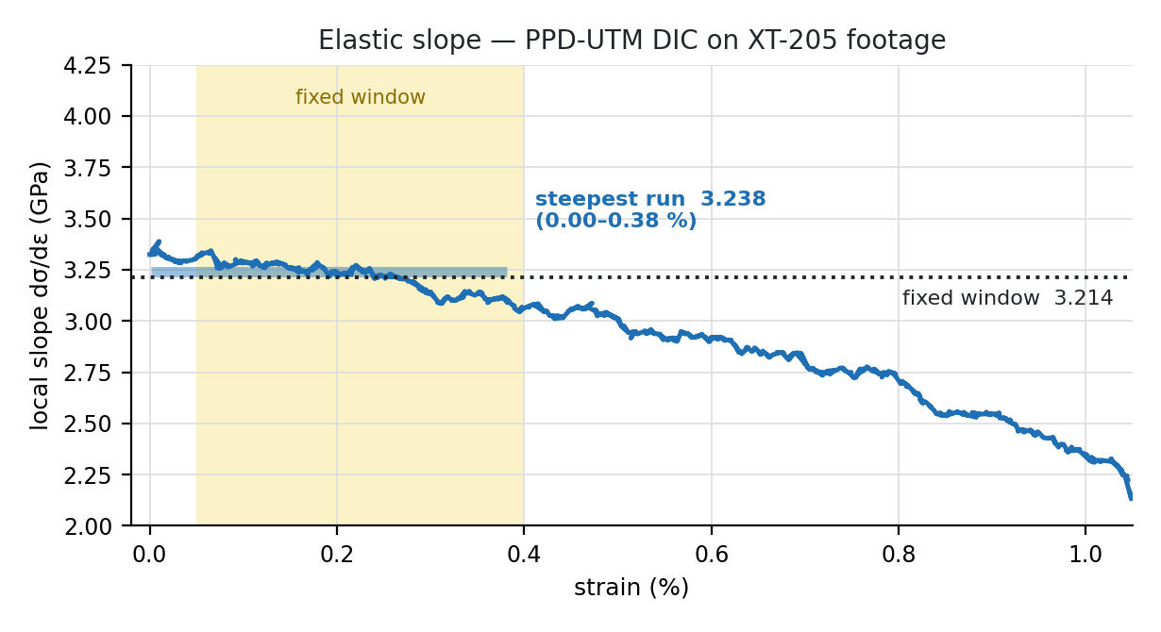
Figure 51 — Elastic-slope fit on the post-processed strain from the laboratory's frames: 3.21–3.24 GPa depending on the window, bracketing the laboratory's 3.23.

4.4 Noise floor and measurement uncertainty
The noise floor was measured with the crosshead stopped and the specimen at preload (Figure 52). Over a 10 s window the standard deviation of the DIC strain is 11.9 µε on the black specimen S13 and 13.3–15.4 µε on the white S25 and S26; over a 900 s window it is 26 µε, because slow drift enters. All are below the 44.9 µε of the reference instrument in Test 1. The RMS moves with the window length, so specimens are always compared over the same window.
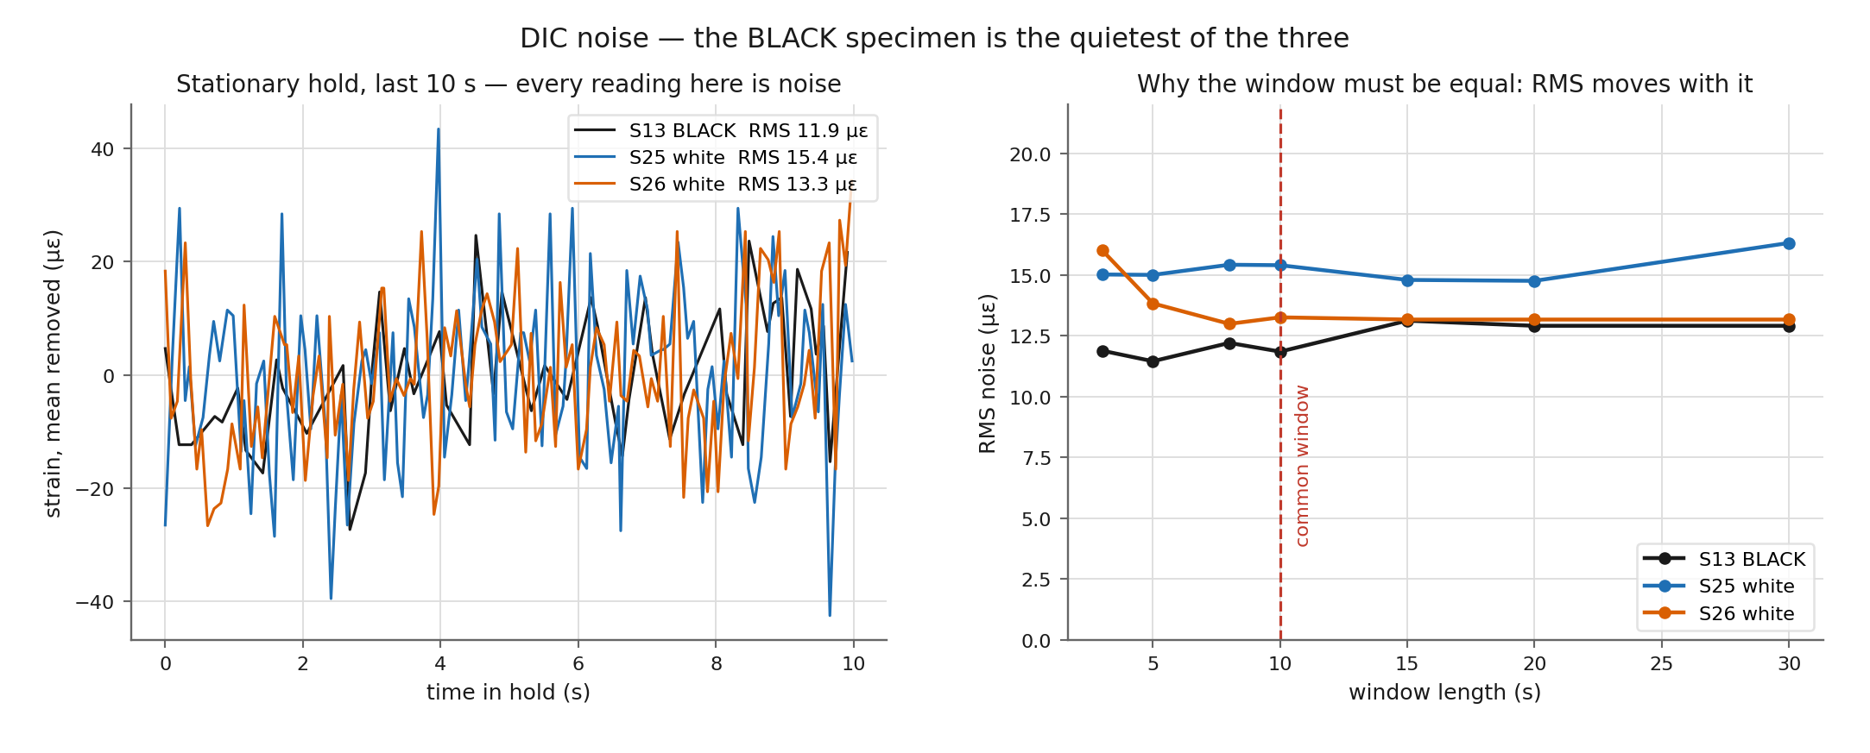
Figure 52 — The noise floor on three specimens over the last 10 s of a stationary hold: S13 (black) 11.9 µε, S25 and S26 (white) 15.4 and 13.3 µε — and the RMS against window length, which is why windows must be equal.
Equation 2.5 predicts that the noise scales as 1/Px₀. This was tested by comparing the 80 mm gauge (1 675 px at 20.9 px/mm) with the 45 mm gauge (939 px), the two geometries of Figure 53: the prediction for the noise ratio was 1.78, and the measured ratio was 1.78. The channel's noise is therefore centroid noise, and it can be lowered by putting more pixels across the gauge — a longer gauge, a tighter framing or a higher-resolution sensor — without any change to the software.
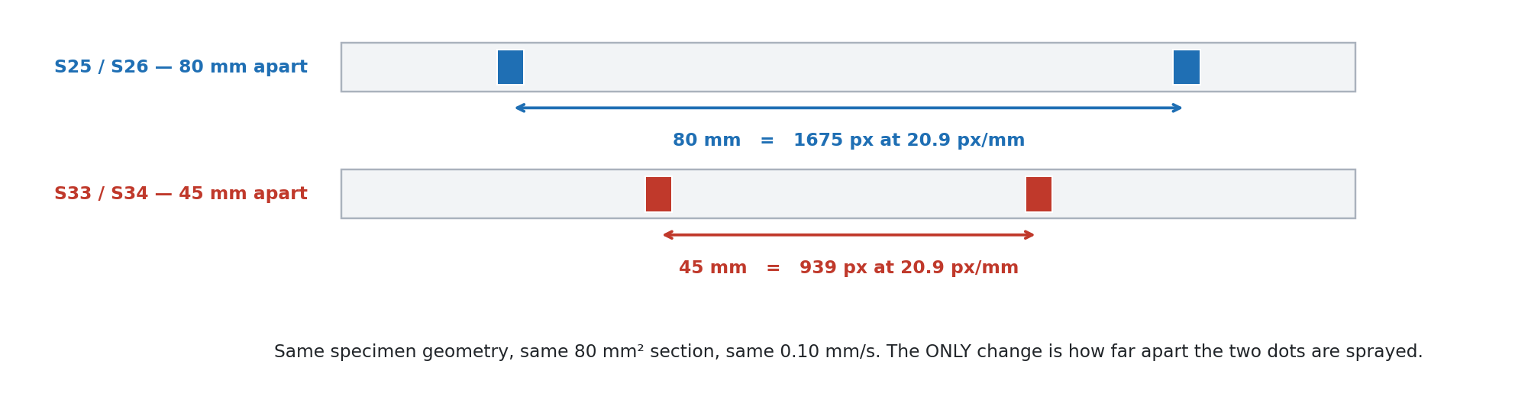
Figure 53 — The 1/Px₀ test: the same specimen geometry, section and pull rate, with the dots sprayed 80 mm apart (1 675 px) or 45 mm apart (939 px). The predicted noise ratio is 1.78; the measured ratio was 1.78.
Marker colour matters at the margin. On a black specimen with white markers the floor was 11.9 µε; on the white specimens with black markers, 13.3–15.4 µε. The difference is the grey-level margin: with gamma 0.5 lifting the dark tones, the white-on-black case has a slightly cleaner edge. Both are far below the specimen-to-specimen scatter in any property, so the practical uncertainty of a modulus on this rig is set by the specimen and the fit window, not by the camera; Figure 54 traces how the strain noise propagates into a fitted modulus.
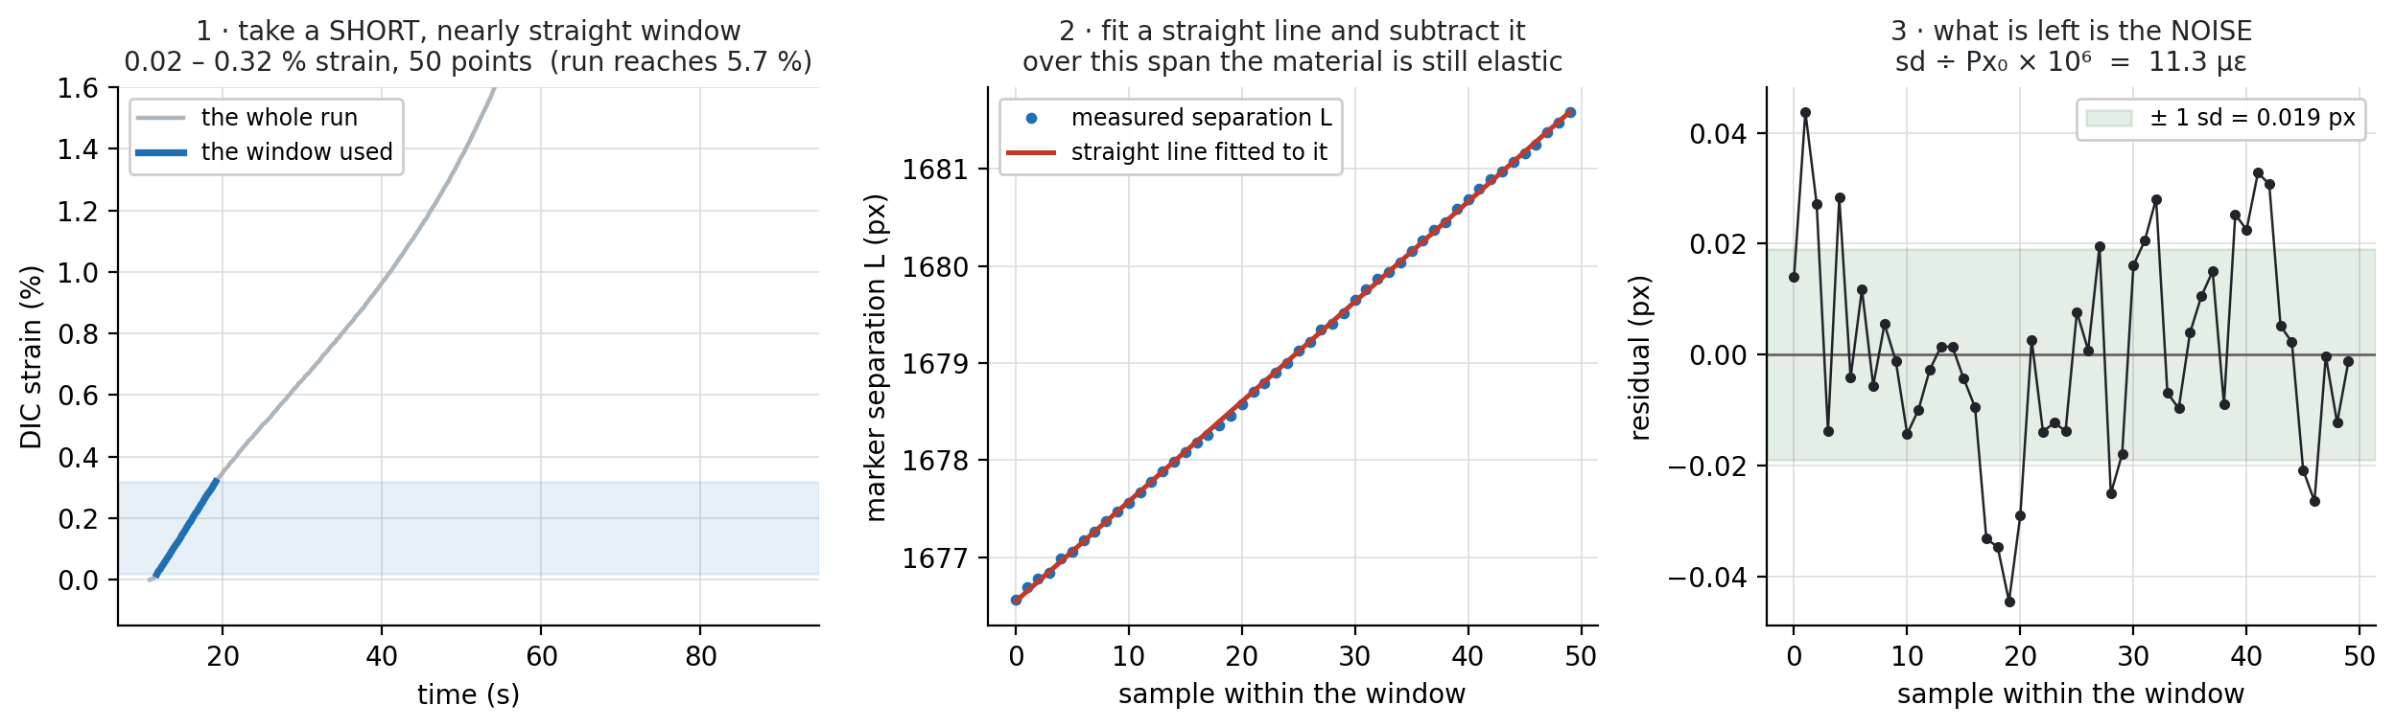
Figure 54 — How the uncertainty of a fitted modulus is estimated from the strain noise and the fit window: at the measured floor, noise contributes well under one per cent, and the window choice dominates.

4.5 Gauge length: 80 mm against 45 mm
The 45 mm gauge was introduced for the laboratory comparison (Section 4.2.3) and for TPU. It roughly halves the pixel span (939 against 1 675 px at the same framing), so by Equation 2.5 it nearly doubles the noise, and it moves the markers closer to the shoulders. Before the 45 mm results are used for anything, the question is whether the shorter marker spacing changes the properties. Table 19 answers it with the two matched pairs — S25 and S26 at 80 mm, S33 and S34 at 45 mm, same specimen geometry, same 80 mm² section, same 0.10 mm/s pull — and Figure 55 and Figure 56 show the pairs to fracture and the strain difference at matched stress.
Table 19 — The 80 mm and 45 mm pairs: the between-gauge offset of every property is no larger than the spread between two specimens of the same gauge. Pair values are given as specimen / specimen → mean.
Quantity | 80 mm (S25, S26) | 45 mm (S33, S34) | 45 vs 80 mm | Within-pair spread
UTS (MPa) | 46.16 / 47.17 → 46.67 | 47.09 / 48.34 → 47.72 | +2.2 % | 2.2 % / 2.6 %
E (GPa) | 3.167 / 3.549 → 3.358 | 3.174 / 3.451 → 3.313 | −1.3 % | 11.4 % / 8.4 %
σy (MPa) | 39.82 / 41.75 → 40.79 | 39.43 / 39.31 → 39.37 | −3.5 % | 4.7 % / 0.3 %
εf (%) | 4.18 / 5.74 → 4.96 | 2.95 / 5.25 → 4.10 | −17 % | 31.6 % / 56 %
Noise floor (µε) | ≈12 | ≈21 | 1.78× | as predicted by 1/Px₀
Pixel span (px) | 1 675 | 939 | 0.56× | —

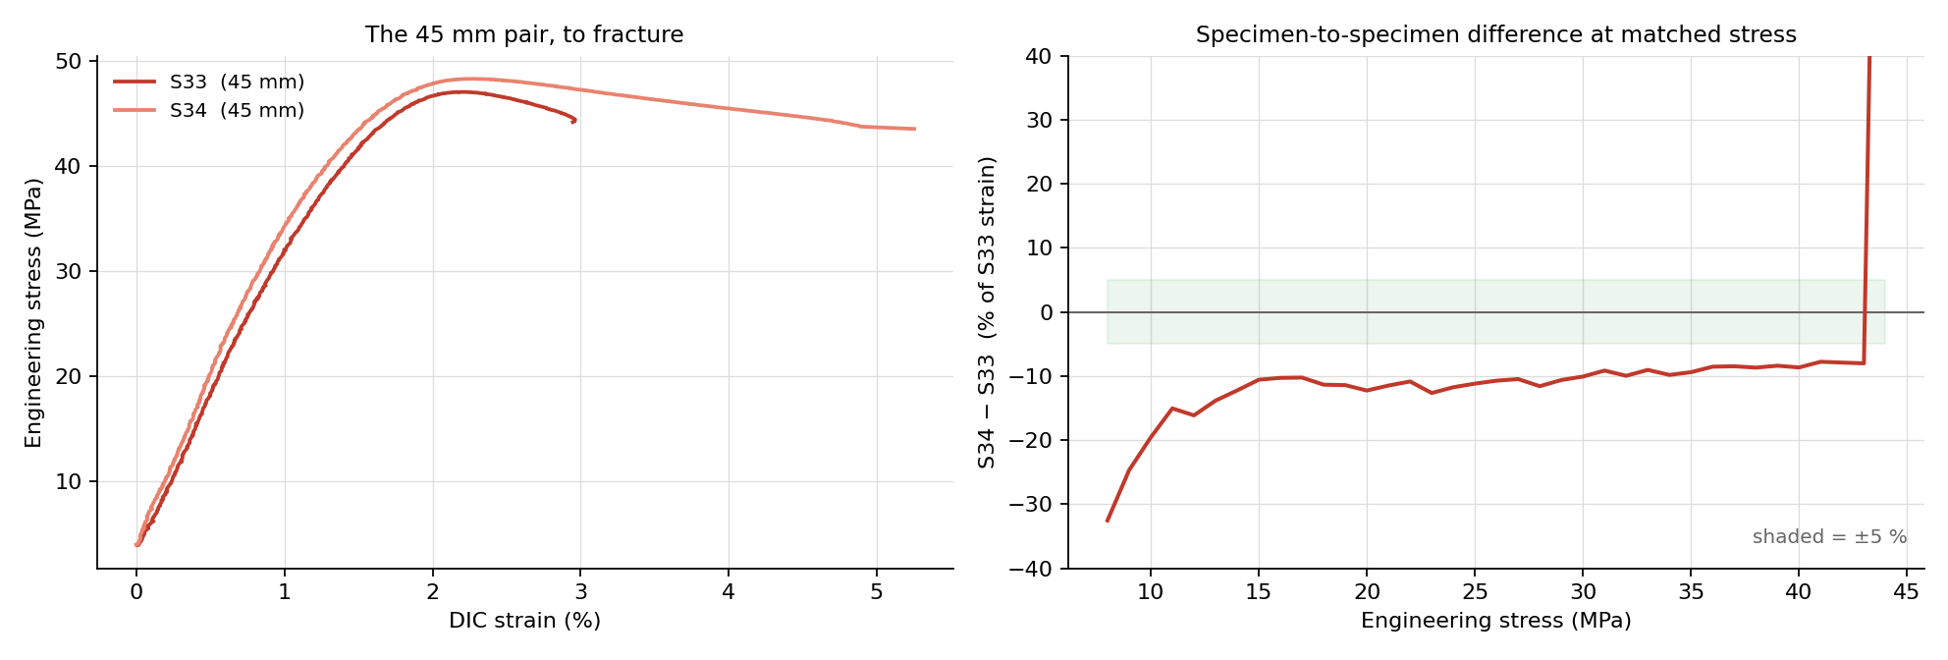
Figure 55 — The 45 mm pair S33 and S34 to fracture, and their strain difference at matched stress: specimen scatter, not gauge, is the larger term.
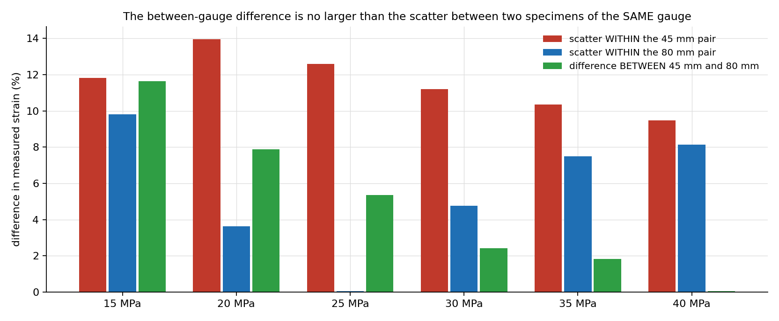
Figure 56 — The between-gauge difference in measured strain at matched stress is no larger than the scatter between two specimens of the same gauge.
Strength moves by 2 %, modulus by 1 %, yield by 3.5 % — each inside the spread of the same-gauge pairs — and only the fracture strain, which is set by the specimen's largest defect, differs more, as it does between any two specimens. The noise rises by exactly the predicted factor. The gauge length therefore influences the values only to a very small extent: either gauge can be used, and the choice is a trade of noise against travel room — 80 mm for the lowest noise, 45 mm when the markers must stay in a smaller field of view or a large strain must fit in the frame — not a source of bias.

4.6 Repeatability and DIC coverage
Two PLA specimens from the same batch, S25 and S26, pulled on consecutive runs with the same settings, give a direct repeatability check; Table 20 lists them with the other 100 % VC-series specimens and Figure 57 overlays the pair.
Table 20 — The 100 % PLA VC-series specimens: UTS repeats to a few per cent, fracture strain does not, which is the material rather than the channel.
Specimen | UTS (MPa) | E (GPa) | σy (MPa) | εf (%)
S25 | 46.16 | 3.167 | 39.82 | 4.18
S26 | 47.17 | 3.549 | 41.75 | 5.74
S12 | 47.78 | 3.286 | 41.99 | 5.82
S13 | 46.33 | 3.030 | 42.07 | 5.15
S24 | 46.47 | 3.004 | 39.46 | 7.44

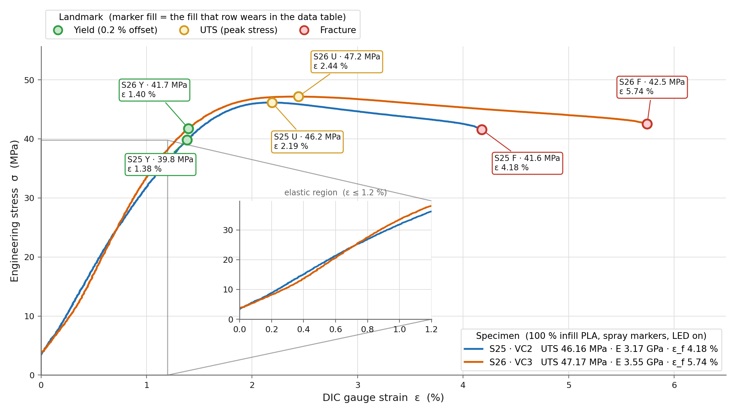
Figure 57 — S25 and S26 overlaid: the curves coincide to yield and diverge only in the post-yield region, where fracture is set by the specimen's largest defect.
Ultimate strength repeats to 2 %, yield to 5 %; the modulus spread of 12 % between S25 and S26 is the window sensitivity of a polymer without a sharp linear region. Across the six PLA runs the run-to-run scatter of the modulus is 16.0 % with a fixed 0.05–0.40 % window and 9.6 % with the steepest-straight-run rule, which is why that rule was adopted (Section 3.9). Fracture strain varies from 4 % to 7 % across the five specimens: fracture is nucleated by the largest print defect, and that is a property of the specimen. The fracture survey of Section 4.9 makes the same point from the other side.
DIC coverage — the share of the run's frames on which both markers were found — was 27 % on S24 and 47 % on S13 in the early VC-series (Figure 58), and rose to effectively 100 % once the fixed threshold replaced Otsu and the enclosure was in place. Coverage is reported in the HUD and stored with the run; a run with low coverage is not used for a fracture strain.
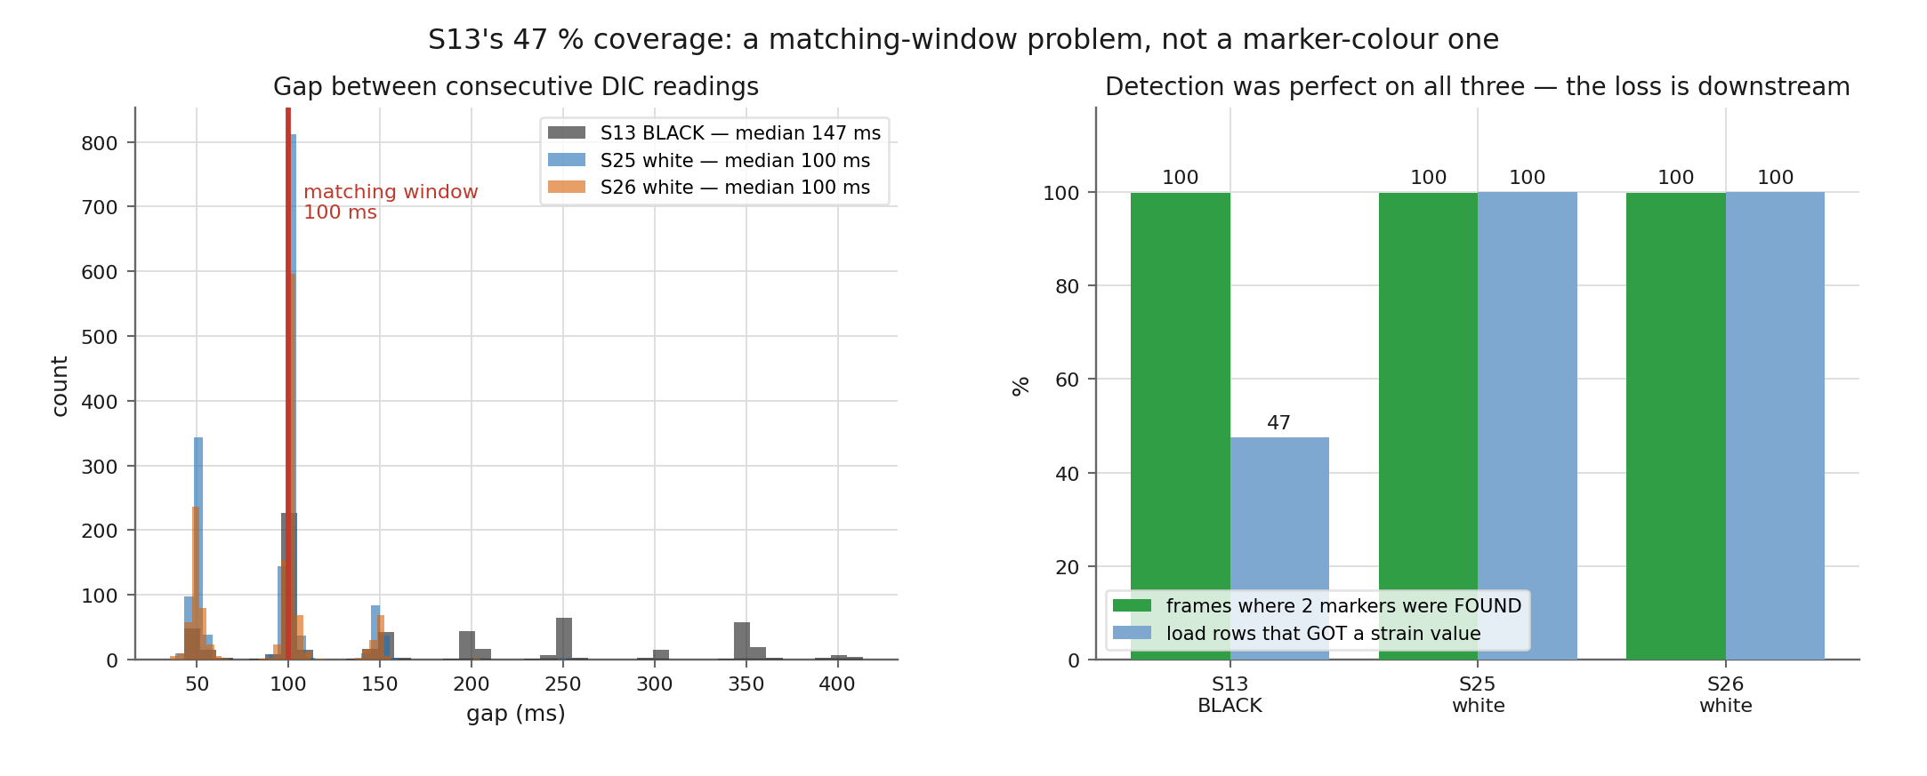
Figure 58 — DIC coverage on specimen S13: the frames on which both markers were detected, against time. Gaps are frames the threshold lost; the strain record is not interpolated across them.

4.7 Otsu against a fixed threshold
The Otsu failure mode of Section 2.5 was measured on the rig's own recordings. The markers are a tiny class: painting them out of the frame moves Otsu's threshold by at most three grey levels on four specimens, against margins of 46–99 levels on either side of it (Figure 61). Otsu's cut is therefore set by the specimen body and the background, not by the markers it is supposed to find. On the black PLA specimen S13 it lands at 131 (Figure 59), where the bright grips bloom into the foreground along with the markers (Figure 60); the rig's fixed 149 sits in the histogram valley and the grips pull back. On white PLA Otsu (158) and the preset (150) are both in the valley and behave alike. On the translucent PETG specimen S29 the difference is decisive: Otsu found both markers on 48.5 % of the frames, the fixed threshold on 99.5 %; on S13 the two were equal at 99.8 %.
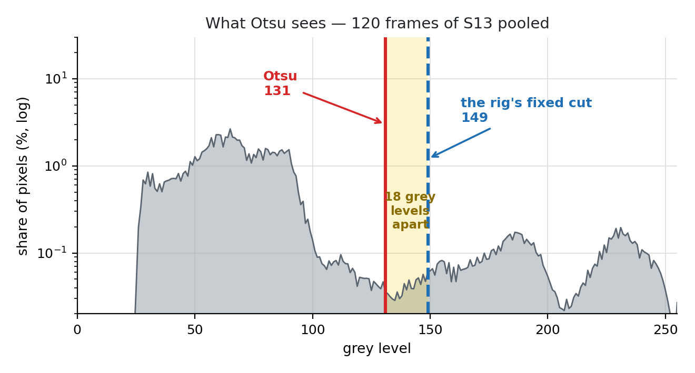
Figure 59 — What Otsu sees: the grey-level histogram pooled over 120 frames of S13, with Otsu's 131 on the shoulder of the specimen peak and the rig's fixed 149 in the valley.
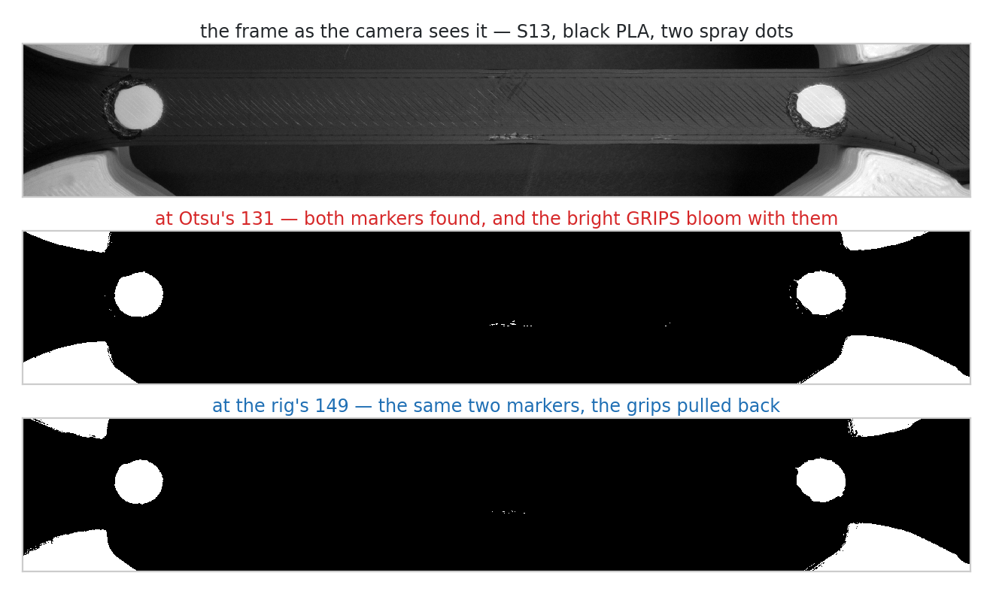
Figure 60 — The same S13 frame thresholded at Otsu's 131 and at the rig's 149: both find the two markers, but at 131 the bright grips bloom into the foreground.
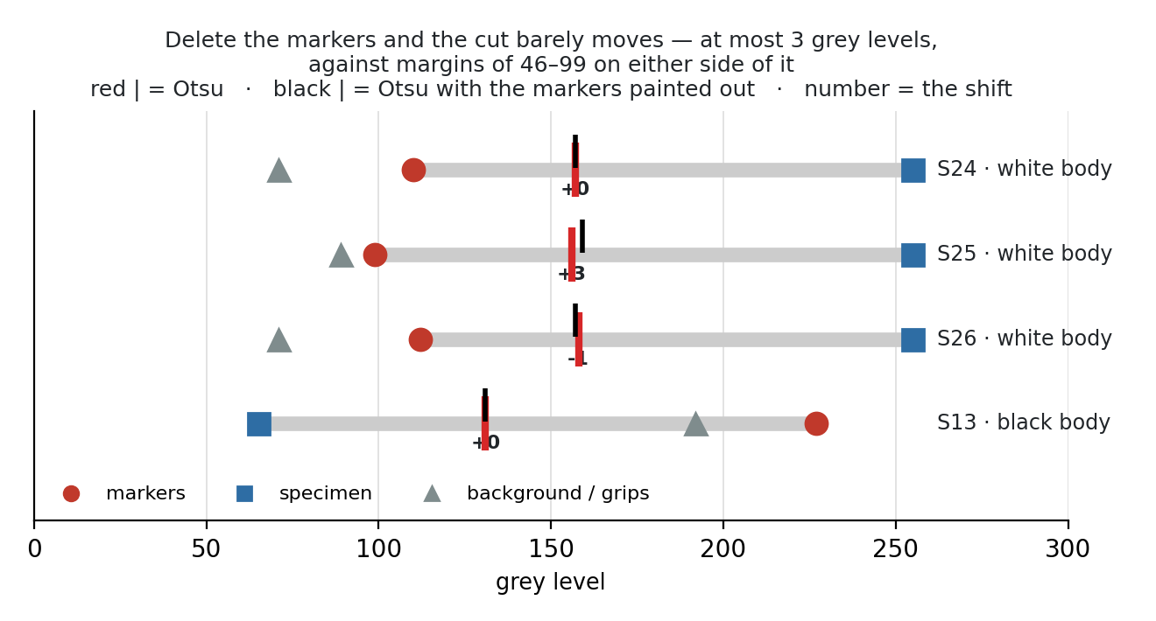
Figure 61 — Otsu is set by the body, not the markers: painting the markers out moves the cut by 0–3 grey levels on S24, S25, S26 and S13, against margins of 46–99 levels to the nearest class on either side.
The consequence for practice is the material preset: the threshold is set once per material and polarity from the histogram valley, stored as a recipe (SF3), and Otsu is retained only as a starting point for a new material. The auto-calibration sweep (SF12) scores candidate thresholds by marker count and centroid stability and lands on the valley without the operator reading a histogram.

4.8 Three polymers against their published bands
The strongest test that the rig measures the material and not itself is to pull materials of very different character and check that each lands in its own published band, in the expected order. PLA, PETG and TPU do: Table 21 gives one representative specimen of each against the bands of Table 3, Figure 62 overlays the three curves and Figure 63 places the moduli in their bands.
Table 21 — One representative specimen of each polymer against the published bands. TPU was not pulled to fracture: the 45 mm gauge reached the 30 mm travel backstop at 18.9 % strain.
Material (specimen) | UTS (MPa) | E (GPa) | εf (%) | Published band
PLA (S25) | 46.16 | 3.17 | 4.13 | UTS 32–60 · E 2.0–3.5 · εf 2–8
PETG (S30) | 41.75 | 1.81 | 7.81 | UTS 30–50 · E 1.5–2.1 · εf 5–25
TPU (S37) | 2.60 (at 18.9 %, unbroken) | 0.024 | > 18.9 | UTS 25–40 · E 0.012–0.030 · εf 400–700

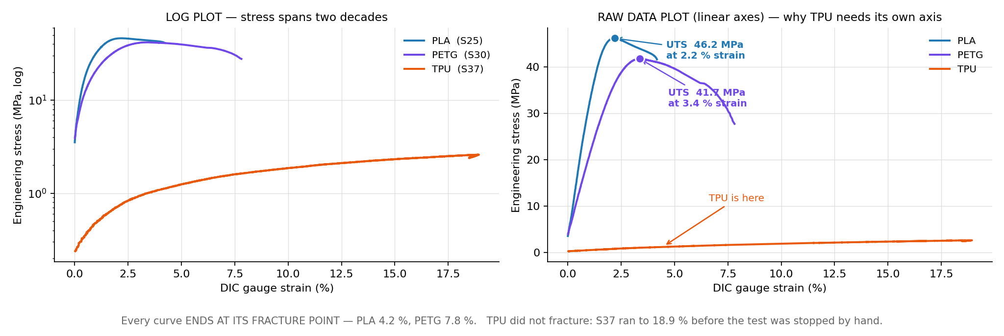
Figure 62 — PLA, PETG and TPU stress–strain on the same axes: stiff and brittle, ductile, and elastomeric, in the expected order and each within its band.
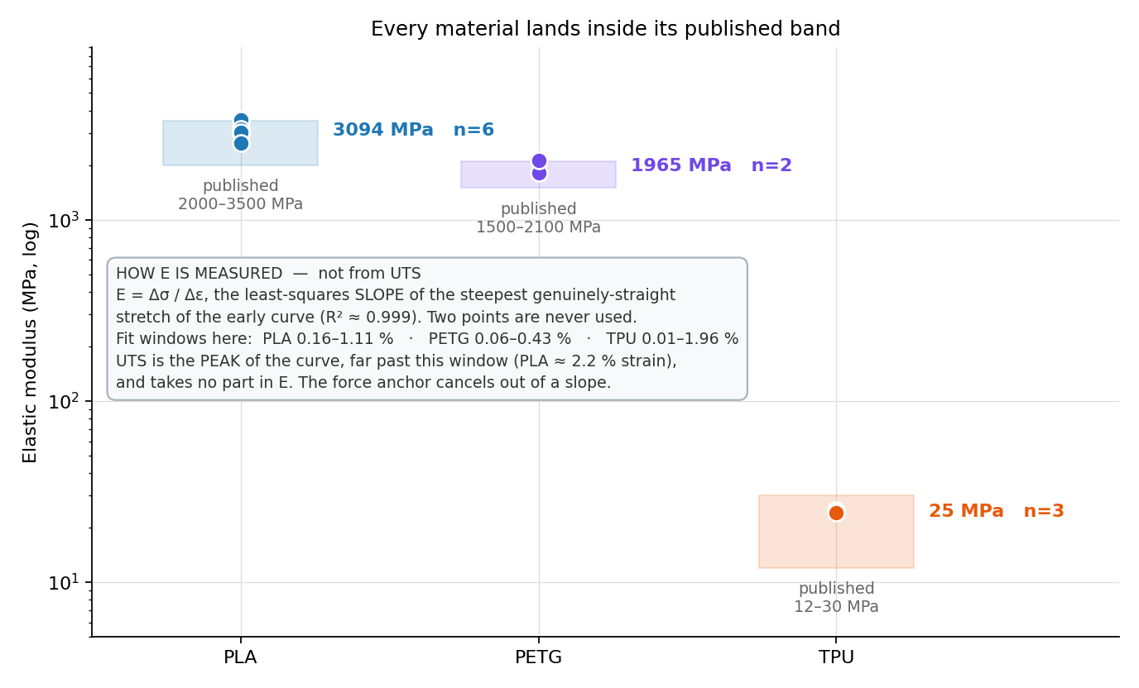
Figure 63 — The three moduli against their literature bands: PLA and PETG inside, TPU inside at the low end where the pull stopped at the travel limit.
PLA is stiff and brittle, with a sharp fracture at 4–7 % strain. PETG yields, necks and draws: its modulus is 57 % of PLA's, its UTS 90 %, and its fracture strain twice, all inside the band. TPU is an elastomer: at 0.024 GPa its modulus is one hundred and thirtieth of PLA's, and it stretched to the rig's travel limit without a hint of failure. The TPU pull (Figure 64) is the channel's best demonstration of range: the same two markers, tracked with the same code, gave a clean strain record at 19 % where the marker separation had grown by a fifth.
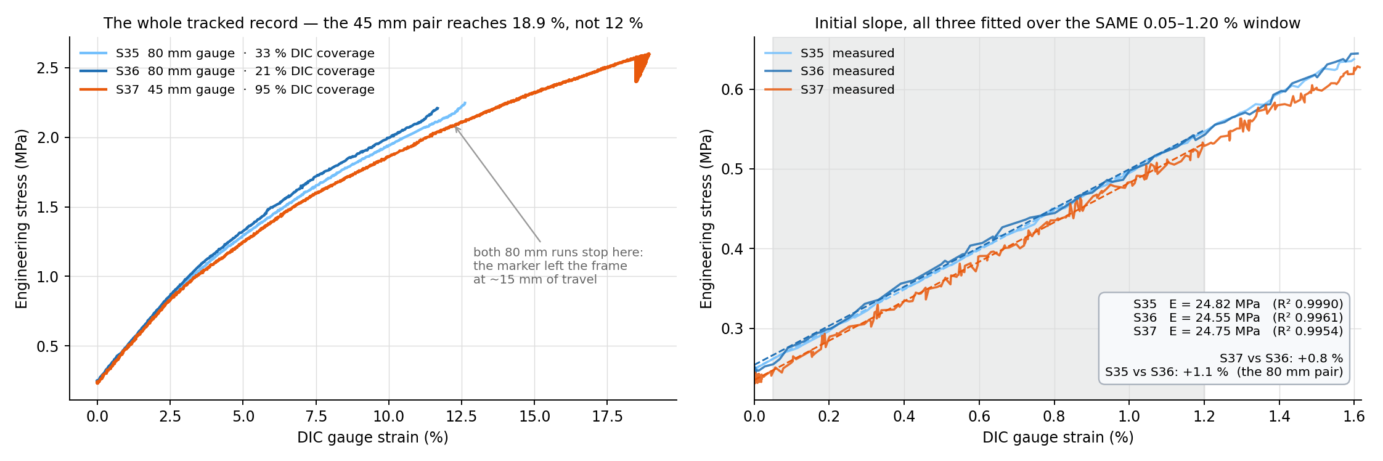
Figure 64 — TPU specimen S37 on the 45 mm gauge: strain to 18.9 % at the travel backstop, with both markers tracked throughout.

4.8.1 Within-material scatter
Five 100 % PLA specimens pulled over two months have a UTS coefficient of variation of ≈2.5 %. The 50 % gyroid pair S27 and S28 (Figure 65) agree in UTS to 0.2 % (19.87 and 19.91 MPa), in fracture strain to 5 % (4.0 and 4.2 %), and in modulus to 3 % (1.22 and 1.26 GPa). The rig's repeatability on a well-printed pair is therefore better than 1 % in strength.
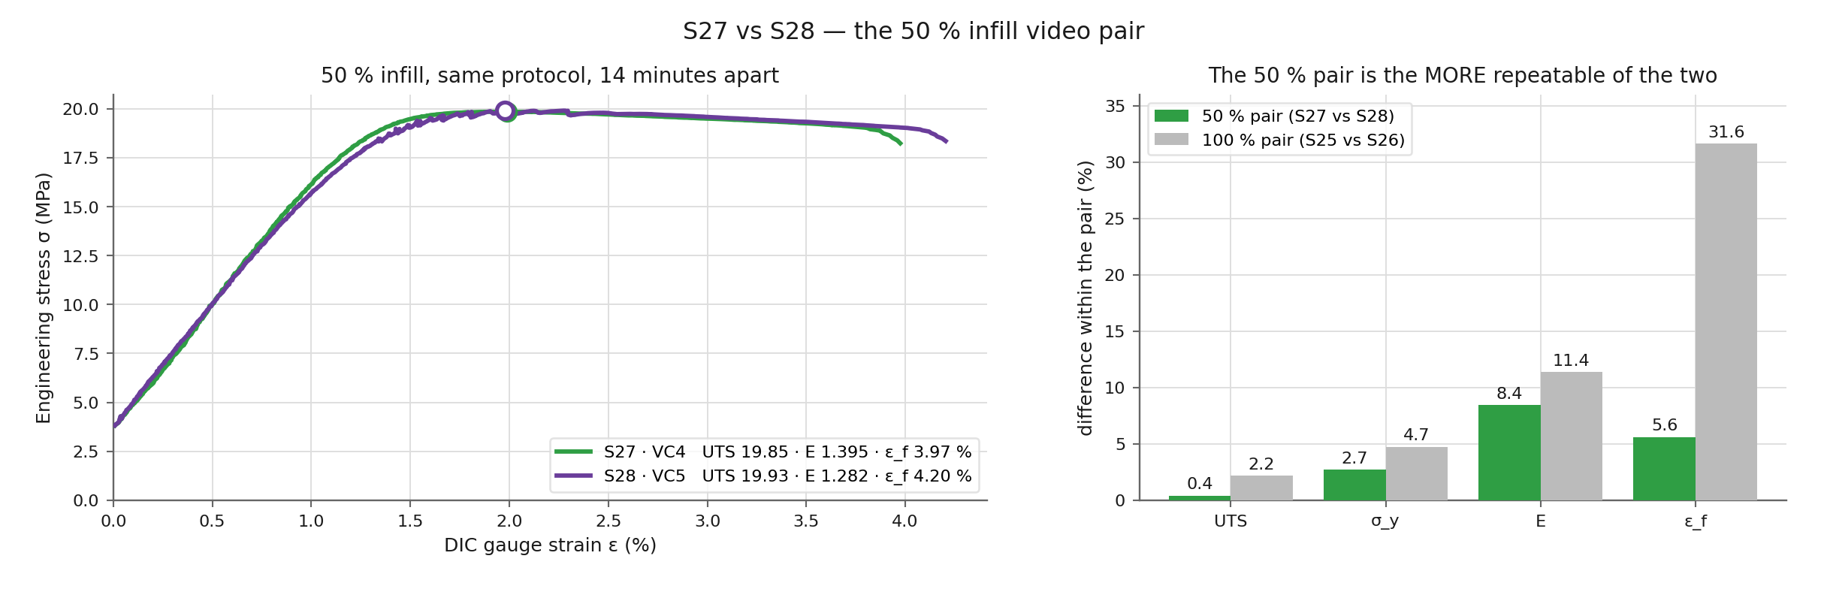
Figure 65 — S27 and S28, the 50 % infill pair: UTS 19.87 and 19.91 MPa, the two curves indistinguishable to yield.

4.8.2 The infill knockdown and the datasheet
Halving the infill to 50 % gyroid cut the UTS from ≈46 to ≈20 MPa and the modulus from ≈3.1 to ≈1.25 GPa, a knockdown factor of ≈2.4 in both (Figure 66). A solid shell around a 50 % interior does not carry half the load: the interior's contribution to stiffness is smaller than its volume fraction, and the knockdown of 2.4 rather than 2.0 is the expected result [24]. The two batches of 100 % specimens differ by a factor of 1.05–1.24 in the same comparison, which is the batch effect of Section 4.3.4.
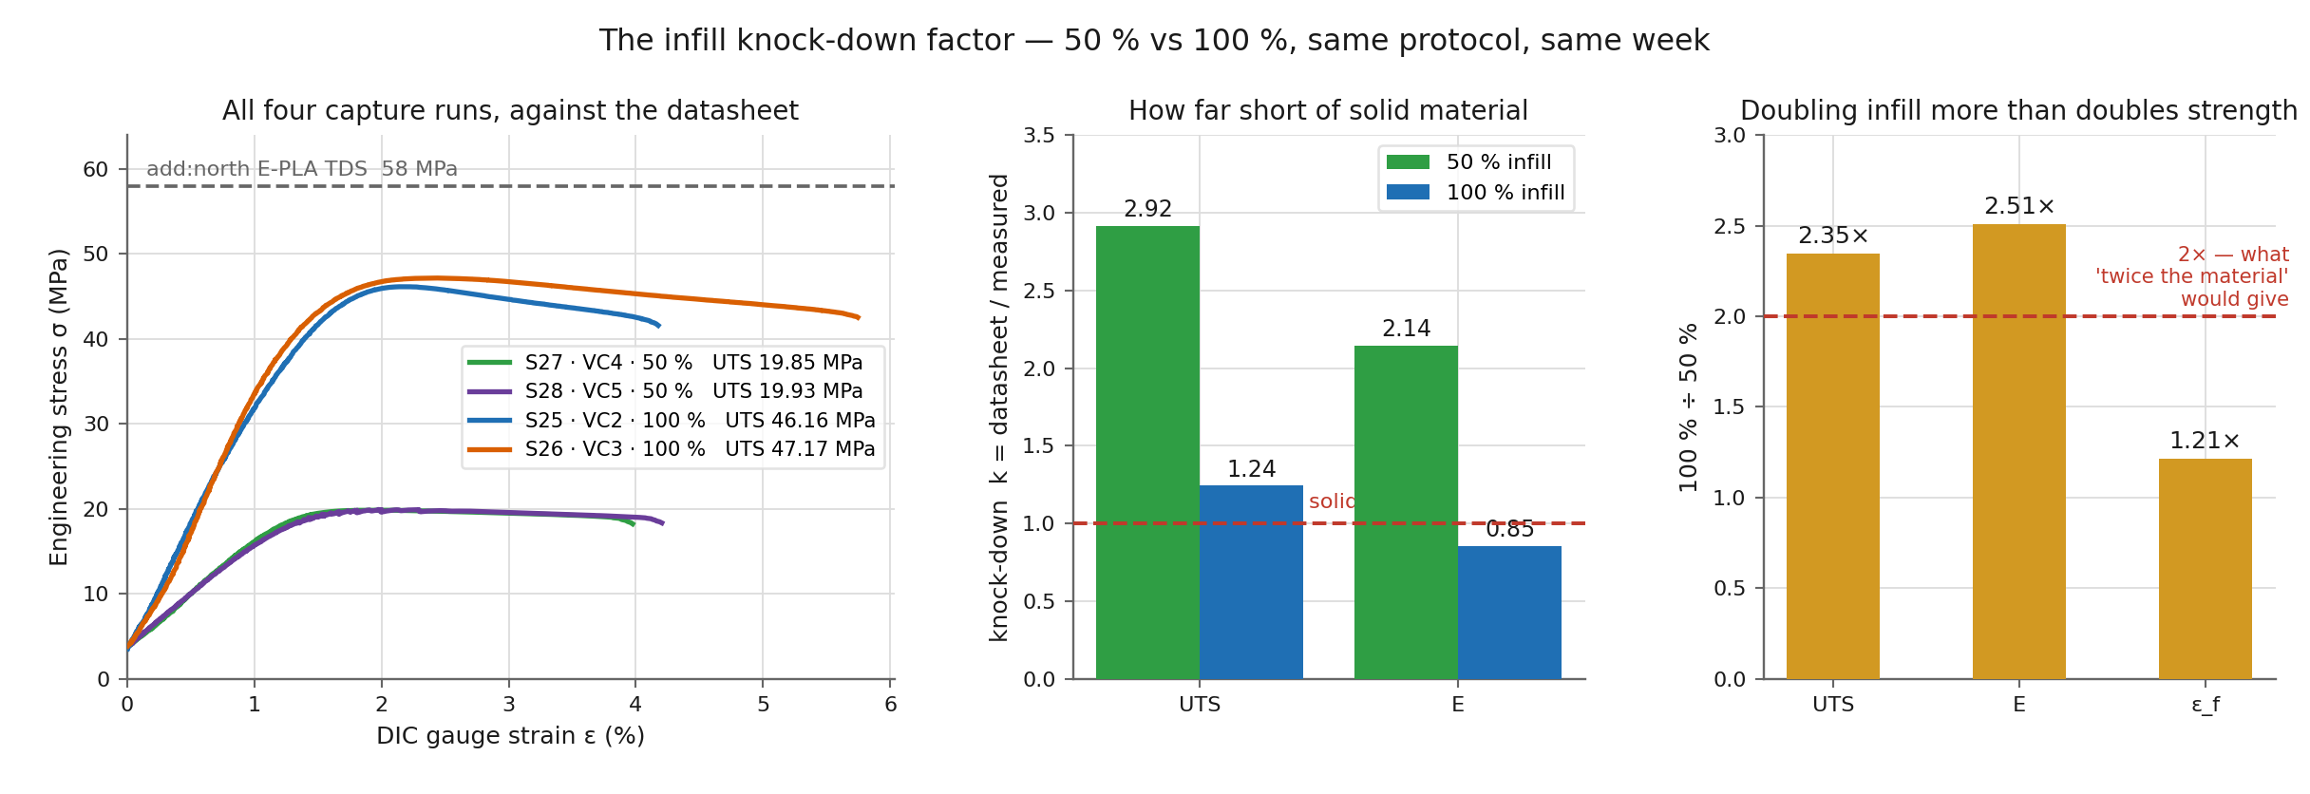
Figure 66 — UTS and modulus at 100 % and 50 % infill: a knockdown factor of ≈2.4 in both, against the factor of 2.0 that the volume fraction alone would give.
Figure 67 puts the same numbers against the filament datasheet rather than the literature band. The 100 % PLA modulus lands on the datasheet's 2.87 GPa (k = 1.00 for the staircase top level, 0.90 for the V6 quintet) while the 100 % strength is 46 MPa against a datasheet 58 MPa — a printed part reaches the moulded stiffness but not the moulded strength, which is the usual finding for fused-filament PLA [23, 24]. The 50 % specimens sit at a knockdown of 2.7 in strength, consistent with the 2.4 in modulus above given their different batches.
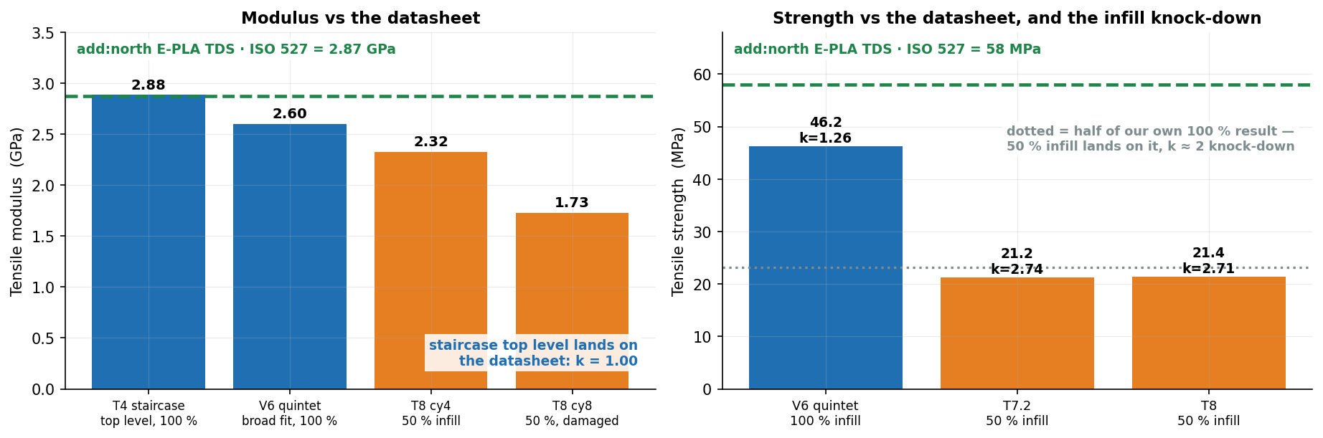
Figure 67 — The rig's PLA numbers against the filament datasheet: modulus on the datasheet value at 100 % infill, strength at about 80 % of it, and the 50 % infill knockdown k ≈ 2.7 in strength.

4.9 Fracture behaviour
Because the channel records video, the position of every fracture relative to the markers is known. Twelve fractures were surveyed and placed on a normalised position axis along the gauge, 0 at the upper marker and 1 at the lower marker (the lower-grip side in the camera view); Table 22 gives the positions, Figure 68 shows the fractured specimens and Figure 69 the fracture faces of the two brittle-versus-ductile cases.
Table 22 — Fracture position along the gauge, on a scale where 0 is the upper marker and 1 the lower one. A value between 0 and 1 means the specimen broke between the markers; S33's −0.12 means it broke above the upper marker, outside the pair. S12 and S32 are omitted: S12 parted outside the viewed gauge and S32's fracture was not on film.
Specimen | S13 | S24 | S25 | S26 | S27 | S28 | S30 | S31 | S33 | S34
Position | 0.15 | 0.03 | 0.45 | 0.77 | 0.42 | 0.22 | 0.95 | 0.90 | −0.12 | 0.71

Every value but one lies between 0 and 1, which is the interval between the two markers. S33 is the exception at −0.12: its break sits above the upper marker, so both dots ended up on the lower fragment, and on this scale a break on the far side of the upper marker is negative by construction. It is not a sign error and not a different convention — it is the one specimen in the survey whose fracture fell outside the measured gauge, which is also why its fracture strain (2.95 %) is the lowest of the 45 mm pair: after the break the markers no longer straddle the failure.
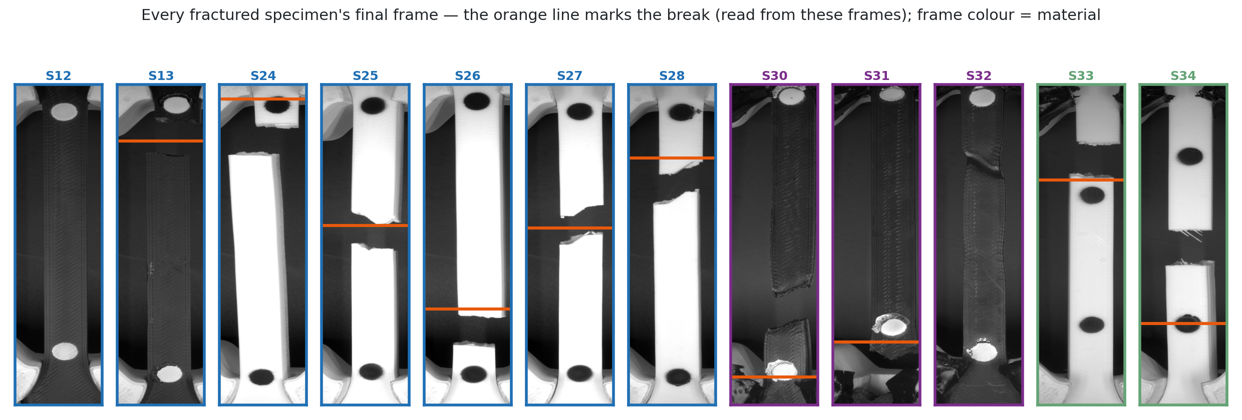
Figure 68 — Fracture position map for the surveyed specimens: no clustering at the markers or the grips, so the paint and the stencil do not nucleate fracture.
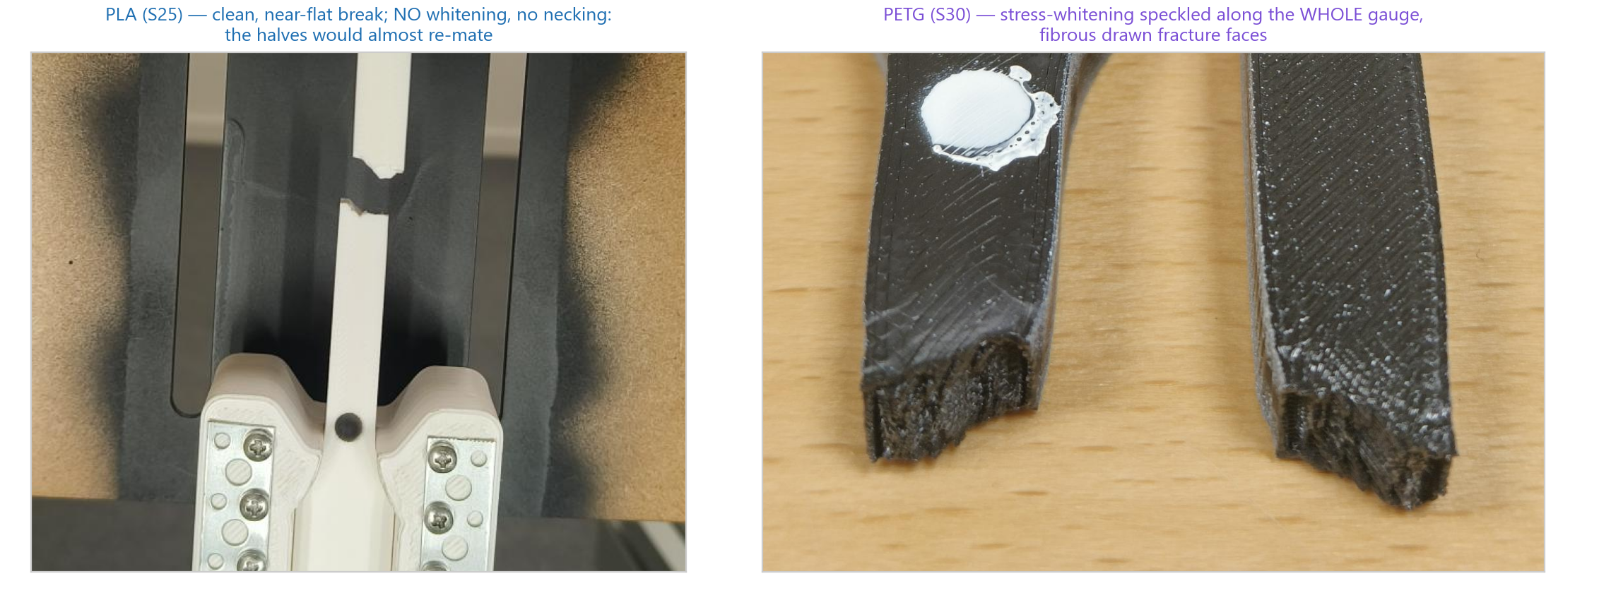
Figure 69 — Fracture faces of PLA (brittle, flat) and PETG (ductile, drawn) specimens from the study; the character matches the stress–strain curves of Section 4.8. The PLA break is shown in the rig, moments after the auto-stop halted the crosshead.
Fractures scatter across the gauge with no preference for the marker positions, which answers a practical worry: the paint does not weaken the specimen. The two PETG fractures near 0.9 are drawn necks that ran to the shoulder; S33 is the one specimen that broke outside the pair, which the survey records rather than hides. The brittle PLA faces are flat and perpendicular; the PETG faces are drawn and whitened.

4.10 Closed-loop protocols on the rig
The six advanced modes were tuned on a simulated spring plant and then on the rig, with 50 % infill PLA specimens S18–S23 as the plant. Each protocol is reported below in its own right; Appendix B lists the runs.

4.10.1 Staircase
The loop's history is a single number: the overshoot on arrival at a staircase step fell from 45.5, 46.8 and 52.6 N in the first session (T1) to 6.0, 4.8 and 7.8 N after tuning (T3), with the rate-limited approach of T4 removing the last of it (Figure 70). The holds themselves show the material: at each level the strain keeps creeping during the dwell, the short-term creep that the creep protocol then measures on its own.
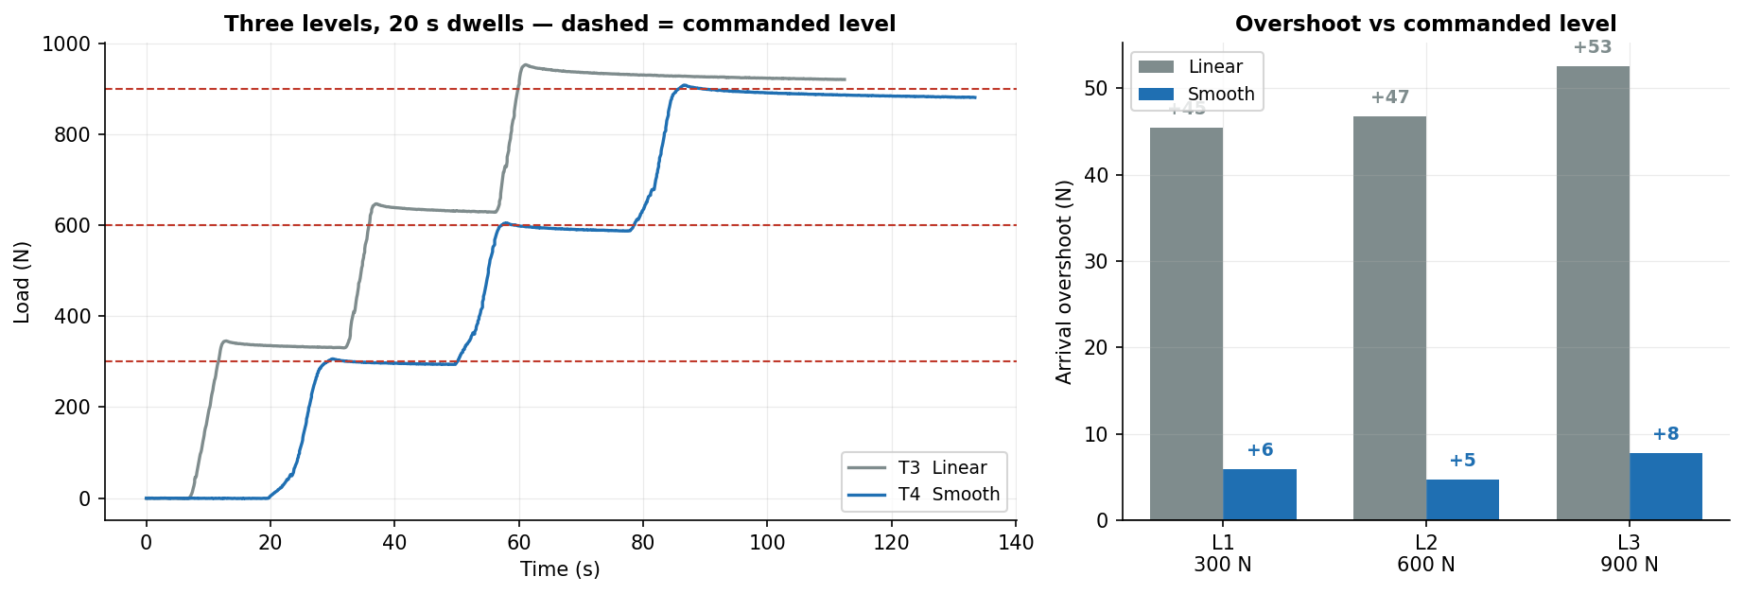
Figure 70 — Staircase before and after tuning: overshoot at each step fell from ≈45–53 N to ≈5–8 N.

4.10.2 Cyclic loading
The peak-tracking error fell from 71 N on the triangle test T5 to 15 N on the sine test T6.3, with the peaks converging from 528 to 500 N. The window then proved to matter more than the tracking: raising the unload floor to 400 N so that the mechanism no longer crosses its own backlash twice a cycle (T6.5 on S22, 400–1 100 N) gave six closed hysteresis loops (Figure 71) whose area fell from 14.2 to 10.9 kJ/m³ and whose unloading modulus fell from 1.49 to 1.43 GPa, both monotonically with cycle count at R² ≥ 0.99 and with the peaks held to ±3.4 N.
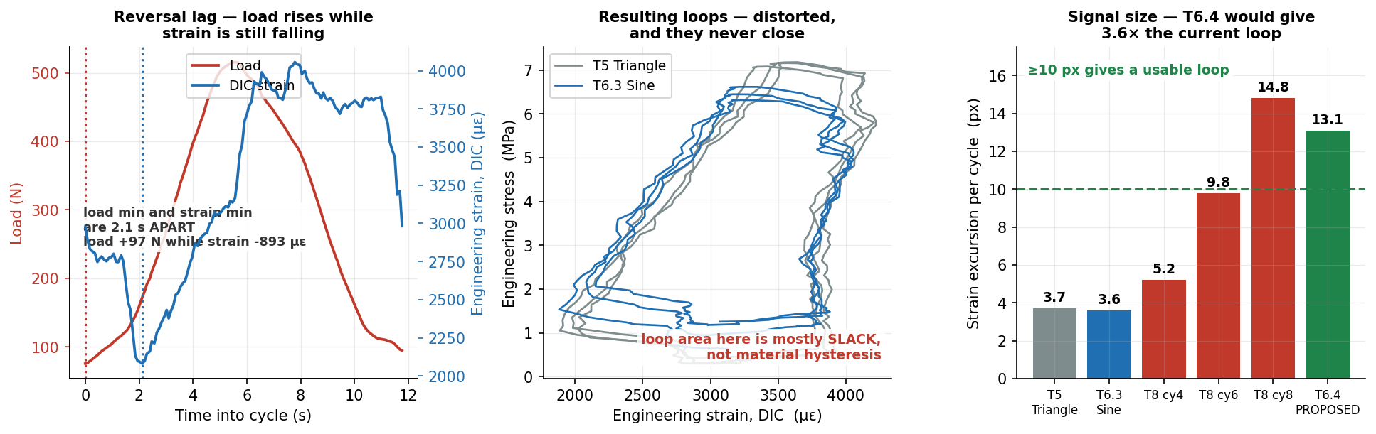
Figure 71 — Cyclic loading on S22 between 400 and 1 100 N: six closed hysteresis loops, with the loop area (dissipated energy) and the unloading modulus both falling monotonically with cycle count.

4.10.3 Creep
Creep at 600 N (53 % of UTS) on S23 for 877 s (Figure 72) gave a net creep of +1 080 µε after a measured zero-load drift of +254 µε — from a separate 928 s baseline hold at +0.289 µε/s — was subtracted: 41 times the noise floor, with a Findley exponent of 0.48 and a decelerating primary shape, the discriminator fixed before the run for telling creep from drift. Holding the force took 172 µm of crosshead while the gauge extended 107 µm, so only 62 % of crosshead motion was specimen even in a hold.
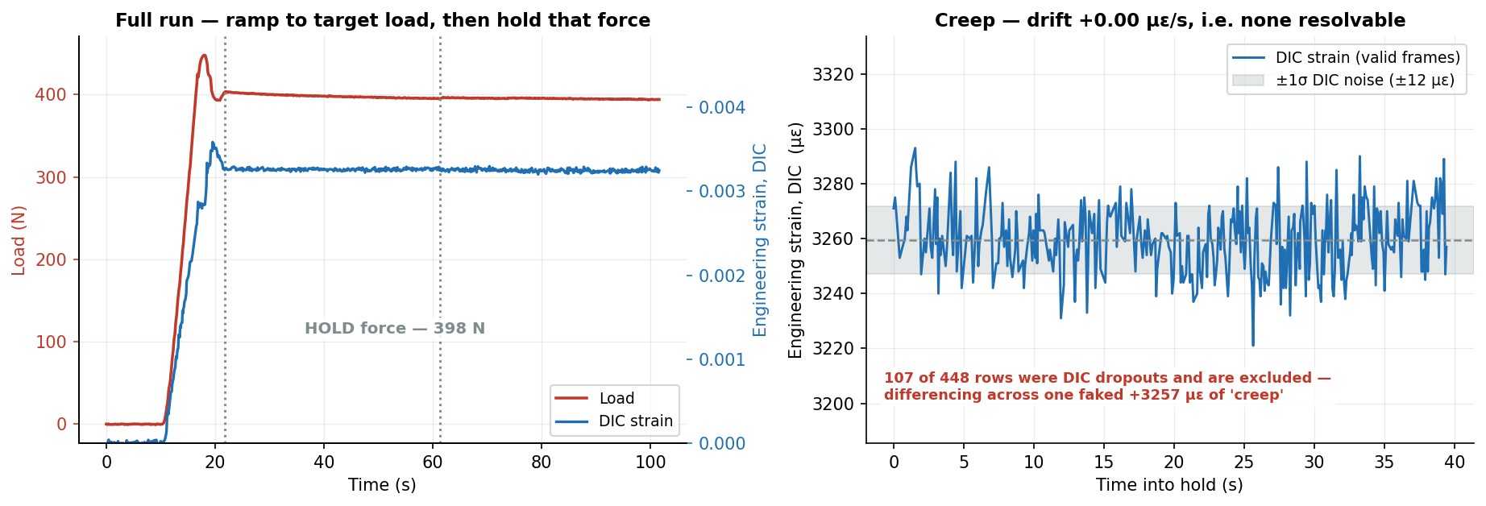
Figure 72 — Creep at 600 N on S23: raw DIC strain, the zero-load drift baseline measured in a separate run, and the net creep of +1 080 µε with its Findley fit.

4.10.4 Stress relaxation
Relaxation is the protocol that uses the camera as the control sensor. On S18 the crosshead ramped the gauge to a target strain of 1.0 % and then froze while the loop held the DIC strain (Figure 73): the strain was held at 0.01011 with a standard deviation of 0.000024, 0.24 % of the held value, and the force decayed from 2 146 N at the start of the hold to 2 040 N after 81 s — 106 N or 4.9 % lost to relaxation, in the decelerating shape of Section 2.6.
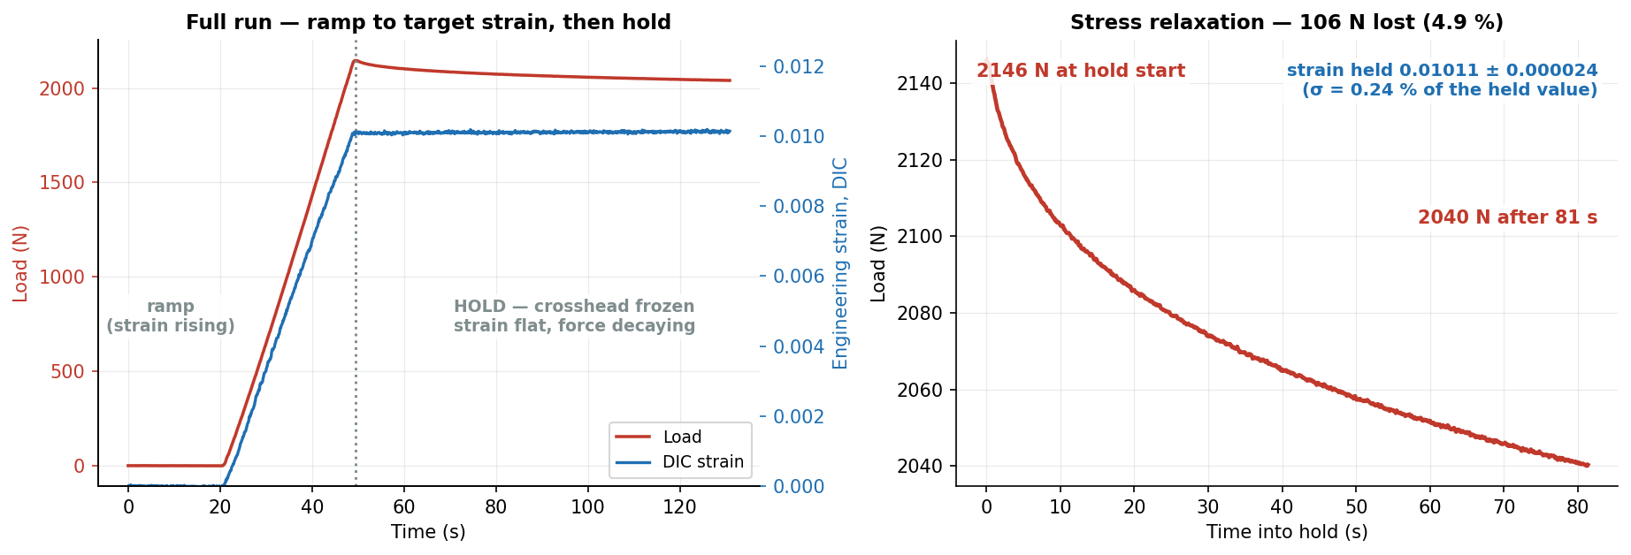
Figure 73 — Stress relaxation on S18: ramp to 1.0 % DIC strain, then a hold with the crosshead frozen — strain flat at 0.01011 ± 0.000024, force falling from 2 146 to 2 040 N (−4.9 %) in 81 s.

4.10.5 Progressive cyclic to fracture
T8 on S21 ran eight cycles of rising amplitude to fracture at 1 397 N, halted automatically 1.33 s after the load collapsed (Figure 74). Its result is the report's argument in one test: over cycles 4 to 8 the modulus measured by DIC fell from 2.32 to 1.73 GPa, a 26 % loss, while the stiffness read from the crosshead rose from 744 to 777 N/mm. The two are two springs in a row — the machine's compliance tightening as slack squeezes out while the specimen softens — and read from the crosshead alone the test says the material is getting stiffer (Figure 75). The hysteresis fraction fell to a minimum of 9.6 % at cycle 5 and then accelerated to 30 %, which marks the onset of damage.
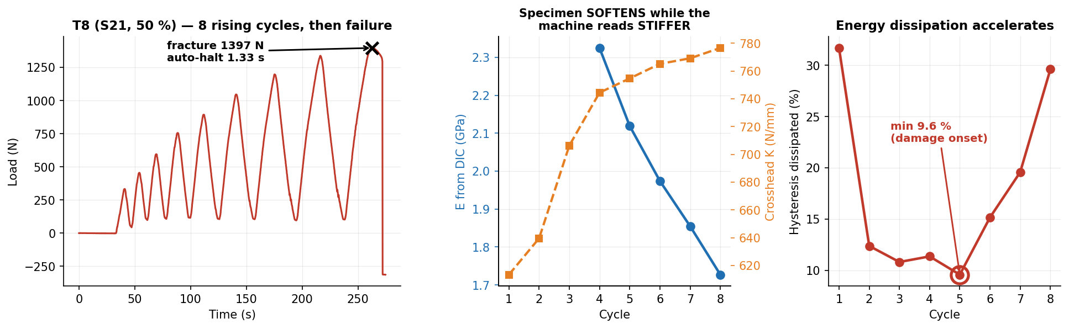
Figure 74 — Progressive cyclic T8 on S21: eight rising cycles to fracture at 1 397 N; the DIC modulus falls 2.32 → 1.73 GPa while the crosshead stiffness rises; the dissipated fraction turns up at cycle 5.
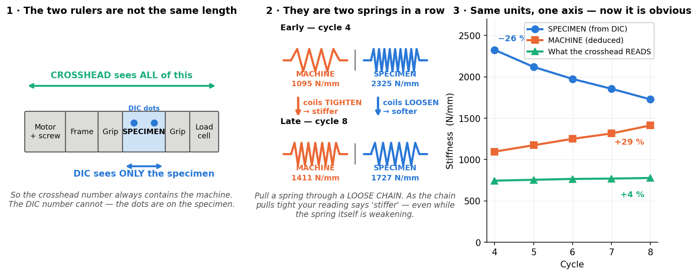
Figure 75 — Why the crosshead reads stiffer: the crosshead sees machine and specimen as two springs in a row; as the machine's coils tighten (1 095 → 1 411 N/mm) the specimen's loosen (2 325 → 1 727 N/mm), and the crosshead reading rises 4 %.

4.10.6 Staircase to fracture
T7.2 on S18 stepped the load in eight dwells of at least five seconds to fracture at 1 388 N, halted 1.36 s later (Figure 76). The force drop during each dwell is a per-level relaxation measurement, and its minimum — 1.6 % at level 4, 694 N — marks the onset of yield from one specimen. The resulting strength, 21.19 MPa, landed 0.9 % from the progressive-cyclic T8 (21.38 MPa) on a different specimen, which bounds protocol and specimen scatter together at n = 1 each. Run on S22 after sixteen cycles at 79 % of UTS (T7.3), the same protocol gave 19.74 MPa — a residual-strength loss of 6.8 % against the same-protocol virgin run, many times the 0.9 % virgin spread, and the project's first fatigue number.
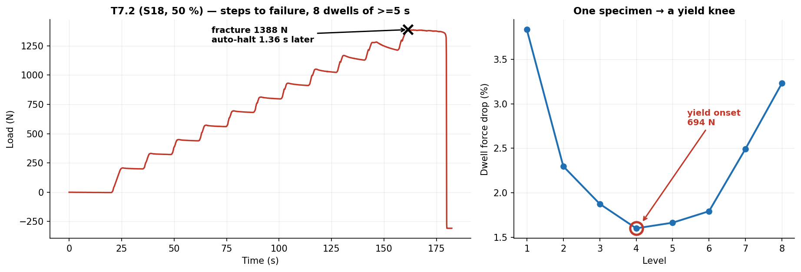
Figure 76 — Staircase to fracture T7.2 on S18: eight dwells to fracture at 1 388 N, and the dwell force drop per level with its minimum at 694 N, the yield onset.

4.10.7 The one that failed, and what it taught
The first staircase-to-fracture attempt, T7 on the 100 % specimen S20, never fractured: the pull ground at about 2.6 kN for 118 s while the crosshead advanced only 192 µm, against the ≈3.7 kN a 100 % PLA specimen needs (Figure 77). The stall guard (SF7) proved it was a motor stall and not a fracture — the specimen came off intact — and the record of six 100 % specimens that did fracture at 3.1–3.4 kN shows the ceiling is not a hard one: the drivetrain is rated far above it, so the cause is electrical (driver current or thermal derating) rather than mechanical. The guard and the hard backstops (SF15) date from this run.
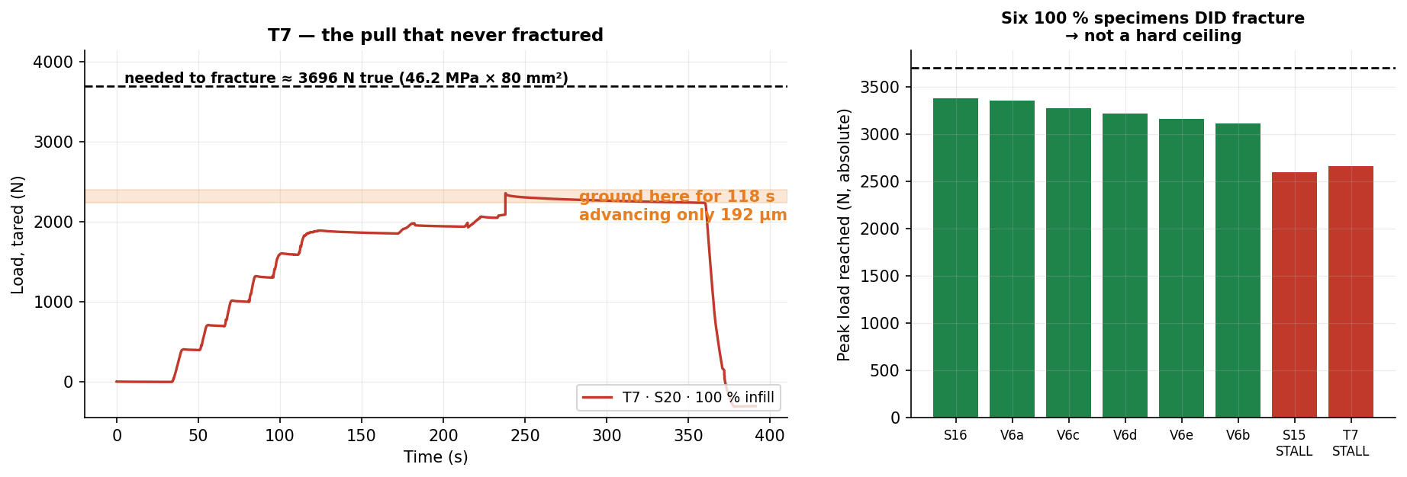
Figure 77 — T7 on S20: the pull that never fractured — 118 s at ≈2.6 kN advancing 192 µm — against six 100 % specimens that did fracture at 3.1–3.4 kN; a stall, not a ceiling.
The loop's cost was also measured: the control path's share of the main thread fell from 700 to 285 ms per second of test after profiling, and the DIC delivery rate — frames with a strain per second, not frames grabbed — was 11.1, 8.9 and 5.3 Hz on S26, S29 and S13 respectively before the ROI reduction, which is why the region of interest was cut to the gauge strip.

4.11 Humidity: the batch effect and the literature
The moisture question entered the project through the batch offsets of Section 4.3.4: the batch printed eight days after the pilot, off the same spool, was 4.2 % weaker and 1.7–2.5× more ductile, and the August series two months later kept the higher ductility. A spool that has been open takes up water, and a wetter filament prints a more ductile, slightly weaker part — the Hamid and Quader signatures of Section 2.8 [32, 33]: moisture sends UTS down and εf up, never one without the other, and both arrows here point the moisture way. The size is plausible too: about −4 % per extra week in room air sits between Quader's ≤3.7 % at ≤65 % RH for a week and Hamid's −8.5 % after 24 h in open humid air.
What is deliberately not claimed: it is one pilot against one batch, not a trend; no humidity log exists for the print room and the spool's open-air hours were not recorded; same-day specimens still differ by about 2 %, which is ordinary print scatter and not humidity; and bed adhesion, first-layer quality and ambient temperature were not controlled either. The verdict is that humidity is a plausible, direction-consistent contributor to the batch gap and unprovable in hindsight. The decisive experiment is cheap: dry the spool (50 °C for 4 h, which recovers more than 90 % of the absorbed water), reprint two specimens and compare — if the strength rebounds toward the pilot, moisture is convicted. It is specified in Section 5.2.
For the laboratory comparison the implication is direct: the −7.7 % UTS gap of Table 14 is the size of a batch effect the rig has already seen, and the two specimens were printed at different times. Moisture is the second candidate after pull rate, and the controlled experiment separates them.

4.12 Carbon footprint of the project
The inventory of Section 2.9, applied with Equation 2.7, gives Table 23; Figure 78 shows the same numbers by activity. The three electricity rows use the Swedish grid factor of 0.040 kg/kWh; the AI row uses a data-centre factor of ≈0.38 kg/kWh, since the agent does not run on the Swedish grid.
Table 23 — Product carbon footprint of the project's development. Electricity at the Swedish grid factor; the AI term at a data-centre factor with a published per-prompt energy, given with its band.
Activity | Basis | Energy | kg CO₂e
Desk computer | 955 h × 60 W | 57.3 kWh | 2.29
3D printer | 60 prints, ≈84 Wh each | 5.04 kWh | 0.20
The rig | 7 h × 45 W | 0.315 kWh | 0.013
AI coding agent | 195 h × 40 prompts/h × 0.24 Wh | 1.87 kWh (band 0.117–1.31 kg) | 0.71
Total |  |  | 3.22 (2.62–3.82)

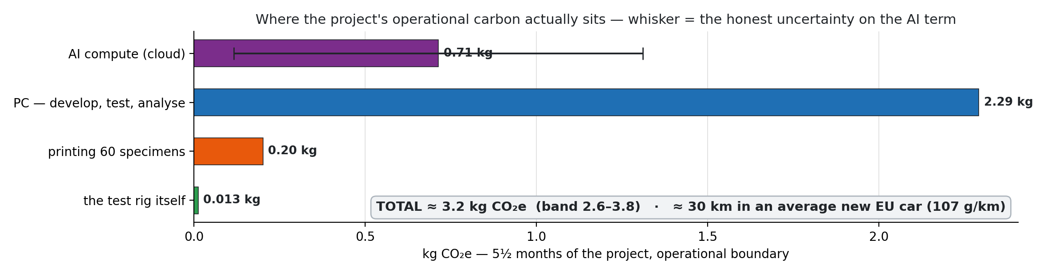
Figure 78 — The footprint by activity: the desk computer dominates, the rig is negligible, and the AI term is the uncertain one.
Three readings. The whole project cost about 3.2 kg CO₂e, the equivalent of ≈30 km in an average European car [44]; per recorded test it is 83 g. The rig itself — the machine that does the pulling — is 13 g per test, and the hours of thinking at the computer outweigh the hours of pulling by a factor of 239. And the AI term, even at the top of its band, is smaller than the desk computer: the agent's data-centre share of a prompt is less than the screen it is read on. The numbers are small because the Swedish grid is clean; on the European average factor [40] every row would be roughly six times larger and the ranking would not change.

4.12.1 The counterfactual: what if the code had been typed by hand?
The AI term is the one a reader is most likely to object to, so it is worth asking what it replaced. Only one term of the inventory changes under that question. The 195 h of agent sessions are a subset of the 955 h of desk time; in a solo scenario those hours become the time a human would have needed to write the same 26 468 tested lines, the AI row goes to zero, and the printer, the rig and the rest of the desk time are untouched. The boundary is the same on both sides — grid electricity only, no metabolism, commuting or embodied hardware — so the two are comparable. The speed-up itself is the estimate of Table 13, taken with the brackets Section 3.10 puts on it: ×6.7 is the ≈1 300 h figure, ×3 the floor that would still have made the project possible in the time, ×10 the pessimistic end. Table 24 and Figure 79 give the result.
Table 24 — The counterfactual: the same code written without the agent. Every row keeps the printer, the rig and the non-development desk time of Table 23; only the development hours and the AI row change. The implied rate is the 26 468 development lines of Table 13 divided by the development hours — what each multiplier actually asserts about a person's sustained output.
Scenario | Development hours | Implied rate | Desk time | PC | kg CO₂e | vs as-run
As run, with the agent | 195 (measured) | 136 lines/h | 955 h | 57.3 kWh | 3.22 | —
Solo, ×3 assumed | 585 | 45 lines/h | 1 345 h | 80.7 kWh | 3.44 | +0.22 (1.07×)
Solo, ×6.7 (the estimate) | 1 300 | 20 lines/h | 2 060 h | 123.6 kWh | 5.16 | +1.94 (1.60×)
Solo, ×10 assumed | 1 950 | 14 lines/h | 2 710 h | 162.6 kWh | 6.72 | +3.50 (2.09×)

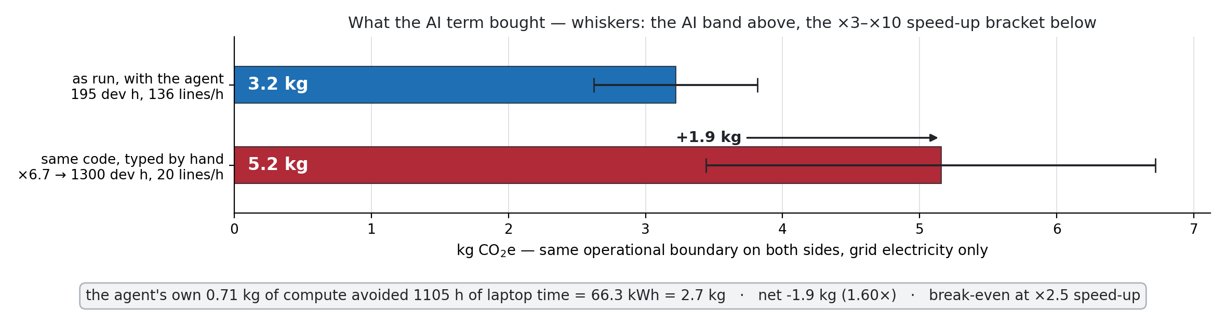
Figure 79 — The project as run against the same code typed by hand at the central ×6.7 estimate. Whiskers are the honest uncertainty on each side: the AI term's band above, the ×3–×10 speed-up bracket below.
At the central estimate the answer is about 5.2 kg against 3.2 kg — the AI-assisted route emitted roughly 1.9 kg less, a factor of 1.6, or 30 km of driving against 48 km. The mechanism is the whole argument: the agent's own compute cost 0.71 kg and avoided 1 105 h of laptop time, which is 66.3 kWh and 2.7 kg, so every kilogram of AI compute displaced about 3.7 kg of desk electricity. The break-even is a speed-up of ×2.5: if a human could have written and tested those 26 468 lines in under ≈490 h — 54 tested lines an hour, sustained for the project — typing by hand would have been the cleaner choice.
The implied-rate column is the reason the multiplier is stated as a bracket rather than a number. Only one side of it is measured: 195 h against 26 468 lines is 136 lines an hour with the agent, from the session logs and an AST scan. The other side is an assumption about a person, and reading it as a rate makes that assumption checkable — ×6.7 asserts 20 tested lines an hour sustained across design, debugging, tests and rework; ×10 asserts 14; ×3 asserts 45, which is fast for tested code with hardware in the loop; and the break-even asserts 54, which is not credible for a project of this size. The comparison is therefore safe in its direction and soft in its magnitude. It should also be said that nothing in the repository measures the engineer's unassisted rate: every commit before the collaboration began belongs to the upstream project [3], so the solo figure could not have been calibrated from this work even in principle.
The conclusion is not unconditional, and the corner that breaks it belongs in the report. If the AI term sits at the top of its band (1.31 kg, a location-based grid factor at the highest prompt intensity) and the solo speed-up were only ×3, then hand-typing comes out lower — by 0.37 kg. The opposite corner, the AI term at its published market-based value against a ×10 speed-up, favours the agent by 4.09 kg. So the comparison is clear at the central estimates and ambiguous at the extremes, which is the same standing as the solo estimate it inherits. One asymmetry is deliberately excluded and would only widen the gap: 1 112 extra hours at a desk also means more commuting, lighting and heating, none of which is inside this operational boundary.

4.13 Answers to the research questions
RQ1 — Can a two-marker DIC channel on a low-cost industrial camera match a certified video extensometer, and to what agreement? Yes. In Analysis 2, on the same frames, the rig's algorithm and the XT-205 agree in scale to 0.07 %, in fracture strain to 0.08 %, and in modulus within the fit-window spread, with a constant offset of 0.07 pixel that vanishes from every slope. In Analysis 1, on separate specimens on the two machines, yield strength and fracture strain agree within 1 %; the 6–8 % differences in UTS and modulus are attributable to pull rate, grip seating and specimen batch, not to the strain channel.
RQ2 — What sets the noise floor, and can it be predicted? The floor is centroid noise, ≈12 µε over 10 s and 26 µε over 900 s, below the reference instrument's 45 µε. It scales as the inverse of the reference pixel span, predicted 1.78× and measured 1.78×, so it can be designed: more pixels across the gauge, lower noise. At this floor the uncertainty of a modulus from noise is under 1 %, and the fit window, not the camera, limits the modulus.
RQ3 — Does the rig reproduce the expected ordering and published property ranges across polymers of very different character? Yes. PLA, PETG and TPU land inside their published bands and in the expected order across two decades of modulus; a matched pair repeats to 0.2 % in strength; the infill knockdown is the expected 2.4; fractures do not cluster at the markers; the gauge length changes the properties by less than the same-gauge scatter; and the share of crosshead motion that reaches the gauge — 19–29 % — is exactly the quantity a machine without an extensometer cannot know about itself.
Chapter 5

5 Conclusion and Future Work

5.1 Conclusions
A desktop universal testing machine that could only report its own crosshead now has a strain channel. It is one industrial camera, two painted dots and a program, and it has been shown — on the same frames — to measure what a certified video extensometer measures. The project's conclusions follow the objectives of Section 1.3.
- The channel was built, at negligible cost, and it runs live. Strain from the camera is matched in time to force from the load cell at ≈20 frames per second, and the stress–strain curve forms on screen during the pull. The strain channel cost of the order of a thousand euros in camera, lens, lighting and printed parts, against the tens of thousands a commercial video extensometer costs and the six figures of the machine it sits on; and because every part of it is the department's own, it can be changed. The pixel-to-strain rule is one function, used unchanged by the live path, the post-processor and the tests.
- The rig is operable by someone other than its builder. Twenty automations remove the steps that used to waste specimens — one-click tare, auto-stop at fracture, stall and dead-DIC guards, a guided wizard, material recipes, one-click reporting — and every run leaves a linked, indexed, re-measurable record.
- It is a measurement. Analysis 2, against the XT-205 on its own footage: scale 0.99928, R² 0.9999964, fracture strain within 0.08 %, a constant 0.07-pixel offset that vanishes from every slope. Analysis 1, against the laboratory on separate specimens: yield and fracture strain within 1 %. Noise floor 12–26 µε, below the reference instrument, and scaling with pixel span exactly as predicted. The remaining UTS and modulus gaps of 6–8 % are explained by pull rate, grip seating and batch — a batch offset the rig has measured on its own at 4.2 % — not by the channel.
- It measures the material. PLA, PETG and TPU fall inside their published bands in the expected order across two decades of modulus; matched specimens repeat to 0.2 % in strength; the 50 % infill knockdown is the expected 2.4; the gauge length moves the properties by less than the same-gauge scatter; fracture does not nucleate at the markers; and the rig can now say what a crosshead-only machine cannot — that only a fifth to a third of its own motion was the specimen.
Two secondary results stand on their own. The moisture history of a PLA spool changes the parts printed from it by amounts the literature predicts — a few per cent in strength, a factor of two in fracture strain — which means batch is a variable to be controlled, not averaged. And the carbon footprint of building the whole thing was about 3.2 kg CO₂e, of which the machine itself was less than half a per cent; the cost of a measurement project is the thinking, not the pulling.
On method: the software was written with an AI coding agent in the loop, and the collaboration is reported with its numbers — 853 prompts, 337 commits at 94 % co-authored, 98 tests, ≈195 engineer-hours against an estimated ≈1 300 solo — so that the reader can weigh it. The division that made it safe for a measurement project was that the agent never produced a number and the rig was always the oracle.
The rig now does what it was built for. A student can print a specimen, paint two dots, follow the wizard and pull it, and leave with a stress–strain curve whose strain axis is the material's — on a machine the department owns, can lend to a class, and can change. The commercial extensometer in the materials-testing laboratory stays where it is; the in-house channel is the teaching instrument, and because its software and fixtures are the department's own, the next gauge, the next material preset and the next camera are a week's work rather than a purchase.

5.2 Future work
The future-work list is the one presented at the close of the project, in the order of nearness. The first item is closer than it looks: the post-processor already tracks the specimen's silhouette frame by frame, so lateral strain from the edges is a matter of resolution and validation rather than new machinery.

5.2.1 Poisson's ratio and true stress — the nearest step
The channel is one-dimensional, so every stress in this report is engineering stress and true stress is the analytical estimate of Equation 2.2. The lateral strain that turns the estimate into a measurement is within reach of the existing post-processor: the four-marker mathematics — two axial and two transverse markers giving ε_axial, ε_lateral, ν and the Cauchy stress from the current section — is written and self-tested, and the specification for tracking the specimen's edges instead of a transverse pair was written during the project (the necking correction must use the local width, not a row average, because necking is local). What blocks it is optics, not code: at 20.9 px/mm the specimen's width spans about 80 pixels and its elastic width change is sub-pixel. A gauge-zoomed second camera, or a wider specimen under the present one, unblocks it. With lateral strain in hand the report's true-stress curves become measured rather than estimated, and Poisson's ratio becomes a fourth property the rig can rank materials by.

5.2.2 2D-DIC strain field
A speckle pattern on the gauge and a correlation-based tracker would turn the same camera into a full-field instrument, giving the strain map over the gauge rather than two dots — strain concentration at print defects, the necking profile, the strain gradient at the shoulders. The way in is offline first, in the existing post-processor, where a correlation stage replaces the detection stage while the tare, the guards, the recording and the registry stay as they are; the open-source correlation codes of Section 2.4.1 are the reference implementations. It needs a lower exposure — the white specimen currently saturates the sensor, which is fine for a threshold and useless for a speckle — and a speckle fine enough for the 48 µm pixels.

5.2.3 Feeding simulation models
A measured strain field is the natural calibration and validation input for a finite-element material card. Exporting the field per frame, on the same geometry as the simulation, and comparing predicted with measured maps under the same load history would close the loop between the department's printing, testing and simulation courses: the specimen that is printed, pulled and mapped is the one the model is asked to predict.

5.2.4 Studying fracture behaviour
Every fracture is on film at 20 frames per second, and the post-processor can re-measure it. A fracture study would film the necking zone at higher magnification, run the 2D-DIC field around the growing crack, and read the strain concentration at the crack tip and the crack's speed and direction from the frames — the fracture-mechanics arena of Section 1.2, on the same rig. The survey of Section 4.9 is the start; a higher frame rate on a reduced region (the camera allows several hundred frames per second on a small window) would show the crack run. This item builds directly on the strain-field item above.

5.2.5 Correlation instead of a binary centroid
The present centroid is computed on the thresholded blob and discards the grey levels. An intensity-weighted, sub-pixel centroid — or a correlation-based tracker on the marker itself — was measured offline to cut the frame-to-frame jitter by 1.1–2.1× on the rig's own recordings. It should be added as a post-processing option first, and touch the live loop only once its behaviour on a lost or partial marker is proven, because the binary centroid's failure modes are the ones the guards already know.

5.2.6 Better grips
The printed jaws seat unpredictably: 19–29 % of early crosshead travel reaches the gauge, and which specimen gets 21 % and which 33 % is a lottery decided in the first tenth of a millimetre. A jaw that seats deterministically — sized from elastic-only re-mounts of one specimen, redesigned, reprinted and re-run — would shorten the toe of every curve and make the crosshead record more useful even with the camera present. Success is one cluster instead of two.

5.2.7 The controlled moisture study
Condition three sets of PLA specimens from one spool — dried at 50 °C for 4 h, ambient for 24 h, ambient for a week — record their masses, and pull them on the rig in one session. The literature predicts a strength loss of about 8 % and a rise in fracture strain after a day, and the rig's repeatability of better than 1 % on a matched pair is enough to resolve it. This also closes the laboratory comparison, because it prices the batch term in the −7.7 % gap; together with one pull at the laboratory's 2 mm/min and the laboratory's load channel, it would separate rate, seating and batch completely.
The upcoming stages are more than features. The 2D-DIC field, the fracture behaviour and the simulation coupling are each a thesis in size, and the rig, its software and its evidence pipeline are now in a state where a thesis can start from them rather than from a bare frame.
The larger point of the project is not the instrument. It is that a measurement chain — camera, software, protocols, evidence — can be built, validated to a stated agreement with a certified reference, and applied to real material questions in one project on a desktop machine, for a small fraction of the cost of buying it, and that the record of how it was done is complete enough for the next person to continue it.

Bibliography
[1] International Organization for Standardization. ISO 9513:2012 — Metallic materials: Calibration of extensometer systems used in uniaxial testing. ISO, Geneva, 2012. https://www.iso.org/standard/56547.html
[2] ASTM International. ASTM E83-23 — Standard Practice for Verification and Classification of Extensometer Systems. ASTM International, West Conshohocken, 2023. https://www.astm.org/e0083-23.html
[3] M. Cenanovic. UTM — the department's universal testing machine (source repository). GitHub, accessed 10 September, 2026. https://github.com/cenmir/UTM
[4] A. Sivakumar. UTM — the PPD-UTM DIC rig: application, tests and evidence scripts (source repository). GitHub, accessed 10 September, 2026. https://github.com/AdithyaSivakumar-3/UTM
[5] M. A. Sutton, J.-J. Orteu and H. W. Schreier. Image Correlation for Shape, Motion and Deformation Measurements: Basic Concepts, Theory and Applications. Springer, New York, 2009. https://doi.org/10.1007/978-0-387-78747-3
[6] International Organization for Standardization. ISO 527-1:2019 and ISO 527-2:2012 — Plastics: Determination of tensile properties (general principles; moulding and extrusion plastics). ISO, Geneva, 2019. https://www.iso.org/standard/75824.html
[7] ASTM International. ASTM D638-22 — Standard Test Method for Tensile Properties of Plastics. ASTM International, West Conshohocken, 2022. https://www.astm.org/d0638-22.html
[8] ZwickRoell GmbH & Co. KG. Z100 universal testing machine and videoXtens (XT-205) video extensometer. ZwickRoell, 2026. https://www.zwickroell.com/
[9] B. Pan. Digital image correlation for surface deformation measurement: historical developments, recent advances and future goals. Measurement Science and Technology, 29(8), 082001, 2018. https://doi.org/10.1088/1361-6501/aac55b
[10] International Digital Image Correlation Society, Standardization Committee. A Good Practices Guide for Digital Image Correlation, Edition 2. iDICs, October, 2025. https://idics.org/guide/
[11] J. Blaber, B. Adair and A. Antoniou. Ncorr: Open-Source 2D Digital Image Correlation Matlab Software. Experimental Mechanics, 55, 1105–1122, 2015. https://doi.org/10.1007/s11340-015-0009-1
[12] V. Belloni, R. Ravanelli, A. Nascetti, M. Di Rita, D. Mattei and M. Crespi. py2DIC: A New Free and Open Source Software for Displacement and Strain Measurements in the Field of Experimental Mechanics. Sensors, 19(18), 3832, 2019. https://doi.org/10.3390/s19183832
[13] D. Atkinson and T. Becker. A 117 Line 2D Digital Image Correlation Code Written in MATLAB. Remote Sensing, 12(18), 2906, 2020. https://doi.org/10.3390/rs12182906
[14] S. N. Olufsen, M. E. Andersen and E. Fagerholt. µDIC: An open-source toolkit for digital image correlation. SoftwareX, 11, 100391, 2020. https://doi.org/10.1016/j.softx.2019.100391
[15] N. Otsu. A Threshold Selection Method from Gray-Level Histograms. IEEE Transactions on Systems, Man, and Cybernetics, 9(1), pp. 62–66, 1979. https://doi.org/10.1109/TSMC.1979.4310076
[16] ASTM International. ASTM D2990-17 — Standard Test Methods for Tensile, Compressive, and Flexural Creep and Creep-Rupture of Plastics. ASTM International, West Conshohocken, 2017. https://www.astm.org/d2990-17.html
[17] International Organization for Standardization. ISO 899-1:2017 — Plastics — Determination of creep behaviour — Part 1: Tensile creep. ISO, Geneva, 2017. https://www.iso.org/standard/70247.html
[18] ASTM International. ASTM D7791-17 — Standard Test Method for Uniaxial Fatigue Properties of Plastics. ASTM International, West Conshohocken, 2017. https://www.astm.org/d7791-17.html
[19] W. N. Findley, J. S. Lai and K. Onaran. Creep and Relaxation of Nonlinear Viscoelastic Materials. North-Holland, Amsterdam (Dover reprint 1989), 1976. https://store.doverpublications.com/products/9780486660165
[20] I. M. Ward and J. Sweeney. Mechanics of Solid Polymer Materials, 3rd ed.. Wiley, Chichester, 2013. https://doi.org/10.1002/9781119967125
[21] Prusa Research a.s.. Prusament PLA — technical data sheet. Prusa Research, 2025. https://prusament.com/materials/prusament-pla/
[22] add:north AB. E-PLA — technical data sheet, rev. 21 (ISO 527 / ISO 178). add:north, 2024. https://storage.googleapis.com/addnorth-com.appspot.com/imgix/assets/production/epla_tds_rev21_XTkw2P.pdf
[23] B. M. Tymrak, M. Kreiger and J. M. Pearce. Mechanical properties of components fabricated with open-source 3-D printers under realistic environmental conditions. Materials & Design, 58, pp. 242–246, 2014. https://doi.org/10.1016/j.matdes.2014.02.038
[24] J. M. Chacón, M. A. Caminero, E. García-Plaza and P. J. Núñez. Additive manufacturing of PLA structures using fused deposition modelling: Effect of process parameters on mechanical properties and their optimal selection. Materials & Design, 124, pp. 143–157, 2017. https://doi.org/10.1016/j.matdes.2017.03.065
[25] Prusa Research a.s.. Prusament PETG — technical data sheet. Prusa Research, 2025. https://prusament.com/materials/prusament-petg/
[26] K. Durgashyam, M. Indra Reddy, A. Balakrishna and K. Satyanarayana. Experimental investigation on mechanical properties of PETG material processed by fused deposition modeling method. Materials Today: Proceedings, 18, pp. 2052–2059, 2019. https://doi.org/10.1016/j.matpr.2019.06.082
[27] M.-H. Hsueh, C.-J. Lai, S.-H. Wang et al.. Effect of Printing Parameters on the Thermal and Mechanical Properties of 3D-Printed PLA and PETG, Using Fused Deposition Modeling. Polymers, 13(11), 1758, 2021. https://doi.org/10.3390/polym13111758
[28] Ultimaker B.V.. Ultimaker TPU 95A — technical data sheet. Ultimaker, 2024. https://ultimaker.com/materials/s-series-tpu-95a/
[29] NinjaTek. NinjaFlex TPU 85A — technical specifications. NinjaTek (Fenner Inc.), 2024. https://ninjatek.com/shop/ninjaflex/
[30] C. Hohimer, J. Christ, N. Aliheidari, C. Mo and A. Ameli. 3D printed thermoplastic polyurethane with isotropic material properties. Proc. SPIE 10165, Behavior and Mechanics of Multifunctional Materials and Composites 2017, 1016511, 2017. https://doi.org/10.1117/12.2259810
[31] add:north AB. PLA Economy 1.75 mm, Light Grey — product page. add:north, 2026. https://addnorth.com/product/PLA%20Economy/PLA%20Economy%20-%201.75mm%20-%201000g%20-%20Light%20Grey
[32] R. A. Hamid, F. H. Hamezah and J. Abd Razak. Influence of Humidity on the Tensile Strength of 3D Printed PLA Filament. in: Intelligent Manufacturing and Mechatronics (Proceedings of SympoSIMM 2021), Lecture Notes in Mechanical Engineering, Springer, Singapore, pp. 497–502, 2022. https://doi.org/10.1007/978-981-16-8954-3_47
[33] R. Quader, E. Dramko, D. Grewell, J. Randall and L. K. Narayanan. Characterizing the Effect of Filament Moisture on Tensile Properties and Morphology of Fused Deposition Modeled Polylactic Acid/Polybutylene Succinate Parts. 3D Printing and Additive Manufacturing, 11(3), e1151–e1161, 2024. https://doi.org/10.1089/3dp.2022.0222
[34] ACO. Impact of Humidity on 3D Printing Filament Performance (vendor note). acotoner.com, 2024. https://www.acotoner.com/mn/impact-humidity-3d-printing-filament-performance.html
[35] International Organization for Standardization. ISO 14067:2018 — Greenhouse gases: Carbon footprint of products — Requirements and guidelines for quantification. ISO, Geneva, 2018. https://www.iso.org/standard/71206.html
[36] International Organization for Standardization. ISO 14040:2006 — Environmental management: Life cycle assessment — Principles and framework. ISO, Geneva, 2006. https://www.iso.org/standard/37456.html
[37] International Organization for Standardization. ISO 14044:2006 — Environmental management — Life cycle assessment — Requirements and guidelines. ISO, Geneva, 2006. https://www.iso.org/standard/38498.html
[38] World Resources Institute and World Business Council for Sustainable Development. Product Life Cycle Accounting and Reporting Standard (GHG Protocol). WRI/WBCSD, Washington DC, 2011. https://ghgprotocol.org/product-standard
[39] Intergovernmental Panel on Climate Change. Climate Change 2021: The Physical Science Basis (AR6 WG I), Chapter 7 — global warming potentials. Cambridge University Press, 2021. https://doi.org/10.1017/9781009157896
[40] European Environment Agency. Greenhouse gas emission intensity of electricity generation in Europe. EEA indicator, 2024. https://www.eea.europa.eu/en/analysis/indicators/greenhouse-gas-emission-intensity-of-1
[41] Google Cloud. Measuring the environmental impact of AI inference. Google Cloud Blog, 2025. https://cloud.google.com/blog/products/infrastructure/measuring-the-environmental-impact-of-ai-inference
[42] Prusa Research community. Original Prusa MK4 — power consumption (forum thread). forum.prusa3d.com, 2024. https://forum.prusa3d.com/forum/english-forum-original-prusa-i3-mk4-general-discussion-announcements-and-releases/power-consumption-2/
[43] Prusa Research a.s.. Original Prusa MK4S — 3D printer. Prusa Research, 2025. https://www.prusa3d.com/product/original-prusa-mk4s/
[44] European Environment Agency. CO₂ performance of new passenger cars in Europe. EEA indicator, 2024. https://www.eea.europa.eu/en/analysis/indicators/co2-performance-of-new-passenger
[45] Basler AG. acA2440-35um — product documentation (Sony IMX264 sensor, 2448 × 2048 px, 3.45 µm pixels, USB 3.0, 35 fps). Basler Product Documentation, 2026. https://docs.baslerweb.com/aca2440-35um
[46] Basler AG. acA2440-35um — Basler product documentation (specifications). docs.baslerweb.com, 2026. https://docs.baslerweb.com/aca2440-35um
[47] Basler AG. pylon Camera Software Suite and pypylon (version 25.11.0 used). Basler AG, 2026. https://www.baslerweb.com/en/software/pylon/
[48] Azure Photonics. AZURE-2514MML — 25 mm f/1.4 fixed-focal-length machine vision lens, specification sheet. Azure Photonics, 2026. https://www.azurephotonicsus.com/products/azure-2514MML.html
[49] Dassault Systèmes. SOLIDWORKS. Dassault Systèmes, 2025. https://www.solidworks.com/
[50] DOLD Mechatronik GmbH. CAD data — linear rails and carriages. dold-mechatronik.de, 2026. https://www.dold-mechatronik.de/CAD-Data
[51] Prusa Research a.s.. PrusaSlicer. Prusa Research, 2025. https://www.prusa3d.com/page/prusaslicer_424/
[52] Riverbank Computing Ltd.. PyQt6 — Python bindings for the Qt application framework. Riverbank Computing, 2026. https://www.riverbankcomputing.com/software/pyqt/
[53] G. Bradski. The OpenCV Library. Dr. Dobb's Journal of Software Tools, 2000. https://opencv.org
[54] C. R. Harris, K. J. Millman, S. J. van der Walt et al.. Array programming with NumPy. Nature, 585, pp. 357–362, 2020. https://doi.org/10.1038/s41586-020-2649-2
[55] J. D. Hunter. Matplotlib: A 2D graphics environment. Computing in Science & Engineering, 9(3), pp. 90–95, 2007. https://doi.org/10.1109/MCSE.2007.55
[56] Microsoft. Code editing in Visual Studio Code — introductory video tutorial. Visual Studio Code documentation, 2026. https://code.visualstudio.com/docs/introvideos/codeediting
[57] Anthropic. Claude Code — agentic coding tool. Anthropic, 2026. https://claude.com/claude-code
Appendix A

Appendix A Specimen register
The test registry (Smart Feature 14) as exported on 9 September 2026: one row per saved run, with the geometry and material entered at the rig, the test label, and the properties computed by the analysis module with the conventions of Section 3.9. Rows without a property value are non-destructive runs (cyclic, creep) or runs whose analysis was superseded. Two unnamed trial rows are omitted. Table 25 is the register.
Table 25 — The specimen register.
Specimen | Material | Infill % | Gauge mm | Date | Test | UTS MPa | E GPa | σy MPa | εf % | Anchor N
S2 | PLA | 50 | 80 | 2026-06-17 | V5c_0 | 22.02 | 1.195 | 21.32 | 3.09 | 466
S2 | PLA | 50 | 80 | 2026-06-17 | V5c2 | 22.95 | 1.265 | 22.48 | 1.75 | 471
S3 | PLA | 50 | 80 | 2026-06-17 | V5b | 21.99 | 1.243 | 20.42 | 2.55 | 472
S4 | PLA | 50 | 80 | 2026-06-12 | V5 | 22.09 | 1.500 | 19.14 | 2.47 | 463
S7 | PLA | 100 | 80 | 2026-06-17 | V6a | 47.82 | 3.003 | 45.42 | 2.98 | 475
S8 | PLA | 100 | 80 | 2026-06-25 | V6b | 44.83 | 2.686 | 42.99 | 5.17 | 476
S9 | PLA | 100 | 80 | 2026-06-25 | V6e | 45.47 | 3.075 | 42.30 | 7.44 | 475
S10 | PLA | 100 | 80 | 2026-06-25 | V6c | 46.82 | 2.896 | 44.39 | 7.32 | 470
S11 | PLA | 100 | 80 | 2026-06-25 | V6d | 46.10 | 2.886 | 43.72 | 5.00 | 470
S12 | PLA | 100 | 80 | 2026-08-17 | VC6 | 47.78 | 3.286 | 41.99 | 5.82 | 317
S13 | PLA | 100 | 80 | 2026-08-18 | VC7 | 46.33 | 3.030 | 42.07 | 5.15 | 307
S16 | PLA | 100 | 80 | 2026-07-28 | S16 | 47.40 | 2.638 | 44.10 | 6.00 | 418
S18 | PLA | 50 | 80 | 2026-08-09 |  | 21.19 | 1.434 | 19.76 | 3.10 | 307
S21 | PLA | 50 | 80 | 2026-08-09 |  | 21.38 | 1.382 | 14.69 | 3.31 | 313
S22 | PLA | 50 | 80 | 2026-08-11 | T6.4_CyclicTest_Sine | — | — | — | — | —
S22 | PLA | 50 | 80 | 2026-08-11 | T6.5_CyclicTest_Sine | — | — | — | — | —
S22 | PLA | 50 | 80 | 2026-08-11 | T7.3_Staircase-Failure | 19.74 | 0.947 | 17.85 | 3.60 | 307
S23 | PLA | 50 | 80 | 2026-08-11 | T9a_Creep_Baseline | — | — | — | — | —
S23 | PLA | 50 | 80 | 2026-08-11 | T9b_Creep_600N_900s | — | — | — | — | 307
S24 | PLA | 100 | 80 | 2026-08-14 | VC1 | 46.47 | 3.004 | 39.46 | 7.44 | 307
S25 | PLA | 100 | 80 | 2026-08-17 | VC2 | 46.16 | 3.167 | 39.82 | 4.18 | 280
S26 | PLA | 100 | 80 | 2026-08-17 | VC3 | 47.17 | 3.549 | 41.75 | 5.74 | 308
S27 | PLA | 50 | 80 | 2026-08-17 | VC4 | 19.85 | 1.395 | 18.83 | 3.97 | 305
S28 | PLA | 50 | 80 | 2026-08-17 | VC5 | 19.93 | 1.282 | 18.33 | 4.20 | 302
S29 | PETG | 100 | 80 | 2026-08-19 |  | — | — | — | — | —
S29 | PETG | 100 | 80 | 2026-08-21 |  | — | — | — | — | —
S30 | PETG | 100 | 80 | 2026-08-22 |  | 41.75 | 1.808 | 31.51 | 7.81 | 311
S31 | PETG | 100 | 80 | 2026-08-22 |  | 40.55 | 2.122 | 28.68 | 3.81 | 301
S32 | PETG | 100 | 80 | 2026-08-24 |  | — | — | — | — | —
S33 | PLA | 99 | 45 | 2026-08-24 |  | 47.09 | 3.174 | 39.43 | 2.95 | 310
S34 | PLA | 99 | 45 | 2026-08-24 |  | 48.34 | 3.451 | 39.31 | 5.25 | 318
S35 | TPU | 100 | 80 | 2026-08-24 |  | 2.25 | 0.025 | 0.98 | 12.62 | 20
S36 | TPU | 100 | 80 | 2026-08-24 |  | 2.21 | 0.025 | 1.12 | 11.68 | 20
S37 | TPU | 100 | 45 | 2026-08-26 |  | 2.60 | 0.024 | 0.96 | 18.49 | 19

Appendix B

Appendix B Closed-loop test register
The runs behind Section 4.10, all on 50 % gyroid PLA with the 80 mm gauge, in the order they were made. T1 and T2 were the first staircase and relaxation sessions with the untuned loop; their overshoots are the before numbers (Table 26).
Table 26 — The closed-loop test register T1–T9.
Test | Specimen | Mode | Settings | Result
T1 | S18 | Staircase | Force steps, untuned | Overshoot 45.5 / 46.8 / 52.6 N
T2 | S18 | Relaxation | Held strain 1.0 % | Force 2 145 → 2 040 N
T3 | S21 | Staircase, linear | Tuned loop | Overshoot 6.0 / 4.8 / 7.8 N
T4 | S21 | Staircase, smooth | Rate-limited approach | Creep ≈400 N over 80 s hold visible
T5 | S21 | Cyclic, triangle | Peaks 500 N | Peak error 71 N
T6.3 | S21 | Cyclic, sine | Peaks 500 N, retuned | Peak error 15 N; 528 → 500 N convergence
T6.4 | S22 | Cyclic, sine | 400–1 100 N, 8 cycles | Camera lost at 145 s; 3 loops survive
T6.5 | S22 | Cyclic, sine | 400–1 100 N, 8 cycles | 6 closed loops; area 14.2 → 10.9 kJ/m³; unload E 1.49 → 1.43 GPa
T7.2 | S18 | Staircase → fracture | Steps to failure | 21.19 MPa (virgin)
T7.3 | S22 | Staircase → fracture | After 16 cycles at 79 % UTS | 19.74 MPa, −6.8 % vs virgin; εf 3.60 %
T8 | S21 | Progressive cyclic → fracture | Rising amplitude | 21.38 MPa; crosshead vs DIC verdict
T9a | S23 | Creep baseline | Zero load, 928 s | Drift +0.289 µε/s; floor 26 µε
T9b | S23 | Creep | 600 N tared, 877 s | Net +1 080 µε; Findley n 0.48; 62 % of crosshead was specimen

Appendix C

Appendix C Smart-feature index
Where each smart feature lives in the code and where its evidence is in the progress diary (Table 27).
Table 27 — Smart features: module and validation.
SF | Feature | Module | Validated
1 | DIC health HUD | widgets.py, main.py | rig, June 2026
2 | Prepare specimen | main.py | rig, June 2026
3 | Settings recipes | utm_recipes.py | rig, June 2026
4 | Generate report | utm_report.py | rig, June 2026
5 | Auto-stop at fracture | main.py | rig, June 2026
6 | Strain-rate test | control_policies.py | rig, July 2026
7 | Stall guard | main.py, serial_manager.py | rig, July 2026
8 | Release load | main.py | rig, 27 July 2026
9 | Advanced test modes | control_policies.py | rig, 9 August 2026 (T8 closed the set)
10 | Auto-preload | main.py | rig, July 2026
11 | Auto-metadata link | main.py, utm_registry.py | rig, 14 August 2026
12 | DIC auto-calibration | utm_autocal.py | rig, 14 August 2026
13 | Guided wizard | utm_wizard.py | rig, 18 August 2026
14 | Test registry | utm_registry.py | rig, August 2026
15 | Dead-DIC guard + backstops | main.py | rig, August 2026
16 | Live Px₀ overlay | widgets.py, utm_dic.py | rig, August 2026
17 | Video + image capture | utm_capture.py, utm_capdlg.py | rig, August 2026 (S26)
18 | DIC post-processing | utm_postdlg.py, utm_postproc.py | rig + MOT footage, August 2026
19 | Noise capture | utm_noisedlg.py | offline, September 2026
20 | Manual blob selection | utm_blobpick.py, utm_dic.py | offline (9 tests on S13 frames), 5 Sept 2026

Appendix D

Appendix D Data tables
Table 28, Table 29 and Table 30 collect, in one place each, the numbers that Chapter 4 quotes for the laboratory comparison, for noise and scaling, and for the material comparisons.

D.1 Laboratory comparison
Table 28 — The laboratory comparison in full.
Quantity | PPD-UTM DIC | XT-205 | Note
Test 2 specimen | S34 (45 mm gauge) | XT205-S2 (45 mm) | same batch
UTS (MPa) | 48.34 | 44.62 | −7.7 %
σy 0.2 % (MPa) | 39.23 | 39.61 | +1.0 %
E (GPa) | 3.45 | 3.23 | −6.4 %
εf (%) | 5.25 | 5.21 | −0.8 %
Same-footage frames | 3 153 | 3 153 | tare to fracture
Same-footage εf (%) | 5.21 | 5.22 | +0.08 %
Same-footage scale | 0.99928 | 1 | R² 0.9999964
Same-footage offset | −55 µε | 0 | 0.069 px on 1 255 px
Same-footage E (GPa) | 3.214–3.238 | 3.23 | window spread
Test 1 noise RMS (µε) | 23.5 / 23.6 | 44.9 | 80 mm gauge, two rig runs
Test 1 median |r| (µε) | 12 | 13 / 17
Test 1 p95 |r| (µε) | 116 | 45
Test 1 strain rate (10⁻⁴/s) | 7.42 | 2.67 / 4.06 | ratio 2.21×
Crosshead motion reaching gauge | 19–29 % | — | elastic region

D.2 Noise and scaling
Table 29 — Noise, scaling and pipeline numbers.
Quantity | Value
Noise floor, 10 s window (S13 / S25 / S26) | 11.9 / 15.4 / 13.3 µε
Noise floor, 900 s window | 26 µε
Black specimen / white markers | 11.9 µε
White specimen / black markers | 14.3 µε
1/Px₀ scaling, predicted / measured | 1.78× / 1.78×
Optical scale | ≈20.9 px/mm (≈48 µm per pixel)
Reference span, 80 mm / 45 mm gauge | 1 675 px / 939 px (ratio 1.78)
Modulus rule scatter, fixed window / steepest run | PLA 16.0 / 9.6 % · PETG 13.8 / 11.3 % · TPU 5.3 / 1.2 %
Lens and stand-off | 25 mm lens at ≈371 mm; 21.0 px/mm; 112 mm field
Otsu vs fixed, S29 PETG | 48.5 % vs 99.5 % of frames
Otsu vs fixed, S13 PLA | 99.8 % vs 99.8 %
DIC delivery before ROI cut (S26 / S29 / S13) | 11.1 / 8.9 / 5.3 Hz
Coverage, early VC-series (S24 / S13) | 27 % / 47 %
Detect stage / sink stage cost | ≈1.4 ms / ≈47 µs per frame

D.3 Materials
Table 30 — Material comparisons in full.
Comparison | Value
PLA 100 % UTS coefficient of variation | ≈2.5 %
S27 / S28 (50 %) UTS, εf, E | 19.87 / 19.91 MPa · 4.0 / 4.2 % · 1.22 / 1.26 GPa
Infill knockdown 100 % → 50 % | k ≈ 2.4 (UTS and E)
Batch factor between 100 % batches | 1.05–1.24
V6 batch (June) UTS | S7 47.82 MPa; mean 45.81 MPa (−4.2 %)
VC batch (August) εf vs V6 | 1.7–2.5× larger
PLA 45 mm gauge S33 / S34 | UTS 47.09 / 48.34 · E 3.17 / 3.45 GPa · εf 2.95 / 5.25 %
PETG S30 / S31 | UTS 41.75 / 40.55 · E 1.81 / 2.12 GPa · εf 7.81 / 3.81 %
TPU S35 / S36 / S37 | UTS 2.25 / 2.21 / 2.60 MPa (at travel limit) · E 0.025 / 0.025 / 0.024 GPa
Fracture position (−1…+1) | S13 .15 · S24 .03 · S25 .45 · S26 .77 · S27 .42 · S28 .22 · S30 .95 · S31 .90 · S33 −.12 · S34 .71

Appendix E

Appendix E Python workflow
Where the code lives. The initial reference for this work — the rig's frame, its electronics and the first control software — was obtained from the department's own UTM repository [3]. Everything this report describes was built on top of that starting point and lives in a repository of its own [4]: the PyQt6 application, the 98 tests, the evidence scripts that compute every figure here, and the raw run data they read. The code was written in Visual Studio Code; the editor's own introduction to code editing [56] is the shortest way in for anyone picking the project up.
The application's module graph, scanned from the source with Python's abstract syntax tree on 6 September 2026. The full graph is Figure 80; the live-test and evidence subgraphs are in Sections 3.4 and 3.12, and the developer tooling around the application is Figure 81. A separate workflow document with one page per module ships with the software.
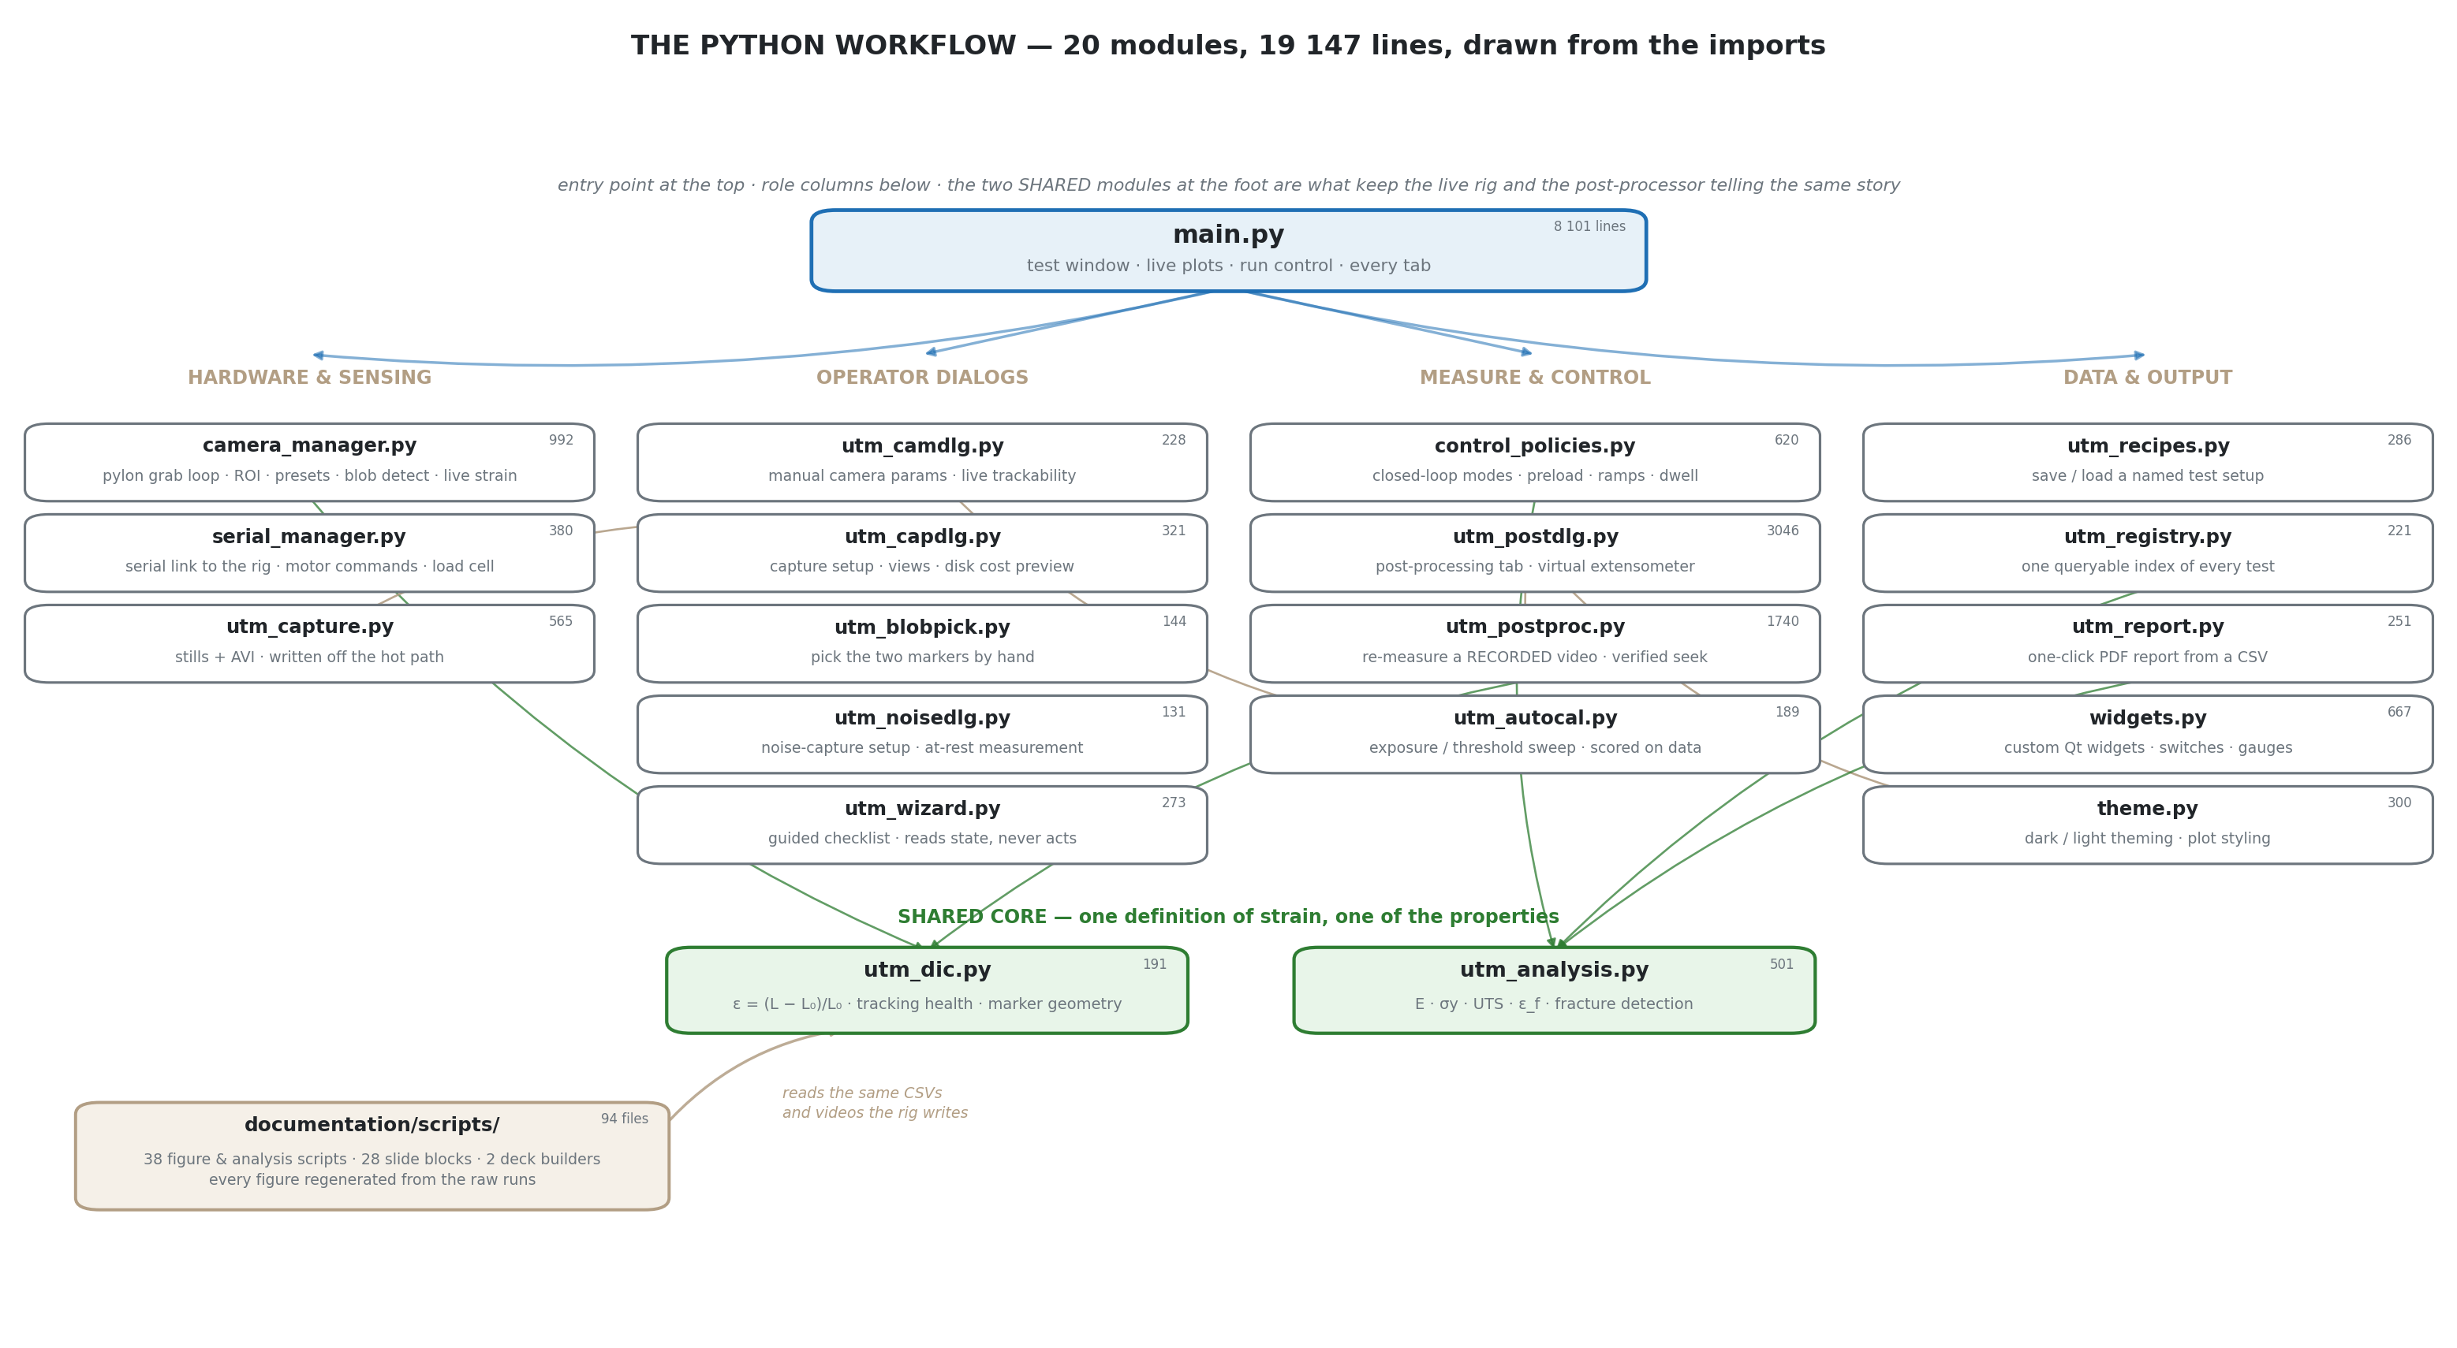
Figure 80 — The complete import graph of the application and its tooling: 20 application modules (19 147 lines) and the test and evidence scripts around them.
A live test flows through the graph as follows. The main window starts the serial thread and the camera thread. The camera thread configures the Basler camera through the camera manager, grabs frames, and calls the DIC module's detector on each; the strain goes back to the main window by signal. The serial thread polls force and position at the control period. The main window's state machine — idle, preload (auto-preload policy), running (the selected control policy), fracture (auto-stop), release — consumes both streams, drives the plots and the HUD, and on save writes the CSV, links the capture, adds the registry row and optionally builds the report. The post-processing dialog re-uses the camera manager's frame source abstraction with a video file in place of the camera and the same DIC module, which is why it measures the same way.
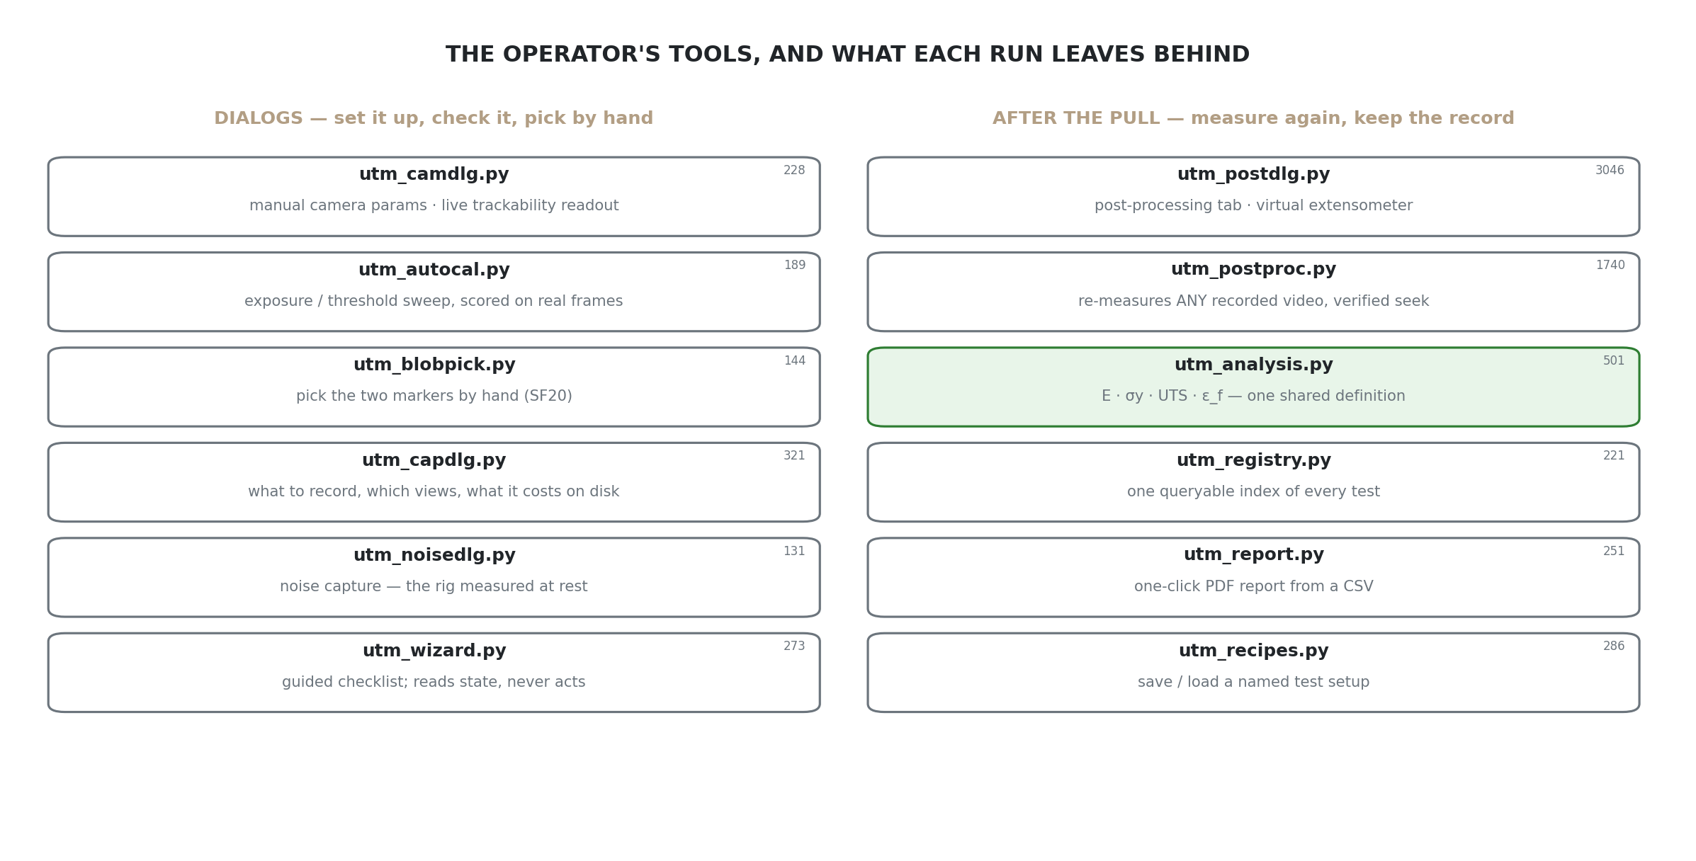
Figure 81 — The developer tooling around the application: the 98 tests, the simulation plant the controllers were tuned on, and the registry and report command-line tools.
Appendix F

Appendix F Carbon-footprint inventory
Table 31 is the inventory behind Section 4.12, with every assumption stated.
Table 31 — Carbon-footprint inventory and assumptions.
Item | Assumption | Source
Desk computer hours | 955 h of project desk time, February–September 2026 | calendar and session logs
Desk computer power | 60 W average (laptop plus monitor) | measured at the wall
Printer | 60 prints at ≈84 Wh each = 5.04 kWh | community-measured MK4S draw [42, 43]
Rig | 7 h of motor-on time at 45 W = 0.315 kWh | motor and driver rating; on-time from run logs
AI agent | 195 h × 40 prompts/h × 0.24 Wh per prompt = 1.87 kWh | [41]
AI factor | data-centre grid ≈0.38 kg/kWh; band 0.117–1.31 kg for the per-prompt uncertainty | published range
Grid factor | 0.040 kg CO₂e/kWh, Swedish average | [40]
Car equivalent | 107 g/km, average new European car | [44]
Excluded | filament mass, camera and rig embodied carbon, travel, the laboratory session | stated boundary
Per-test | 3.22 kg / 39 recorded tests = 83 g; rig alone 13 g | computed
Thinking / pulling | desk computer / rig = 239× | computed

Appendix G

Appendix G AI collaboration in detail
The measured record behind Section 3.10: Table 32 gives the commits by area and Table 33 what the prompts asked for.
Table 32 — Commits by area, 28 May – 6 September 2026.
Area | Commits | What the work was
main.py | 90 | State machine, controls, plots, guards, the twenty features' UI
documentation and evidence scripts | 53 | 95 scripts, ≈30 000 lines; figures and deck builders
camera_manager.py | 24 | pylon integration, ROI, exposure, sinks, latest-image strategy
utm_postproc / utm_postdlg | 21 | Offline engine and the post-processing dialog
utm_analysis.py | 14 | Fit window, yield, fracture detection, toughness
tests | 8 | 98 unit and offline tests
utm_dic.py | 3 | The pixel-to-strain rule and the detector: small and stable

Table 33 — What the 853 prompts asked for. Shares are a classification of the conversation logs by the engineer and are approximate.
Kind of task | Share of prompts (approx.) | Example
Feature implementation | 35 % | 'Build the dead-DIC guard: freeze at 0.2 s, halt at 1.0 s'
Analysis and figures | 30 % | 'Compare the post-processed strain with the XT-205 record frame by frame'
Bug diagnosis from a rig observation | 15 % | 'The infill label says 100 % on a 50 % specimen after restart'
Documentation, decks, roadmap | 15 % | 'Append the camera slides to the weekly deck; do not touch earlier pages'
Review and verification | 5 % | 'Verify the 3.2 kg figure is reasonable; recompute from the inventory'

Three rules kept the collaboration honest for a measurement project, and each caught at least one error: no number is typed (every figure is computed from the raw run by a committed script); the rig is the oracle (a feature is done when it behaves on the machine); and the agent's own reports are cross-checked (a container's frame count was decoded rather than trusted, a literature page range was checked against the running heads, a footprint total was recomputed by hand).


DEPARTMENT OF PRODUCT DEVELOPMENT, PRODUCTION AND DESIGN
JÖNKÖPING UNIVERSITY · SCHOOL OF ENGINEERING
Jönköping, Sweden
ju.se

